
ST. THOMAS’ ANGLICAN
CHURCH
October 16– October 22, 2025

4 Mary St, Bracebridge, Ont., P1L 2B6
705-645-3486
Email: 4saintthomas@gmail.com
Website: stthomasanglicanchurch.ca
Messages From Rev. Phelan
If you know anyone who is unable come to church, whether at home or in the hospital, and would like to take communion, please let me know. Due to privacy laws, the hospital does NOT call the church to let us know, so we depend on you. Thanks

The monthly ‘Bible verse to memorize’ for October is: "O Lord our governor, how exalted is your name in all the world! Out of the mouths of infants and children your majesty is praised above the heavens." Psalm 8: 1-2


Condolences
The Family of Art Cox is having a Celebration of Life on Saturday, October 18 from 1pm to 4pm at the Rotary Center.

Thinking of the Hammond/Kruger family for the burial service of Daniel Hammond October 18 at St Thomas Cemetery.

Prayer Group
Join us to pray on Sunday mornings at 10:00 a.m. in the Rector’s office.
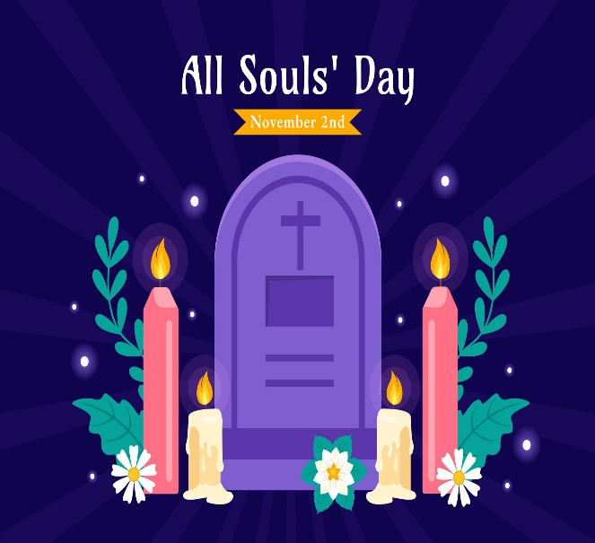

All Soul’s Service
St Thomas Cemetery is holding their annual All Soul Service on Sunday November 2nd, beginning at 1:30 pm. This service is for prayer and remembrance of loved ones we have lost. The Board members will read the names of the loved ones that were buried this year.
Reverand Phelan will be leading the service.
All Welcome

Our Vision
At the June Parish Council meeting, we were asked what our vision for the church is. The wardens and I have brainstormed, and our vision is to spread God’s word by:

- Introducing ourselves to every household in Bracebridge We have begun our canvassing of Bracebridge, handing out our flyers. We still need volunteers! It is not our tradition to bother people in their homes; we simply ask you to take the flyer and place it in the door handle or behind the door. If a homeowner is out and visible, it is best to say, "I have a flyer from the church; may I leave it at your door?" A map of Bracebridge is on the greeter’s table. All you need to do is take some flyers, mark the street you are doing with the highlighter, and complete delivery; it may be best to start with your own street or one close by. Any undelivered flyers are to be returned to the church. This approach has worked in the past at several parishes in which Phelan worked.

- Do a better job explaining our liturgy. You may notice the laminated pew cards. They are there to help explain what goes on in an Anglican service. The word 'liturgy', which describes ordered public worship, means, "the work of the people". We feel the presence of God in worship when we better understand the meaning and purpose of liturgy. Please return them as found after each service.


Pumpkin Carving
The children of St Thomas are invited to Pumpkin Carving and Pizza on Wednesday October 29th, 3:30 – 5 with Rev Phelan. Kids under 10 require a parent or guardian to stay with them. All are welcome to come in costume if they wish. Please RSVP to Ann Marie at the office so we have enough provisions for all!
Phelan+
Our Regular Services
On Sunday, October 19, we will celebrate Holy Eucharist for the at 10:30 a.m. with the Rev Phelan Scanlon. Here are the readings for this week –Jeremiah 31: 27-34, Psalm 119 97-104, 2 Timothy 3: 14-4:5, Luke 10: 1-8. This Friday at 10 am there will be a BAS Eucharist service.

Parish Office Hours: The office is open Tuesdays to Fridays from 9:00 a.m. to 2:00 p.m. On Wednesdays from 12-2pm those in need are offered frozen meals, gift cards and clothing if available. All donations are appreciated!

Parish Council
We had a Parish Council meeting this week on Tuesday October 14. The minutes from this meeting are posted in the hall.

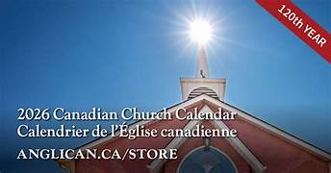

Church Calendars
The new church calendars for 2026 are available for purchase from the office for $7.00.
Please see Ann Marie

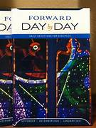
Day by Day
The new Day by Day for November 2025 – January 2026 is now available at the greeters table for $1 each to help cover the cost. Day by Day is a daily devotion booklet that has suggested readings, inspiring stories, thought provoking questions and of course prayers.

Messy Church – We Need Candy!!!


The first session will be on Friday, October 24th from 5:30 to 7pm (we normally do the last Friday of the month, but Halloween is the last Friday so, we can't do it then).
We are putting together treat bags for the children who attend. If you can donate a box of candy, please hand it into the office by Thursday October 23rd so we can sort it for the 24th. Please also help promote and support Messy Church to the extent you can. Numbers have been falling off a bit, and we would like to see that change. Thank you for your support.

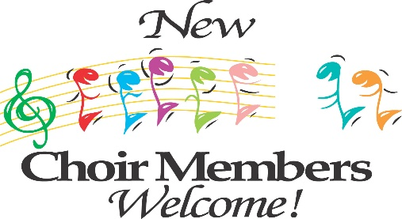
St Thomas Church Choir
The choir is looking for new members. Choir Practice will begin soon. They meet Thursday evenings starting at 5:30pm. They are also looking for a guitarist to accompany them from time to time.


Happy Birthday
Happy October Birthday to Jane Lever, Jo Nickason, Dorothy Douglas, Todd Jones, John Mitchell and Connie Knighton!

YOU’RE INVITED

MUSKOKA WOMEN COME ONE COME ALL
Church of the Good Shepherd Emsdale
Wednesday October 29, 2025
10:00 AM Registration Cost 15.00
10:30 Service led by Rev. Catharine Murkin
Hot Lunch
Speaker
PLEASE advise Sharon Boyuk 705 636- 5009
or
risingsunep53@gmail.com
no later than October 25 of attendance
and Dietary sensitivities
Anyone from St Thomas who would like to join Margot and Mary, please contact them so they can arrange carpooling.


Thank You
A big thank you goes to Beth Galbraith who is retiring after many years of caring for our gardens around our church. You and your team always make our grounds loved. The Parish Council is working on a way to thank her. You have left hard shoes to fill.


Sunday Assistants
Do you ever wonder how we choose who assists each Sunday service doing the readings, running the slide show or even greeting at the door? We have a rotating list created by Ann Marie every couple of months. If you would like to participate in any capacity, please reach out to the office by phone, email, or in person and let her know to add you to the list. Thanks to all our assistants who keep the service moving like a well-oiled machine!

Thanks to some very generous donors to date we have raised $7785.20
for our new flooring to date!
The numbers are in, and we are so close to the finish line. Only $900 still needed to pay the bill. Thank you to everyone who has helped us achieve this goal.



Volunteers Needed
Thanks to some generous donations, we have lots of clothing for those in need, BUT they need to be labelled and organized in bins to make it easier to offer to them. If you can help, please reach out to Ann Marie.
