
ST. THOMAS’ ANGLICAN
CHURCH
November 13– November 19, 2025

4 Mary St, Bracebridge, Ont., P1L 2B6
705-645-3486
Email: 4saintthomas@gmail.com
Website: stthomasanglicanchurch.ca
Messages From Rev. Phelan
If you know anyone who is unable to come to church, whether at home or in the hospital, and would like to take communion, please let me know. Due to privacy laws, the hospital does NOT call the church to let us know, so we depend on you. Thanks

The monthly ‘Bible verse to memorize’ for November is: “Not everyone who says to me, ‘Lord, Lord,’ will enter the kingdom of heaven, but only the one who does the will of my Father in heaven”. Matthew 7:21

Prayer Group
Join us to pray on Sunday mornings at 10:00 a.m. in the Rector’s office.


Shoebox Project
The Youth will be filling Shoeboxes again this year for the women at Interval House. We are looking for donations of new, unwrapped, personal care items, chocolate, mitts/hats/scarves, and small thoughtful gifts to put in the boxes. Small gifts for young children can also be donated. Please leave the items with Ann Marie in the office, or hand them to the greeter on Sundays. Thank you!


Grief Night
On Wednesday December 17, from
7-8:15pm, for anyone who is struggling after the loss of a loved one. Grace Donaldson from Andy’s House will be the guest speaker. All Welcome

Our Vision
At the June Parish Council meeting, we were asked what our vision for the church is. The wardens and I have brainstormed, and our vision is to spread God’s word by:

- Introducing ourselves to every household in Bracebridge We have begun our canvassing of Bracebridge, handing out our flyers. We still need volunteers! Thank you to Alva & Phelan for your help this week! It is not our tradition to bother people in their homes; we simply ask you to take the flyer and place it in the door handle or behind the door. If a homeowner is out and visible, it is best to say, "I have a flyer from the church; may I leave it at your door?" A map of Bracebridge is on the greeter’s table. All you need to do is take some flyers, mark the street you are doing with the highlighter, and complete delivery; it may be best to start with your own street or one close by. Any undelivered flyers are to be returned to the church. This approach brought in two new visitors last week. It is working!

- Do a better job explaining our liturgy. You may notice the laminated pew cards. They are there to help explain what goes on in an Anglican service. The word 'liturgy', which describes ordered public worship, means, "the work of the people". We feel the presence of God in worship when we better understand the meaning and purpose of liturgy. Please return them as found after each service.

Collect of the Day
You will find strips of paper with a marker or pencil in the pews. This is for you to write down your prayer concerns anonymously and then place the paper on the altar either before or after the service so they can be addressed. I will “collect” the thoughts of the congregation to add them to the Collect of the Day. Please use them.

Phelan+
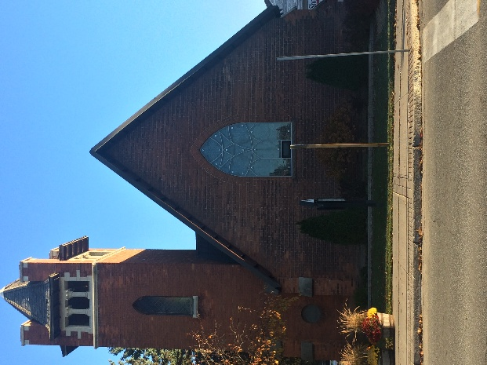
Our Regular Services
On Sunday, November 16, we will celebrate Holy Eucharist at 10:30 a.m. with the Rev Phelan Scanlon. Here are the readings for this week –Malachi 4: 1-2, Psalm 98, II Thessalonians 3: 6-13, Luke 21: 5-19. This Friday at 10 am there will be a BAS Eucharist service.

Parish Office Hours: The office is open Tuesdays to Fridays from 9:00 a.m. to 2:00 p.m. On Wednesdays from 12-2pm those in need are offered frozen meals, gift cards and clothing if available. All donations are appreciated!
Parish Council
The Parish Council Meeting for November was on Tuesday November 11th. Minutes from this meeting will be posted shortly.
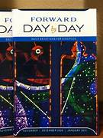
Day by Day
The new Day by Day for November 2025 – January 2026 is now available at the greeters table for $1 each to help cover the cost. Day by Day is a daily devotion booklet that has suggested readings, inspiring stories, thought provoking questions and of course prayers.
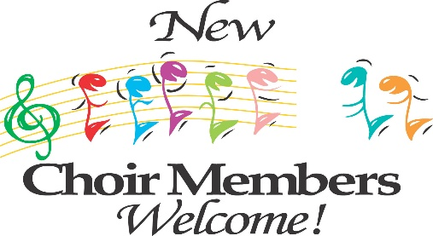

St Thomas Church Choir
The choir is looking for new members. Choir Practice starts tonight, November 13 at 5:30pm. They are also looking for a guitarist to accompany them from time to time.
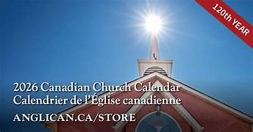
Church Calendars
The new church calendars for 2026 are available for purchase from the office for $7.00.
Please see Ann Marie

Happy Birthday
Happy November Birthday to Stella Lovelock, Ken Lovelock, Ann Newroth, Brenda Watt, Michele Fox, Sybil Jackson, Lucy McLean and Christine Lees!

Open Door Worship
Iris will be here in November and December will be on the 1st and 2nd Fridays of the month 12-1pm. All Welcome!

Spread the Warmth
Starting next week until the end of November, we will be having a Coat/Boot/Hat/Mitt/Scarf Drive for those in need, that includes members of our congregation. A special coat rack will be set up by the doors to the courtyard for you to hang up your donated coat, with boots neatly underneath and other items in the basket provided. Please make sure all donations are in good repair and clean. We have already provided coats to some grateful people this week. This winter lets show our kindness by keeping others warm!
We have given away 4 Winter Coats, 3 pairs of boots, many hats, mitts and scarves in November! Keep the donations coming!
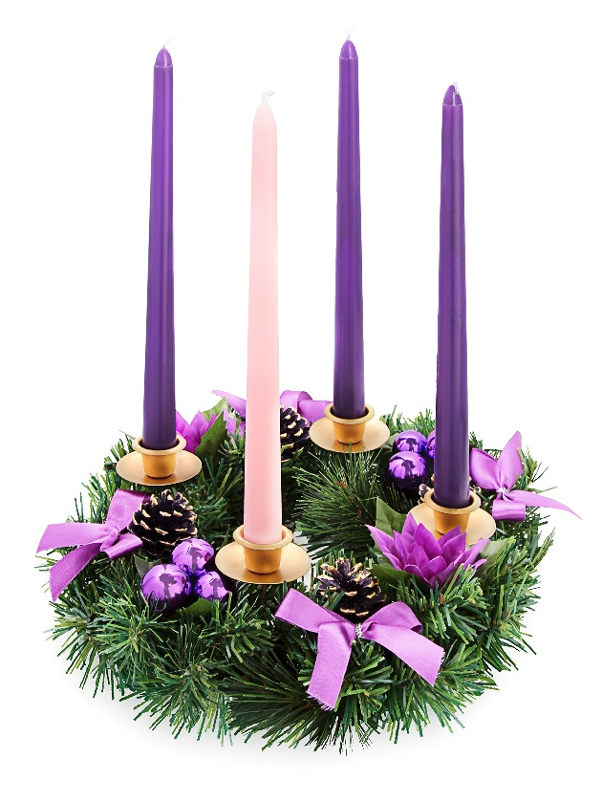
Advent Wreaths
Back by request, we will have an Advent Wreath Making afternoon on Thursday November 27th beginning at 2pm. The purpose of lighting Advent wreath candles and praying is to prepare for the coming of Christ at Christmas. The wreath and candles have a long history as symbols of hope, peace, joy, and love, which are the themes of the Advent season. Saying an Advent wreath praying as you light the candles is a way to reflect on the meaning of Christmas and to anticipate the arrival of Christ. We will be making natural greenery table wreaths with 4 candles, pinecones and ribbons. All materials will be provided. We will also be serving hot apple cider and Christmas Cookies while listening to Christmas carols. After the wreaths are done, Rev Phelan will bless the wreaths as we light our first candle. If interested, please sign up your family on the congregation bulletin board outside the sanctuary. You MUST register if you want materials to make a wreath.


Messy Church

Our next Messy Church will be held on Friday, November 28 at 5:30pm. Please help promote and support Messy Church to the extent you can. Numbers have been falling off a bit, and we would like to see that change.


The Social Justice Committee of the Diocese of Algoma is receiving a special award at the Fall Convocation of Thornloe University. Connie Knighton is going to Sudbury on Thursday to receive the award on behalf of the committee. It is lovely to have this recognition. Prayers for snow free driving appreciated.

The Rev Phelan Scanlon will be preaching for this, and John Mitchell will be lead morning prayer here at
St Thomas’ on Sunday December 7th

