
ST. THOMAS’ ANGLICAN
CHURCH
June 4 – June 10, 2026

4 Mary St, Bracebridge, Ont., P1L 2B6
705-645-3486
Email: 4saintthomas@gmail.com
Website: stthomasanglicanchurch.ca

Messages From Rev. Phelan
The monthly ‘Bible verse to memorize’ for June is: "But the Advocate, the Holy Spirit, whom the Father will send in my name, will teach you all things and will remind you of everything I have said to you " (John 14:26)


Home Communions
I continued my home visits again this week. If you know anyone who is unable to come to church, whether at home or in the hospital, and would like to take communion, please let me know. Due to privacy laws, the hospital does NOT call the church to let us know, so we depend on you. Thanks,
Phelan+

Our Regular Services
On Sunday, June 7, we will celebrate Pentecost II Sunday at 10:30 a.m. with the
Rev Phelan Scanlon. This week’s readings are Genesis 12: 1-12, Psalm 33:1-12,
Romans 4:13-25, Matthew 9:9-13, 18-26. This Friday at 10am there will be a BCP service.


Parish Office Hours: The office is open Tuesday to Friday,
9:00 a.m. to 2:00 p.m. Our Office Administrator is Ann Marie.
Pop in and say “Hi” when you are in the church or the neighborhood. You can call the church office at 705-645-3486.

Prayer Group
Join us to pray on Sunday mornings at 10:00 a.m. in the Rector’s office.


Happy Birthday
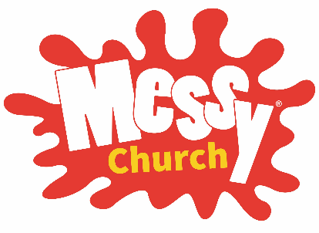
Happy June Birthday to Ann Marie Taylor, Ross McLean, Ivy Lee, Barb Mitchell and Laura Lovelock. If you want to see your birthday in the Loop, please let the office know about your birthday.

Messy Church
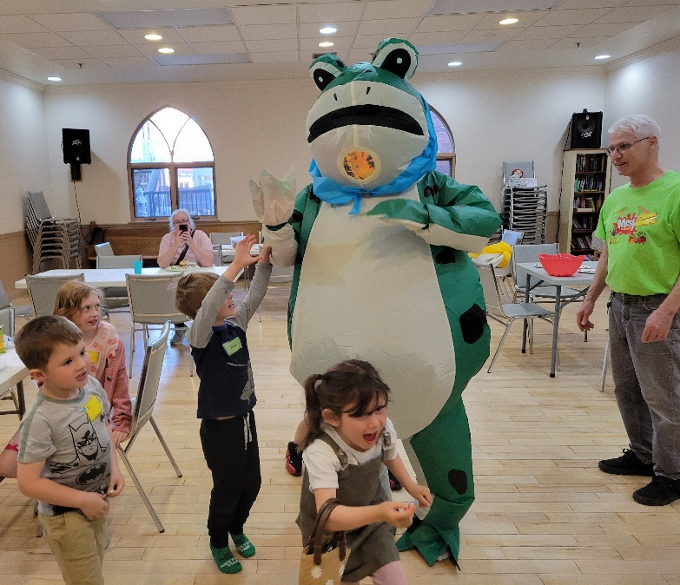
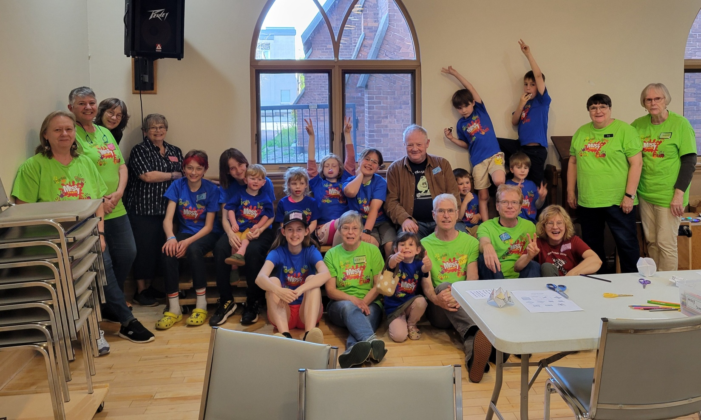
Our last Messy Church for this school year was on Friday May 29th. Thank you to the Messy Church Team for a great year, but who invited the GIANT FROG!

End of the Year BBQ 2026

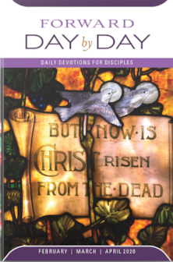
Day by Day
Day by Day is a small booklet that offers a brief daily devotion based on scripture readings. The May, June & July 2026 edition is now ready for pick up at the greeters table in the main hall for the suggested donation of $1.

Gardeners Help
On Wednesdays at 10am, the Gardening Crew meet weekly throughout the summer to tend to the church grounds. If you have an hour/week to join them, they are looking for new members. Many hands make light work. Just bring your gloves!

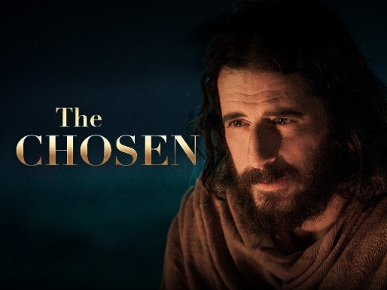
Movie Night
Join us the second Friday of each month for the viewing of “The Chosen, Season 1. We will finish the season On Friday, June 12 at 6:30pm and finish by 8pm. Popcorn and refreshments will be served. Donations to the Manna Food Bank Welcome (but not necessary). This does contain violence, so it is rated PG13. All Welcome.

Outreach
As decided at Vestry, we need volunteers from the congregation to help each week to support our Outreach program, Wednesdays from 12-2pm. On the last Wednesday of each month, we will offer a hot meal. If you would like to help on a Wednesday, please sign up on the bulletin board. We are in need of men’s …


Shorts t-shirts track pants running shoes

Sweat shirts also Sleeping bags.


Ho Parish Council
Our Parish Council Meeting will be next Tuesday June 16th at 6pm. Minutes from the May meeting are available on the bulletin board outside the sanctuary.
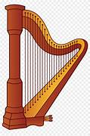
Open Doors Worship
Iris Jones will be here the 2nd and 3rd Friday each month to play her soothing harp for anyone who wishes to come and meditate. Now that the weather is nicer, she hopes to play in our courtyard. We hope to see you there!

QUESTIONS FOR PHELAN

The Idea!
Some of our parishioners may feel they don’t fully understand some
biblical passages, some theological ideas or even some historical events.
A few weeks ago, while Rev. Phelan and I were chatting, we discussed the idea of inviting parishioners to submit questions they might have about the Bible, theology or the Church. We felt there might be an appetite among our members for an opportunity to deepen their faith by resolving some of those old nagging questions about it - if only we could find someone with
answers. Well, we have! Our own well-loved Priest - Phelan.

Here are some of the types of questions we think might come in:
With respect to the Bible: Why are there two creation stories in Genesis?
Why does Joseph (Jesus’ father) suddenly disappear from the gospels?
Or more on the theological side: What does it mean that Jesus died for our sins?
The Process!
Here’s how it would work. There will be a new feature in The Loop called "Questions for Phelan". Parishioners will write out their concerns/queries and email them to me (Steve Newroth) at newroth@surenet.net. I will then review them (e.g. amalgamate similar questions) and submit them to Phelan for his reply. When Phelan’s reply is ready, I will forward the question and Phelan’s reply to Ann Marie who will publish them in The Loop the following week.
So, start those questions coming! Phelan has sharpened his pencil.

Sincerely,
Steve Newroth

This Week’s Question???

What is your concept of the devil and demons?
What does the bible say about the subject and what is your personal belief?
Do you believe the devil is a literal entity or an allegory for evil?

Phelan’s reply:

In Isaiah 14 there is a passage which suggests that Satan is a fallen angel who wanted to take God's place. This is an important clue in understanding Satan. The word "Satan" means "adversary". He is not 'the god of evil', but rather a created being who rebelled against God.

I counted almost 100 references to the devil in the Bible. Satan is an adversarial figure who tempted Jesus in the wilderness and tested Job. The overwhelming Scriptural evidence points to Satan as a person, a deceiver, a tempter. As Peter writes, "Your adversary the devil prowls around like a roaring lion, waiting for someone to devour". (I Peter 5: 8-9).

One of the most enigmatic phrases in the New Testament is this from the mouth of Jesus: "I saw Satan fall like lightning from heaven". That phrase alone points to the personification of rebellion. When we test God, when we work against the will of God, we have given in to the tempter.

We sometimes like to think that we are too sophisticated to believe in Satan, yet the Scriptural evidence for Satan (as a being) is voluminous.
Phelan+
