
ST. THOMAS’ ANGLICAN
CHURCH
June 18 – June 24, 2026

4 Mary St, Bracebridge, Ont., P1L 2B6
705-645-3486
Email: 4saintthomas@gmail.com
Website: stthomasanglicanchurch.ca
Messages From Rev. Phelan
The monthly ‘Bible verse to memorize’ for June is: "But the Advocate, the Holy Spirit, whom the Father will send in my name, will teach you all things and will remind you of everything I have said to you " (John 14:26)


Home Communions
If you know anyone who is unable to come to church, whether at home or in the hospital, and would like to take communion, please let me know. Due to privacy laws, the hospital does NOT call the church to let us know, so we depend on you.

Planning a Wedding or Funeral?
Before you plan or book these events, please contact me to check my availability. I try to respect your wishes, but with the responsibility of several churches, I may not be available. Best to make me one of your first calls to check availability.
Thank you,
Phelan+
From the Wardens

Rev. Phelan is part-time at our parish and is already working full-time hours, thus, Rev Phelan asks to be free of parish related engagements, between Sunday afternoon until Tuesday morning, when the office reopens. This includes all emails, texts and calls. The ONLY exception of course, is for urgent matters (ie death). He deserves some time off too.

Our Regular Services
On Sunday, June 21, we will celebrate Pentecost IV Sunday at 10:30 a.m. with the
Rev Phelan Scanlon. This week’s readings are Genesis 21: 8-21, Psalm 86 1-10, 16-17, Romans 6:1b-11, Matthew 10:24-39. This Friday at 10am there will be a BCP service.


Parish Office Hours: The office is open Tuesday to Friday,
9:00 a.m. to 2:00 p.m. Our Office Administrator is Ann Marie.
Pop in and say “Hi” when you are in the church or the neighborhood. You can call the church office at 705-645-3486. Summer hours begin July 1. The office will be open 9am-1pm, Tuesday to Friday.

Prayer Group
Join us to pray on Sunday mornings at 10:00 a.m. in the Rector’s office.

Happy Birthday
Happy June Birthday to Ann Marie Taylor, Ross McLean, Ivy Lee, Barb Mitchell and Laura Lovelock. If you want to see your birthday in the Loop, please let the office know about your birthday.
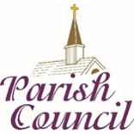
Ho Parish Council
Our Parish Council Meeting was on Tuesday June 16th. Minutes from the meeting are available on the bulletin board outside the sanctuary.
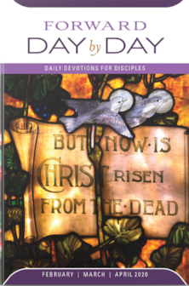
Day by Day
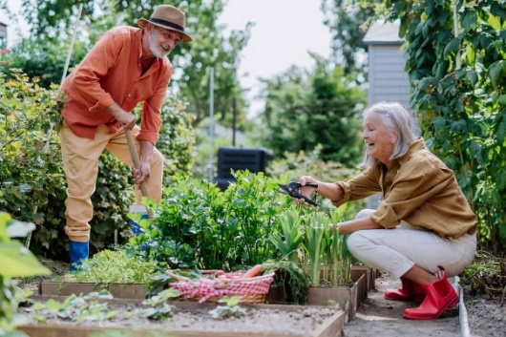
Day by Day is a small booklet that offers a brief daily devotion based on scripture readings. The May, June & July 2026 edition is now ready for pick up at the greeters table in the main hall for the suggested donation of $1.

Gardeners Help
On Wednesdays at 10am, the Gardening Crew meet weekly throughout the summer to tend to the church grounds. If you have an hour/week to join them, they are looking for new members. Many hands make light work. Just bring your gloves!
Outreach

As decided at Vestry, we need volunteers from the congregation to help each week to support our Outreach program, Wednesdays from 12-2pm. On the last Wednesday of each month, we will offer a hot meal. If you would like to help on a Wednesday, please sign up on the bulletin board. We are in need of MEN’s …


Shorts t-shirts track pants
running shoes Sweat shirts
also Tents, Sleeping bags and Backpacks.
Thank you to all who brought in donations of food and clothing this week!
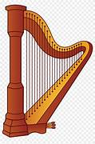
Open Doors Worship
Iris Jones will be here the 2nd and 3rd Friday each month to play her soothing harp for anyone who wishes to come and meditate. Now that the weather is nicer, she hopes to play in our courtyard. We hope to see you there!


QUESTIONS FOR PHELAN WE NEED MORE QUESTIONS
The Idea!
Some of our parishioners may feel they don’t fully understand some
biblical passages, some theological ideas or even some historical events.
A few weeks ago, while Rev. Phelan and I were chatting, we discussed the idea of inviting parishioners to submit questions they might have about the Bible, theology or the Church. We felt there might be an appetite among our members for an opportunity to deepen their faith by resolving some of those old nagging questions about it - if only we could find someone with
answers. Well, we have! Our own well-loved Priest - Phelan.

Here are some of the types of questions we think might come in:
With respect to the Bible: Why are there two creation stories in Genesis?
Why does Joseph (Jesus’ father) suddenly disappear from the gospels?
Or more on the theological side: What does it mean that Jesus died for our sins?

The Process!
Here’s how it would work. There will be a new feature in The Loop called "Questions for Phelan". Parishioners will write out their concerns/queries and email them to me (Steve Newroth) at newroth@surenet.net. I will then review them (e.g. amalgamate similar questions) and submit them to Phelan for his reply. When Phelan’s reply is ready, I will forward the question and Phelan’s reply to Ann Marie who will publish them in The Loop the following week.
So, start those questions coming! Phelan has sharpened his pencil.

Sincerely,
Steve Newroth

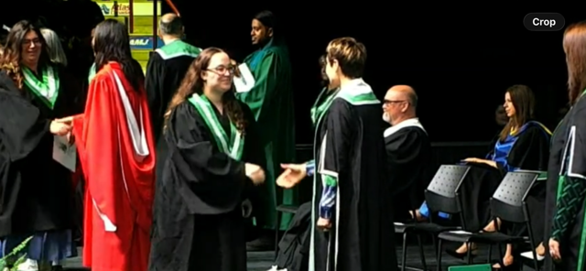

Proud Grandma Moment

Alva is thrilled to share a picture from her granddaughter, Keegan Woods, graduation from Durham College today in Practical Nursing! Congratulations Keegan (and Alva)!
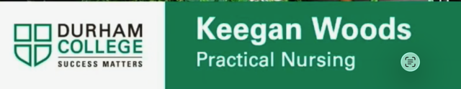

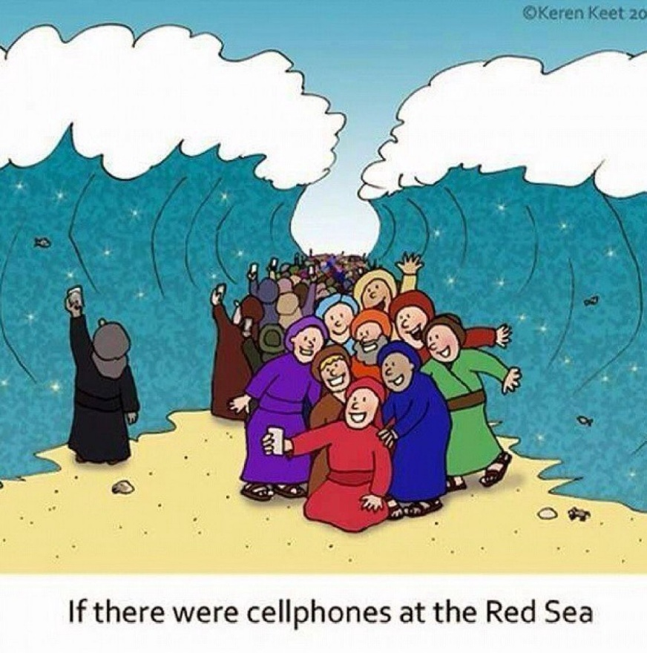



Use the link below:
https://www.dioceseofalgoma.com/?mailpoet_router&endpoint=track&action=click&data=WyI4NDYiLCJoejIwODMxbTU1Yzg4ZzgwNHNzOGt3c293a3dnazR3OCIsIjI3MyIsIjZlYTA1YjBiNzdjMSIsZmFsc2Vd

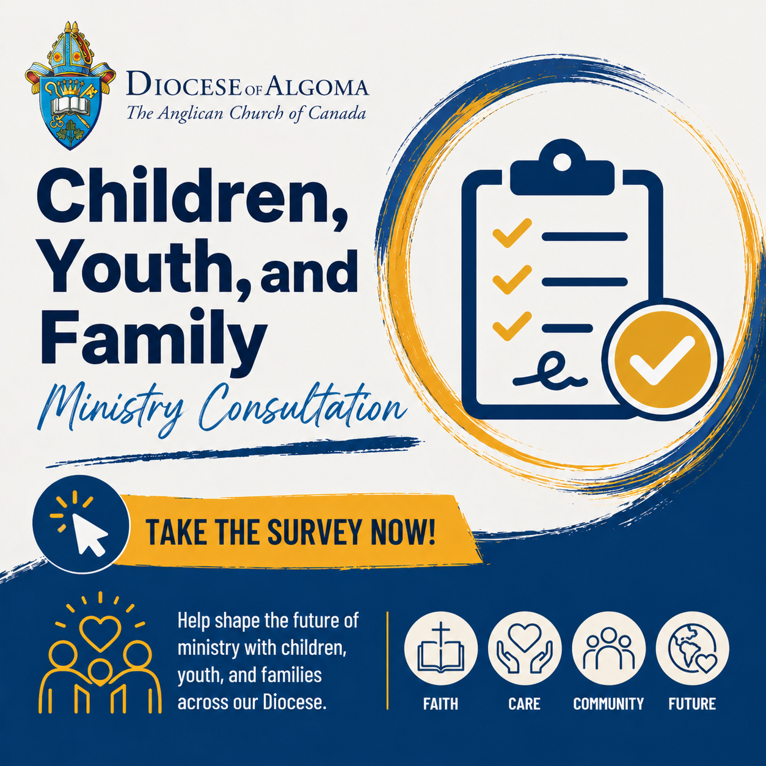


You are Invited to attend this information event

Come learn about Hospice Muskoka’s care and support services, including
palliative care, grief support, and wellness programs.

Event Details
Time: 10am-2pm
Date: Wednesday, July 8, 2026

Place: Muskoka Discovery Centre
275 Steamship Rd
Gravenhurst Register

Please RSVP: Register by July 2nd as a light lunch will be served

705-204-2273
intake@hospicemuskoka.com

