
ST. THOMAS’ ANGLICAN
CHURCH
January 22 – January 28, 2026

4 Mary St, Bracebridge, Ont., P1L 2B6
705-645-3486
Email: 4saintthomas@gmail.com
Website: stthomasanglicanchurch.ca
Messages From Rev. Phelan

The monthly ‘Bible verse to memorize’ for January is: “Zacchaeus: Look, half of my possessions, Lord, I will give to the poor; and if I have defrauded anyone of anything, I will pay back four times as much." Luke 19: 8.

Our Annual Vestry Meeting is on Sunday February 15th, in Browning Hall following the service. A light Luncheon will be served. If you would like to bring something for the Luncheon, speak with Margot Almond. We ask that you get all your reports into the office by January 28. Please consider becoming a part of our church council to help make decisions for this next year.


Candlemas this year will be on Monday, February 2nd at 5pm. For those new to us, this is a service “in the dark” with candles. No book, leaflet or PowerPoint.

Home Communions
If you know anyone who is unable to come to church, whether at home or in the hospital, and would like to take communion, please let me know. Due to privacy laws, the hospital does NOT call the church to let us know, so we depend on you. Thanks

Condolences
On Monday, January 19, Jo Nickason passed away in her sleep. She was a long time member of this parish. We keep her family in our prayers.

Teen Group
The Teens will meet next on Wednesday, January 28th from 3:30 to 5pm to make candles and eat pizza...or make pizza and eat candles.

Bible Study
Phelan has a question. Remember the small group sessions from a couple of years ago? Is anyone interested in doing that again? The best time would be after Easter. Please let me know if you are interested.


Vacation Time
I will be away for my winter break February 19-26. The Friday morning parishioners are welcome to meet for prayer while I am gone. John Mitchell will conduct morning prayer on Sunday, February 22 in my absence.

Collect of the Day
You will find strips of paper with a marker or pencil in the pews. This is for you to write down your prayer concerns anonymously and then place the paper on the altar either before or after the service so they can be addressed. I will “collect” the thoughts of the congregation to add them to the Collect of the Day. Please use them.

Phelan+


Parish Office Hours: The office is open Tuesdays to Fridays from 9:00 a.m. to 2:00 p.m. On Wednesdays from 12-2pm those in need are offered frozen meals, gift cards, personal care items and clothing if available. All donations are appreciated!

SOS We Need Meals

This week we had to turn people away as our freezer was empty of frozen meals to give to our drop-ins on Wednesday. All donations are truly appreciated. Stew, casserole, soup, leftovers. Put them in a freezer safe, individual serving containers, labelled with what it is and the date it went in the freezer. If you need containers, please ask Ann Marie or Margot. Treats like cookies and muffins are also fun to share. Store bought freezer meals are also acceptable for those who do not have time to cook. Watch the sales!

We are also in need of donations of sweatshirts and track pants, especially for men. Please check your closets! Socks, toothbrushes, toothpaste and other personal care items are also appreciated.

Our Regular Services
On Sunday, January 25, we will celebrate Eucharist for Epiphany III at 10:30 a.m. with Rev Phelan Scanlon. This week’s readings are Isaiah 9: 1-4, Psalm 27: 1,4-9 , I Corinthians 1: 10-18, Matthew 4: 12-23. This Friday at 10 am will be a BAS service.

Ash Wednesday
Ash Wednesday is the first day of Lent, a season in the liturgical church calendar that is dedicated to preparing minds, hearts and souls for Easter. This year we will have two Ash Wednesday services at 11am and 7pm. All Welcome

Celebration of Life
A Celebration of Life for Donald Evans will be held on Sunday Feb 8, at the Bracebridge Legion from 1 to 4pm. Sharon has invited anyone who would like to honour Don’s memory to attend the service.

Prayer Group
Join us to pray on Sunday mornings at 10:00 a.m. in the Rector’s office.

Happy Birthday
Happy January Birthday to Mary Mitchell, George Moroz, Blaine Lovelock and Alva Woods this month!


Parish Council
The Parish Council Meeting was held on Tuesday January 13th,. At this meeting we decided to increase our rental rates as they have not been updated since 2023. The new rates and the minutes from this meeting are posted on the bulletin board by the sanctuary.


Messy Church
Our next Messy Church is on Friday January 30th starting at 5:30pm.
Please help promote and support Messy Church to the extent you can. Numbers have been falling off a bit, and we would like to see that change.

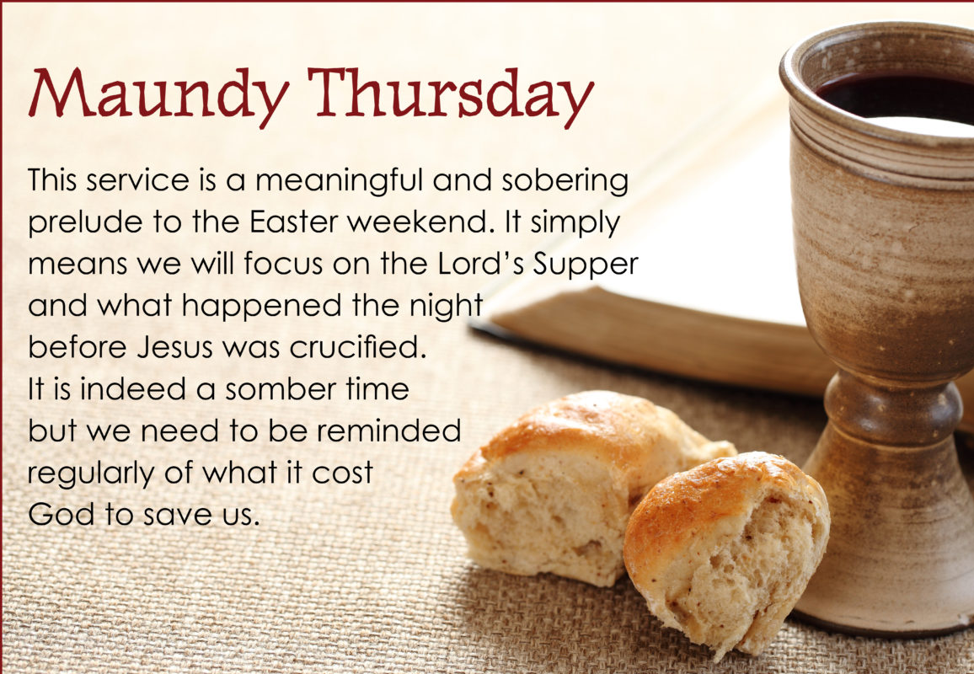
Seder Supper Volunteers
Mary Mitchell is still looking for interest from volunteers to have another Seder Supper on Maundy Thursday April 2, to cook food, set up or clean. Please email Mary at mmm.serenity@yahoo.com or phone her at 705-646-8881 to let her know you are interested in helping out. If there are not enough volunteers, it will not happen. A sign-up sheet for VOLUNTEERS is posted on the board outside the sanctuary

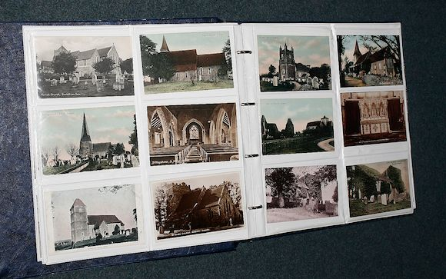
Church Archives
Pam Hough and Kathleen are working on the photos for the church archive. If you have any photos of church events, please bring them in to share. We can make copies of your photos if you wish them to be returned to you. Electronic versions can be emailed to the office for printing. Any photos we can share on our website as well are appreciated.

Open Door Worship
Iris will be here with her harp in the sanctuary the 1st and 2nd Fridays of the month 12-1pm. Come relax, pray, meditate with her melodic sounds.
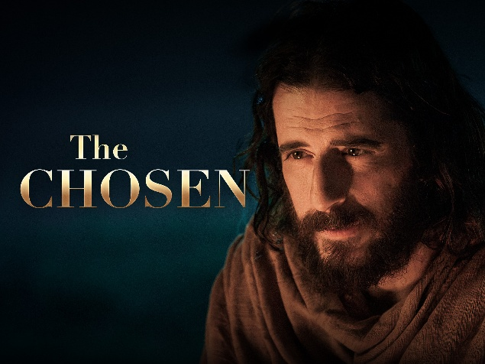
Movie Night
Join us the second Friday of each month for the viewing of “The Chosen, Season 1. On Friday, February 13th we will be watching the first two episodes. We will begin at 6:30pm and finish by 8pm. Popcorn and refreshments will be served. Donations to the Manna Food Bank Welcome (but not necessary). This does contain violence, so it is rated PG13. All Welcome.

St Thomas Church Choir
The Choir will resume their Thursday at 5:30 practices, later this month. They are looking for a guitarist to accompany them from time to time.


New Policy
Like many other area churches, we have decided to keep our door LOCKED when our office administrator is alone in the building for her personal safety. If you come to find the door locked, please ring the old doorbell for entrance. We are working on getting the new doorbell camera and intercom working. It will be open for drop ins Wednesday 12-2pm and when we have services classes or events.



