
ST. THOMAS’ ANGLICAN
CHURCH
April 23 – April 29, 2026

4 Mary St, Bracebridge, Ont., P1L 2B6
705-645-3486
Email: 4saintthomas@gmail.com
Website: stthomasanglicanchurch.ca

Messages From Rev. Phelan
The monthly ‘Bible verse to memorize’ for April is: "And if Christ has not been raised, our preaching is useless and so is your faith. But Christ has indeed been raised from the dead."
I Corinthians 15: 14, 20

Home Communions

This week, I have gone to visit shut ins at their individual homes to offer them communion for this Easter season. If you know anyone who is unable to come to church, whether at home or in the hospital, and would like to take communion, please let me know. Due to privacy laws, the hospital does NOT call the church to let us know, so we depend on you. Thanks

Phelan+

Our Regular Services
On Sunday, April 26, we will celebrate Easter IV at 10:30 a.m. with Rev Phelan Scanlon. This week’s readings are Acts 2:42-47, Psalm 23, I Peter 2:19-25, John 10: 1-10. This Friday at 10am there will be a BCP service.


Prayer Group
Join us to pray on Sunday mornings at 10:00 a.m. in the Rector’s office.


Parish Office Hours: The office is open Tuesdays to Fridays from 9:00 a.m. to 2:00 p.m. On Wednesdays from 12-2pm those in need are offered frozen meals, gift cards, personal care items and clothing if available. All donations are appreciated!

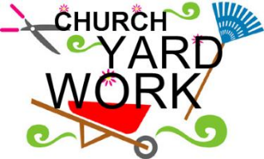
Yard Clean Up
We are looking for Volunteers for a church ground clean up on Tuesday May 5th at 10am. Many hands make light work! Remember to bring your work gloves!


Happy Birthday
Happy April Birthday to Della Lovelock, Mary Thomas, Dave Stammer, Rob Knighton, Joan Jelly, Louise Dennys and Pam Hough. If you want to see your birthday in the Loop, please let the office know about your birthday.
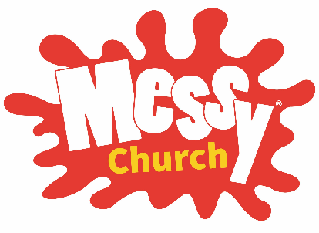
Messy Church
Our next Messy Church will be held this Friday, April 24th at 5:30pm. Please help promote this FREE program to families with children and support Messy Church to the extent you can.

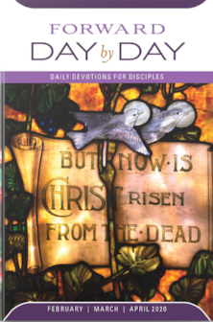
Day by Day
Day by Day is a small booklet that offers a brief daily devotion based on scripture readings. The May, June & July 2026 edition is now ready for pick up at the greeters table in the main hall for the suggested donation of $1.

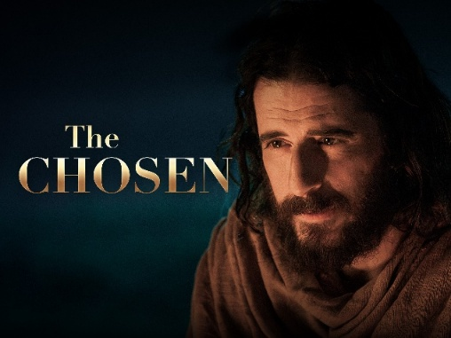
Movie Night
Join us the second Friday of each month for the viewing of “The Chosen, Season 1. On Friday, May 8th we will be watching episodes 7 & 8. We will begin at 6:30pm and finish by 8pm. Popcorn and refreshments will be served. Donations to the Manna Food Bank Welcome (but not necessary). This does contain violence, so it is rated PG13. All Welcome.

Outreach

As decided at Vestry, we need volunteers from the congregation to help each week to support Ann Marie. On the last Wednesday of each month, we will offer a hot meal. If you wish to donate the lunch, please let us know. If you would like to help on a Wednesday, please sign up on the bulletin board. We are now looking for clothing for warmer weather, especially for Men, socks t-shirts and shoes. We are also running low on personal care items of toothbrushes and toothpaste.


Meals Committee Update
This week we are so thankful to Shawn the manager from our local M&M’s for donating 54 individual frozen meals to our outreach program! Please support this local business as our way of saying thanks. A thank you letter will be delivered by Mary Mitchell.
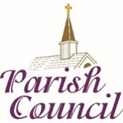
Ho Parish Council
The next Parish Council Meeting will be held on Tuesday May 12th starting at 6pm. Minutes from the April meeting are available on the bulletin board outside the sanctuary.


The AMSC (Anglican Missions Service Committee) has partnered with Pamala Stickney, to continue the work of financially supporting and spiritually nourishing the young children and youth in Madagascar. Here is her latest update.

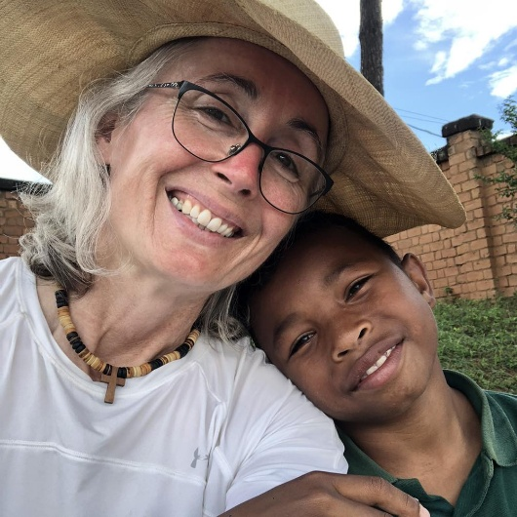
Good evening from Madagascar:
I’ve come again to Madagascar quite soon after my last visit to work with the Akany Famonjena board. We are moving towards having the new well drilled. The geological survey was completed during my last visit and they were able to confirm that the best place for a well also is the place we were hoping that the well might be drilled.
I am very happy to be here again spending time with the Akany Famonjena children and staff. The children are doing well in school, some excelling more in the academia and some thriving in the practical trades routes.
This week I meet with both the Akany Famonjena (orphanage) board and with the Akany Tafita (the inner-city school) board to find how each are moving forward with new ideas to offer the best possible care to the children we support both financially and by holding up in prayer.
I have a Facebook page, AMSCMadagascar, that I will continue to share my journey with you and shall be sending a newsletter yet this month with updates and photos of smiling faces and moments of interest.
In Christ's love,

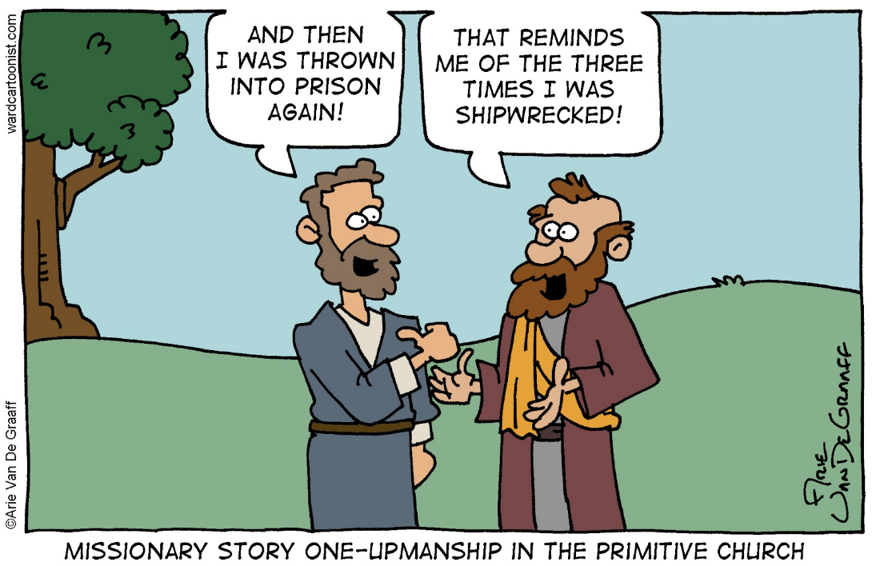
Pamala

I was Wondering… Part 2

Why do doctors leave the room while you change? They're going to see you naked anyway.
Why is “bra" singular and "panties" plural?
Why do toasters always have a setting that burns the toast to a horrible crisp, which no decent human being would eat?
Can a hearse carrying a corpse drive in the carpool lane?
If the professor on Gilligan's Island can make a radio out of a coconut, why can’t he fix a hole in a boat?
If corn oil is made from corn, and vegetable oil is made from vegetables, what is baby oil made from?
If electricity comes from electrons, does morality come from morons?
Why do the Alphabet song and Twinkle, Twinkle Little Star have the same tune?
Why did you just try singing the two songs above?
Did you ever notice that when you blow in a dog's face, he gets mad at you, but when you take him for a car ride, he sticks his head out the window?
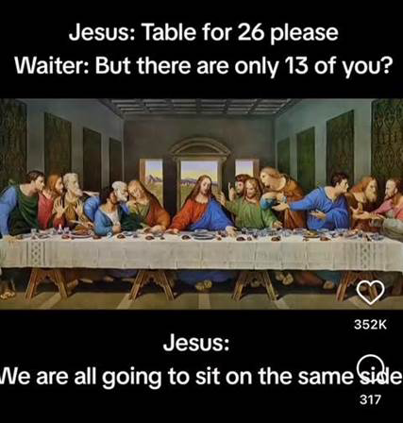
HOW DID THE MAN WHO MADE THE FIRST CLOCK, KNOW WHAT TIME IT WAS?

"Questions for Phelan"

The Idea!
Some of our parishioners may feel they don’t fully understand some
biblical passages, some theological ideas or even some historical events.
A few weeks ago, while Rev. Phelan and I were chatting, we discussed the idea of inviting parishioners to submit questions they might have about the Bible, theology or the Church. We felt there might be an appetite among our members for an opportunity to deepen their faith by resolving some of those old nagging questions about it - if only we could find someone with
answers. Well, we have! Our own well-loved Priest - Phelan.

Here are some of the types of questions we think might come in:
With respect to the Bible: Why are there two creation stories in Genesis?
Why does Joseph (Jesus’ father) suddenly disappear from the gospels?
Or more on the theological side: What does it mean that Jesus died for our sins?
The Process!
Here’s how it would work. There will be a new feature in The Loop called "Questions for Phelan". Parishioners will write out their concerns/queries and email them to me (Steve Newroth) at newroth@surenet.net. I will then review them (e.g. amalgamate similar questions) and submit them to Phelan for his reply. When Phelan’s reply is ready, I will forward the question and Phelan’s reply to Ann Marie who will publish them in The Loop the following week.
So, start those questions coming! Phelan has sharpened his pencil.

Sincerely,
Steve Newroth

We need more questions for Phelan. Please send them to Steve at newroth@surenet.net.

