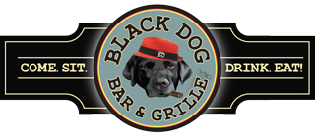

**TOP DOG BBQ BUFFET**

**Available for Lunch or Dinner Minimum of 30 people**

***(If less a service fee may apply)***

**Choice of Two Entrée Items for $32.99 Per Person**

Pulled Pork

BBQ Chicken Quarters

Burnt Ends

Beef Brisket

House Side Salad with White Balsamic Dressing

Corn Bread and Butter Seasonal Vegetable

Mac & Cheese House Bake Beans

Mashed Potatoes OR Roasted Red Bliss Potatoes

**ADD ONS**

Choice of Three Meats $36.99 Per Person

Choice of Four Meats $39.99 Per Person

*Pricing & Availability of Items Subject To Change*

***\*This menu is available for Onsite Functions or Off-Site Catering\****

*Coffee Service is for In House Events Only*