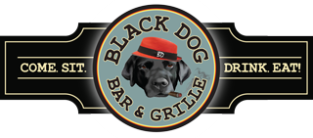
TOP DOG BBQ BUFFET

Available for Lunch or Dinner Minimum of 30 people
(If less a service fee may apply)

Choice of Two Entrée Items for $32.99 Per Person
Pulled Pork
BBQ Chicken Quarters
Burnt Ends
Beef Brisket

House Side Salad with White Balsamic Dressing
Corn Bread and Butter Seasonal Vegetable
Mac & Cheese House Bake Beans
Mashed Potatoes OR Roasted Red Bliss Potatoes

ADD ONS
Choice of Three Meats $36.99 Per Person
Choice of Four Meats $39.99 Per Person

Pricing & Availability of Items Subject To Change

*This menu is available for Onsite Functions or Off-Site Catering*
Coffee Service is for In House Events Only

