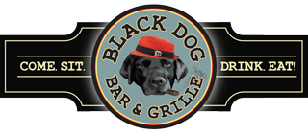

**Black Dog Luncheon Buffets**

***Served Until 3 PM***

Minimum of 30 People

***(If Less a Service Fee Shall Apply)***

**Sandwich & Salad Buffet $25.99**

House Salad with White Balsamic Drizzle

Coleslaw & Pasta Salad

**Sandwich Selections**

Stuffed Finger Rolls

Smoked Turkey Salad /Ham Salad/ Albacore Tuna Salad

Sliced Turkey/Sliced Ham

Pulled Pork Sliders (Add $2.99/ Person)

served with Fresh Fried Chips and Pickles

~~

Freshly Brewed Coffee & Tea

Cookie and Brownie Platter

*Consider Adding Potato Salad, Macaroni Salad or Baked Beans*

$1.99 for each additional side option per person

***Lobster Rolls also Available! Inquire for more info and pricing!***

**Hot Luncheon Buffet $32.99**

House Salad with White Balsamic Drizzle

Rolls & Butter

Main Course (Choose3)

Baked Haddock with Crumb Topping

Lemon Chicken or Smoked BBQ Chicken Quarters

Vegetable or Meat Lasagna

Beef Brisket or Pulled Pork with BBQ Sauce

*Main course includes seasonal vegetable & choice of one:*

*Red Bliss Potatoes, Macaroni and Cheese or Mashed Potatoes*

~~

Cookie and Brownie Platter

Freshly Brewed Coffee & Tea

**Dessert**

Cookie & Brownie Platter

Freshly Brewed Coffee & Tea

*Pricing & Availability of Items Subject To Change*