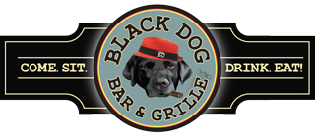

**Black Dog Dinner Buffets**

**Minimum of 30 People**

**(If Less a Service Fee May Apply)**

**Pinnacle Buffet**

House Side Salad with White Balsamic Drizzle

Rolls & Butter

~~

***Choice of Three***

Baked Haddock with Newburg Sauce

Carved Smoked Turkey Breast

Baked Stuffed Scrod

Vegetable Lasagna

Boneless Breast of Chicken with Lemon Glaze

Smoked Carved Beef Brisket

Carved Roast Beef add$2.99

***Red Bliss Potatoes or Mashed Potatoes***

***Mixed Vegetable***

~~

Cookie & Brownie Platter

Freshly Brewed Coffee & Tea

$35.99

**Chairman Buffet**

House Side Salad with White Balsamic Drizzle

Rolls & Butter

~~

***Choice of Three***

House Smoked Beef Brisket

Baked Scrod with a Lobster Newburg Sauce OR Grilled Salmon with Lemon Dill Butter Sauce

Chicken Cordon Bleu in a Puff Pastry with Gravy OR Chicken Marsala

Prime Rib of Beef (Add $4.99/person)

***Red Bliss Potatoes or Mashed Potatoes***

***Mixed Vegetable***

~~~

Cookie & Brownie Platter

Freshly Brewed Coffee and Tea

$39.99

*Pricing & Availability of Items Subject To Change*