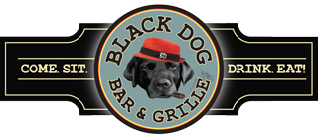

**Black Dog Brunch Buffet**

**Minimum of 30 People**

***(If less a service fee shall apply)***

**Black Dog Brunch**

Fresh Fruit

House Salad with White Balsamic Drizzle

Morning Pastries

Frittata

Lemon Chicken

Waffles with Maple Syrup & Butter

Roasted Red Bliss Potatoes

Crispy Bacon & Breakfast Sausage

Freshly Brewed Coffee & Tea

$26.99

***Mimosa Bar*** $50.00

Set Up Fee *Includes:*

*1 Bottle of Prosecco*

*Orange Juice & Cranberry Juice*

*Orange Slices, Strawberries, Blueberries*

$28.00 Each Bottle of Prosecco After

*Pricing & Availability of Items Subject To Change*