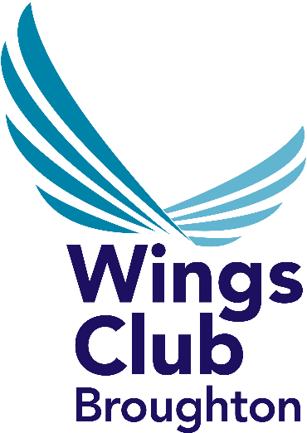
EMPLOYEE
WEEKLY LOTTERY DRAW

Name (BLOCK CAPITALS): ............................................................

I confirm that I wish to join Wings Club Broughton and I am over 18 years of age.
Date of birth: ................................... I wish to join the Weekly Lottery Draw and will make payment in accordance with the guidelines. Please read rules overleaf.

I REQUIRE: .............. SHARES AT A COST OF 20p PER SHARE PER WEEK.

(Minimum holding 10 shares - Maximum 50 Shares)

Airbus SAP Number: .......................................

Department: ……………………........................Date:......................................................................

Full Address: ............................................................................................................................................................

............................................................................................................................................................

…………………………………………………………………Post Code: .......................................................

Contact Number: ..............................................Email:-…………………………………………………...

I hereby request and authorise you to deduct from my wages / salary until further notice the amount listed above and to pay such deductions to Wings Club Broughton. Please note: Lottery members must also be Sports and Social Club members. This is £1.08p per month.

Signed: ...............................................Date:.................................

LOTTERY PRIZES - 13 Week Prize cycle.

6 Weekly prizes:= £1,000, £500, £250, £150, £125, £100,

Week 6 = includes extra prizes of £1,000, £500, £500

Week 13 = includes an extra prize of £10,000

WEEKLY LOTTERY DRAW RULES

1) The Draw shall be promoted for and by Wings Club Broughton herein after known as the “Club”

2) The draw shall conform to Section 4, Lotteries and Amusements Acts 1976.

3) The promoter of the Draw shall be the Club Manager.

4) All members over the age of 18 shall be eligible to join the Draw subject to the scrutiny by the promoter in consultation with the Club Council. No individual member may purchase more than 50 shares for any cycle.

5) Allocation of stake money to prizes will be at the discretion of the Club Council, but shall never be less than 70% of contributions. The Total Amount allocated to any cycle will be published to the start of that cycle.

6) The number and amount of the prizes shall be set according to the stake money available.

7) The share price cost may be adjusted as and when the committee feels appropriate.

8) The Draw will take place on Monday each week and the names will be published on Club Notice boards. . All prize monies will be paid by bank transfer. Identification required.

9) Prizes shall only be awarded to the person to whom the winning chance was sold.

10) The Draw will operate on a 13 week cycle with major prizes being drawn at the end of each cycle. The prizes and dates on which they are to be drawn will be announced at the beginning of each cycle. Members may join or leave the scheme six weeks before the beginning or end of each cycle.

11) Each Draw shall consist of a random selection of numbers from all the numbers allocated to members for the complete cycle.

* All information on draw prizes was correct as of January 1998 and may be subject to change if the numbers of participants alter.

Results will be published on notice boards throughout the site.

