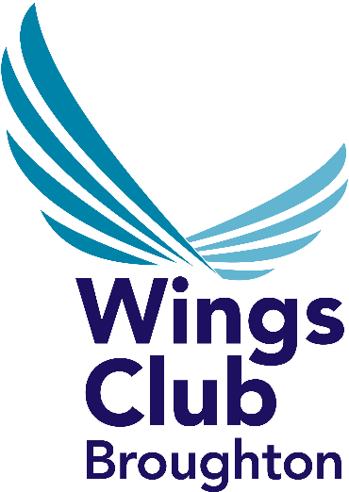
EMPLOYEE
MEMBERSHIP FORM

NAME:………….…………………………………………………………….

SAP NUMBER:..........................DEPARTMENT:…………………….

HOME ADDRESS:…………………………………………………………..

…………………………………………………………………………………

…………………………………………………………………………………

CONTACT NUMBER:……………………………………………………….

EMAIL…………………………………………………………………..………

I wish to become a member of Wings Club Broughton. I agree to abide by the rules of the Club.

I authorise the Wages Department of Airbus UK Broughton to deduct from my wages each week the sum of £1.08 pence per month.
(*subject to review by Wings Club)

SIGNATURE: .......................................................................................

EMAIL:- membership@wingsclub.co.uk

Tel: 01244 522302
www.broughtonwings.co.uk

