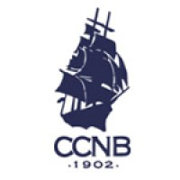

Wednesday morning league play
6/10/26
2 Best ball of 4 - 80% Handicap

1st Place 132 $25 each
Joe Adao
Robert Lachapelle
Ron Dias
Hugh Fanning (blind draw)

