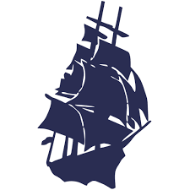

48th Annual Women’s four-ball Invitational

Results

2026 Championship Winners – Lorraine Duval – Mary Tribou

2026 Championship runners-up – Annette Mallen – Kristen Sethares

2026 Semi-Finalist Winners – Diane Lacoste – Jillian Grolley

2026 Semi-Finalist Runners-up – Kathleen Meeker – Martha Welch

2026 First Division Winners – Carlin Moroney – Amy McCoog

2026 First Division Runners-up – Bethany Mello – Sue Ribeiro

2026 First Division Consolation Winners- Pat Ansay – Linda LeMieux

2026 First Division Consolation Runners-up – Barbara Young – Elizabeth Huidekoper

2026 Medal Play Winners – Deb Hynes – Terry Garrett

