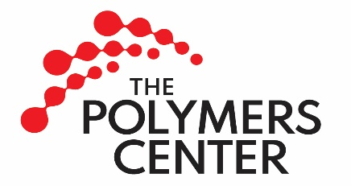
8900 Research Drive
Charlotte, NC 28262
704-602-4100
www.polymers-center.org

COURSE REGISTRATION FORM

Course: |  | ____________________________________ Date: --
Cost: | ______________________ _________________________

Student Contact Information
Print or type name as it should appear on certificate. You may duplicate this form for additional people.
Please notify us if special assistance is needed.

Name: |  | __________________________________________ |  |  |  |  |  |  | Phone: | _________________
Company: |  |  | ____________________________ |  |  | Email: |  | ____________________________
Mailing Address: |  |  |  | ___________________________________________________________
City: | _______________________________ |  |  |  | State: |  | _________ |  |  | ZIP: | ____________

Credit Card #___________________________ Exp Date:____________
Signature:__________________________________________________

To register, do one of the following:
EMAIL the completed form (save file as your name) to: bjarrell@polymers-center.org
FAX the completed form to: 704.602.4114 (Beverly Jarrell's private fax.)
MAIL the completed form to: Polymers Center of Excellence, 8900 Research Drive,
Charlotte NC 28262 (Make checks payable to the "Polymers Center of Excellence".)

Payment: Payment accepted by check, credit card. Payment must be received one week prior to class date. There is no refund for cancellations, but the student may take the course the next date it is offered, or a different student may be substituted.

You will receive confirmation of your registration via email. If payment is not included with this registration form, it must be received one week prior to class date to guarantee a seat.

Questions? Please call Beverly Jarrell at (704) 602-4127.

Please mark your calendar with date and time of class. No reminder notice will be sent.

Class begins at 8:30AM and ends at 4:30PM.

A map to our facility, phone numbers, and links to area hotels are on the “Contact” page of our website: www.polymers-center.org

