Insert Player Picture Here

Alex Morgano
Graduation Year: 2026

Email: SoccerStar@gmail.com

Phone: (303) 466-1245

Address: 123 Mail

Date of Birth: 2001
Position: Forward Height: 5’8”

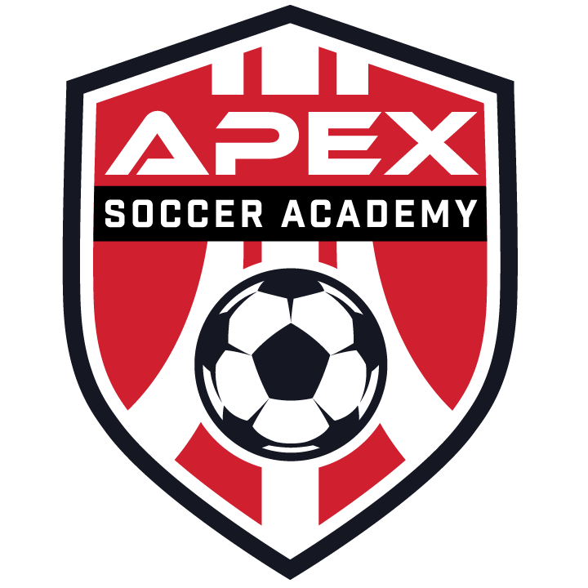

Team: Coach:
Coach Phone: Coach Email:

Academics
Club Soccer
High School: SAT: 1250
GPA: 4.0 ACT: 27
Class Rank: 01/400 NCAA Clearinghouse #:

High School Soccer

Team: Coach:
Jersey #: 5 Coach Phone:
Position: Left Back / Center Back Coach Email:

Academics:
- Academic Honor Roll
- College Prep Biology
- National Honor Society
- Perfect Attendance

Volunteer & Other Interests:
- 50+ Hours for Salvation Army
- Elementary School Mentor

Highlight Video:
- www.youtube.com/ilovesoccer

Club Soccer:
- 2018 State Cup Champion
- 2017 State Cup Champion
- 2016 Denver Cup Champions

High School Soccer:
- Starting Varsity Forward
- Led team in goals and assists
- Team Captain

Additional Soccer Activities:

2017 ODP Regional Pool

2015 ODP State Pool

Upcoming Club Events:

2017 Surf Cup (San Diego)

2018 Players Showcase (Las Vegas)

Achievements

