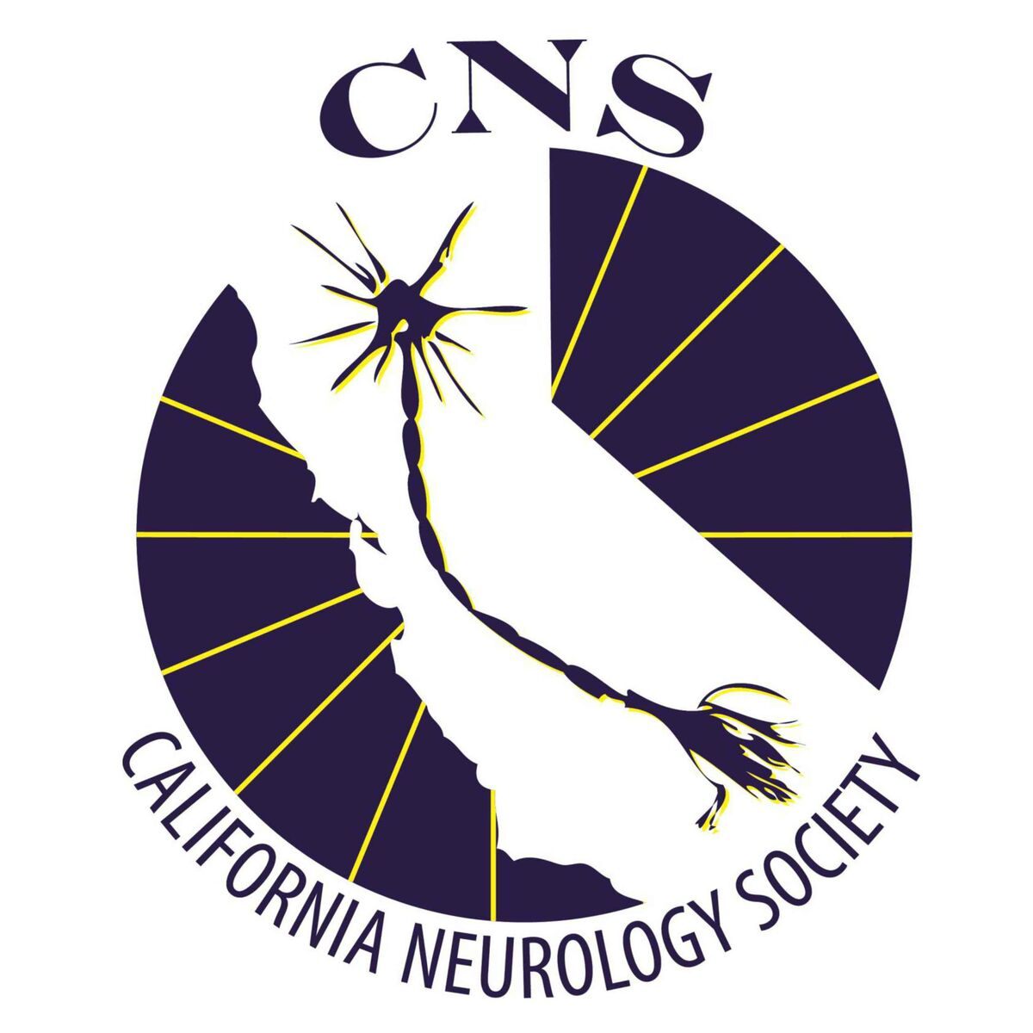
California Neurology Society
Palatucci Young Investigator Awards
Neurology

9/28/2026

Fellows, residents and medical students engaged in neuroscience research are invited to submit abstracts for the CNS Palatucci Young Investigator Award. Please submit your abstracts for consideration soon and share this opportunity with your peers! All California residents, fellows, and medical students in the Neurosciences are invited to submit.

The young investigator(s) selected for the Palatucci Award will receive $500, free conference registration and meals, one night's complimentary lodging, a year of membership in the California Neurology Society. and will be invited to present their submitted research (15 min. each) at the CNS fall conference, Genes to Junction: The Nexus of Neuromuscular Disease”, on Saturday, Oct. 31, 2026 at the Monterey Beach Hotel 2600 Sand Dunes Dr., Monterey, CA 93940. Presentations may be made on Zoom, but we hope that you will be able to attend in person at the conference which will take place Thursday, Oct. 29th to Sunday, Nov. 1st, 2026 with the Award Lectures scheduled for Saturday, Oct. 31st.

SUBMISSION REQUIREMENTS:
- Application deadline: October 16th, 2026.
- ONE abstract submission per person.
- All submissions must be original and unpublished (pending publications accepted).
- Word limit: 500 words.
- Must be available to present your abstract at the CNS conference or on Zoom, Saturday, Oct.31st,2026.
- Required presentation length: 15 minutes.
- Also complete and return the disclosure form and we will forward the winning applications, presentations and disclosures to CME Consultants. We are aware and are asking you to discuss research and it will be less than 4 weeks prior to the conference.

Donald M. Palatucci, M.D.
Professor of Neurology - San Francisco
1940—2002

After receiving his B.A. degree with honors from Holy Cross College in Worcester, MA, in 1962 and his M.D. from Columbia University in New York City in 1966, and following military service as a U.S. Naval Hospital staff neurologist in San Diego and then in Oakland in 1970-1972, Dr. Palatucci practiced neurology in San Francisco for the next 30 years while earning numerous awards for his outstanding teaching at the UCSF School of Medicine, rising at last to the rank of full professor. Not content with these accomplishments, he was the prime mover in the organization of all neurologists in our state into the Association of California Neurologists (ACN), as its founder and first president in 1999. He was justifiably proud of his work in this capacity, and in his concomitant work with patient-advocacy groups at the state level as well. These fundamental, yet arduous accomplishments led to a model which he developed on a national level with the assistance of the American Academy of Neurology (AAN). There is little, if any, doubt, after his leadership role in the state organization he was so instrumental in founding, and after his work as a member of the AAN Board of Directors, shortly before his final illness took hold, that he would have been a quintessential representative of San Francisco, UCSF and our specialty of neurology as a strong candidate for the presidency of our national organization. Don Palatucci’s personal and professional style incorporated storytelling with humor, both in his instruction as a clinician and teacher as well as in his guidance as a colleague, administrator and devoted family man. These might be considered rare gifts in a man of such keen intellect. He had a gift for relating in a unique way to each individual and for expressing his thoughts and feelings concisely, trenchantly and eloquently. He would have been as outstanding a leader in law, politics or public service in general as he in fact was in his chosen profession of medicine. In grateful remembrance for his 30 years of professional service, Don was declared by his colleagues in the UCSF Association of Clinical Faculty to have “held the glue between town and gown in a seemingly effortless model. He held equal respect from the community [as well as from the] academic world.”

Palatucci Young Investigator Award Application (Please submit this with your full presentation and Disclosures)

Name: ____________________________________________________ Degree:_____________

Institution: ____________________________________________________________________

Department: ___________________________________________________________________

Street Address/Suite:___________________________________________________________________

City:______________________________________ State:________ Zip Code:_______________

Phone:_______________________________ Fax:____________________________

Email:____________________________________________________________________

Title of Paper: __________________________________________________________________

______________________________________________________________________________

______________________________________________________________________________

Has your paper been published? □ Yes □ No (if you select yes, you do not qualify)
Are you a resident, fellow, or medical student? □ Yes □ No (if you select no, you do not qualify)
What is your present training level and specialty? _______________________________________

Deadline for Receipt of Application, Disclosure form and Presentation: Oct. 16th, 2026.
Send to Conferences@CANeurologySociety.org ; rgyoungmd.cns@gmail.com;

For questions:
Robyn G. Young, MD
Mobile: (341) 348-1338
RGYoungMD.CNS@gmail.com

