Lough Sallagh Lodges

Access Welcome Guide

Updated 2nd July 2026
Contents
A Warm Welcome 3

Contact Information 4

Getting Here 5

Key Accessible Features 8
Facilities & Equipment
Virtual Tour of Accessible Accommodation
Parking
Access to Public Areas
Bedrooms & Bathrooms General

Additional Accessibility Features 11

Gallery of Images 12

Sensory Story 15

Accessible Destination Highlights 15

Emergency & Medical Information 20

Testimonials – What our Customers tell us 21
A Warm Welcome
_________________________________________________________

We warmly welcome you to Lough Sallagh Lodges.

This Access Welcome Guide provides information to help you get the most from your stay here in Lough Sallagh Lodges and explore Ballinamuck and our neighbouring towns and villages in Irelands Hidden Heartlands.

At Lough Sallagh Lodges we want all our guests to take time out to enjoy the natural peaceful surroundings, ideally located on a working farm with panoramic views of Lough Sallagh Lake. Two of our three lodges have been carefully designed to ensure that they are as accessible as possible to meet all our guests needs. Whether its unwinding with a glass of bubbly in your own private hot tub, catching a sunset from your veranda overlooking Lough Sallagh, or exploring the countryside on our accessible bicycle, we hope you thoroughly enjoy your stay.
We are a small family business with vast experience in supporting people with disabilities and our customer focus is not only to meet, but to exceed your expectations of accessible self-catering accommodation. We have put together this Access Welcome Guide to showcase what is available and to help you plan your stay with us at Lough Sallagh Lodges.
We hope this Access Welcome Guide provides all the necessary information you need to plan your stay at Lough Sallagh Lodges. If you have additional queries, please do not hesitate to contact us on +353 85 8484304 or email us at: lslodges@gmail.com and we will be happy to answer your questions.
We look forward to welcoming you to Lough Sallagh Lodges.
Damien McKenna
Proprietor
Contact Information
_________________________________________________________

To speak to a member of our team, please telephone or email and we will be happy to help. We aim to reply to your query as soon as possible.

Contact us by telephone/WhatsApp on: +353 (0)85 8484304
Contact us by email on: lslodges@gmail.com
Browse our website on: www.loughsallaghlodges.ie
Follow us on Facebook: Lough Sallagh Lodges
Follow us on Instagram: @lslodges

Getting Here
_________________________________________________________
By Car:
- If you are arriving by car and using a Sat Nav, our Eircode is N39 K2H5.
- Lough Sallagh Lodges has its own private car park with 3 accessible parking spaces and 1 EV charging point.

By Train:
- The nearest railway station to Lough Sallagh Lodges is Longford town railway station and it is a direct line servicing Dublin to Sligo. For more information check out https://www.irishrail.ie/en-ie/station/longford
- The trains serving Longford station offer ramped access for wheelchair users.
- Passenger assistance must be booked in advance and passengers are advised to contact https://www.irishrail.ie/en-ie/contact-us/accessibility-onboard to book.
- There is no catering available onboard this service at present.
- Guide dogs and Assistance dogs are permitted on board.
By Bus:
- From Dublin (including Dublin Airport), the Expressway Dublin to Sligo Route 23 offers six services per day stopping at Longford station. This service is listed as a non-accessible service and passengers who require an accessible service should contact +353 1 703 4111 for further information.
- From Longford station, the Transport For Ireland Cavan to Drumlish Service offers five services per day stopping in Ballinamuck Village and the 98 pub (which is closer to Lough Sallagh Lodges). The timetable can be found at https://www.transportforireland.ie/wp-content/uploads/2023/08/TFI-Bus-Route-975-Cavan-Longford-A3-fold-to-A6-August-2023-FINAL-WEB2.pdf This journey takes approximately 30 minutes. This route usually has an accessible bus assigned to it. For further information contact 0818 294 015 or download the TFI Live App.
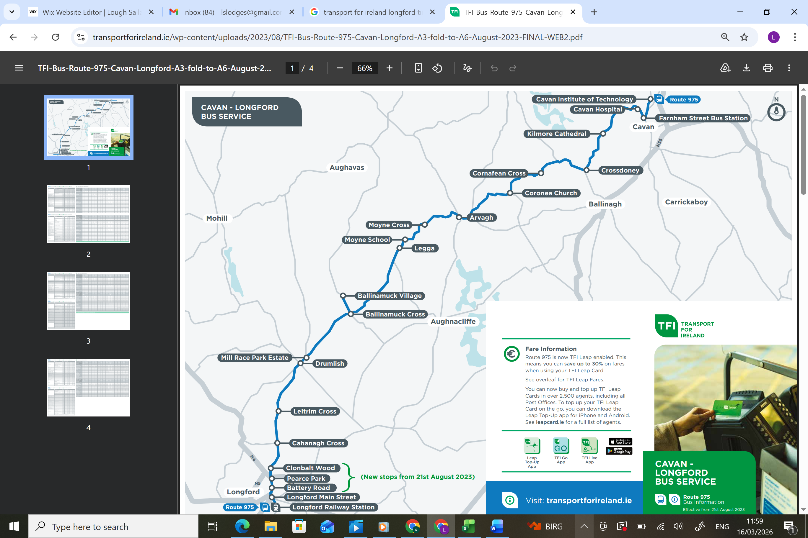
N39 K2H5
- From the 98 pub, Lough Sallagh Lodges is a 40 minute walk (3km) or a 4 minute drive.

By Taxi:

- There is a taxi rank located at the market square in Longford town. However, if you book in advance, the taxi will pick you up at your exact location. There are several accessible taxi’s available in Longford:

- Paddy’s Taxi Longford Town +353 96 2471065
- TC Cabs Longford Town +353 87 9519519
- Nevin’s Taxi Longford Town +353 86 2595690
- Ciaran Grimes Taxi, Drumlish +353 87 7514607

Airport:
- Knock West Airport is approximately 89KM from Lough Sallagh Lodges and would take approximately 1hr 20mins to drive.
- Dublin Airport is approximately141KM from Lough Sallagh Lodges and would take approximately 2hrs to drive. This route is served by tolls and motorway.

Ferry Port:
Dublin Port is the closest port to Lough Sallagh Lodges. It is approximately 148KM away and would take approximately 1hr 50min to drive via motorway.

Key Accessible Features
___________________________________________________________________
At Lough Sallagh Lodges we have given great consideration to all users of our self-catering accommodation including those with disabilities, limited mobility and other additional needs. We have strived to make it as universally accessible and inclusive as reasonably possible and with that in mind, we have a range of features and bespoke accommodations available to make your stay as enjoyable as we can. Take time to read through our key features summarised below. Although we cannot be all things to everyone, we have strived to enhance your stay by including key accessible features such as:
- Hoists in lodges (booked in advance)
- Pool hoists for hot tubs (booked in advance)
- Free-standing shower chairs (comes automatically when hoist is booked)
- Level access showers
- Emergency assistance alarm in accessible bathrooms
- Grab rails
- Dimmable lighting
- Antiglare surfaces
- Emergency evacuation plans
- Assistance/guide dogs welcome
- Colour contrast mats
- Table blocks for wheelchair users
- Vibrating smoke detection pillow pad with flashing lights
- Access step
- Sheet magnifiers
- Accessible bbq areas
- Accessible bicycle
- Level terrain
- Accessible parking
- Enclosed outdoor garden space
- Free familiarisation visits

- Virtual Tour of our Accessible & Inclusive Lodges
A virtual tour of our Lodges is available in our Gallery (add link to gallery here) and showcases the accessible and inclusive features:
- Croppie’s Cottage: Within Croppie’s Cottage you can have access to a mobile hoist (which must be booked in advance), shower chair, level access shower and grab rails, vibrating smoke detection. Direct access from the bedroom to the outdoors. Croppie’s Cottage offers a private outdoor space that includes a private hot tub with hoist, a private accessible BBQ and seating area, a veranda overlooking Lough Sallagh and an enclosed garden space. All areas within the cottage and leading to the cottage have level access or gentle slopes.

- Humbert Lodge: Within Humbert Lodge you can have access to a ceiling track hoist in the bedroom, shower chair, ensuite with level access shower and grab rails, vibrating smoke detection. Direct access from the bedroom to the outdoors. Humbert Lodge offers a private outdoor space that includes a private accessible hot tub with hoist, a private accessible BBQ and seating area, a veranda overlooking Lough Sallagh and an enclosed garden space. All areas within Humbert Lodge and leading to Humbert Lodge have level access or gentle slopes.

- Parking
There is 3 designated accessible parking bays available within 50 metres of your lodge. There is a step-free route with a firm surface from the parking area to your lodge. See photos below.
- Access to Public Areas
All areas onsite have level access or gentle slopes.
Our Wellness area has level access. There is no hoist facilities/grab rails in this area at present.

- Bedrooms and Bathrooms General: Feature and Description
All bedrooms are on the ground floor. There is one bedroom in two of the lodges with a level access en-suites. The other bedrooms have access to a separate bathroom with a shower unit that is not over a bath. Twin and double bed configuration. Travel cots & highchairs available on request.

Additional Accessibility Features
___________________________________________________________________
We offer accessible private hot tubs to our guests staying in either Croppie’s Cottage or Humbert Lodge. At each of these hot tubs, there is a wall mounted hoist facility, to support wheelchair users to transfer into the hot tub. Each guest using this facility must supply their own sling, that is prescribed for their personal use. There is no slings available onsite. There is steps available at the hot tubs for those who do not require a hoist. A handrail is available for your safety entering and exiting the hot tubs.
Ceiling Track Hoist Hot Tub Hoist
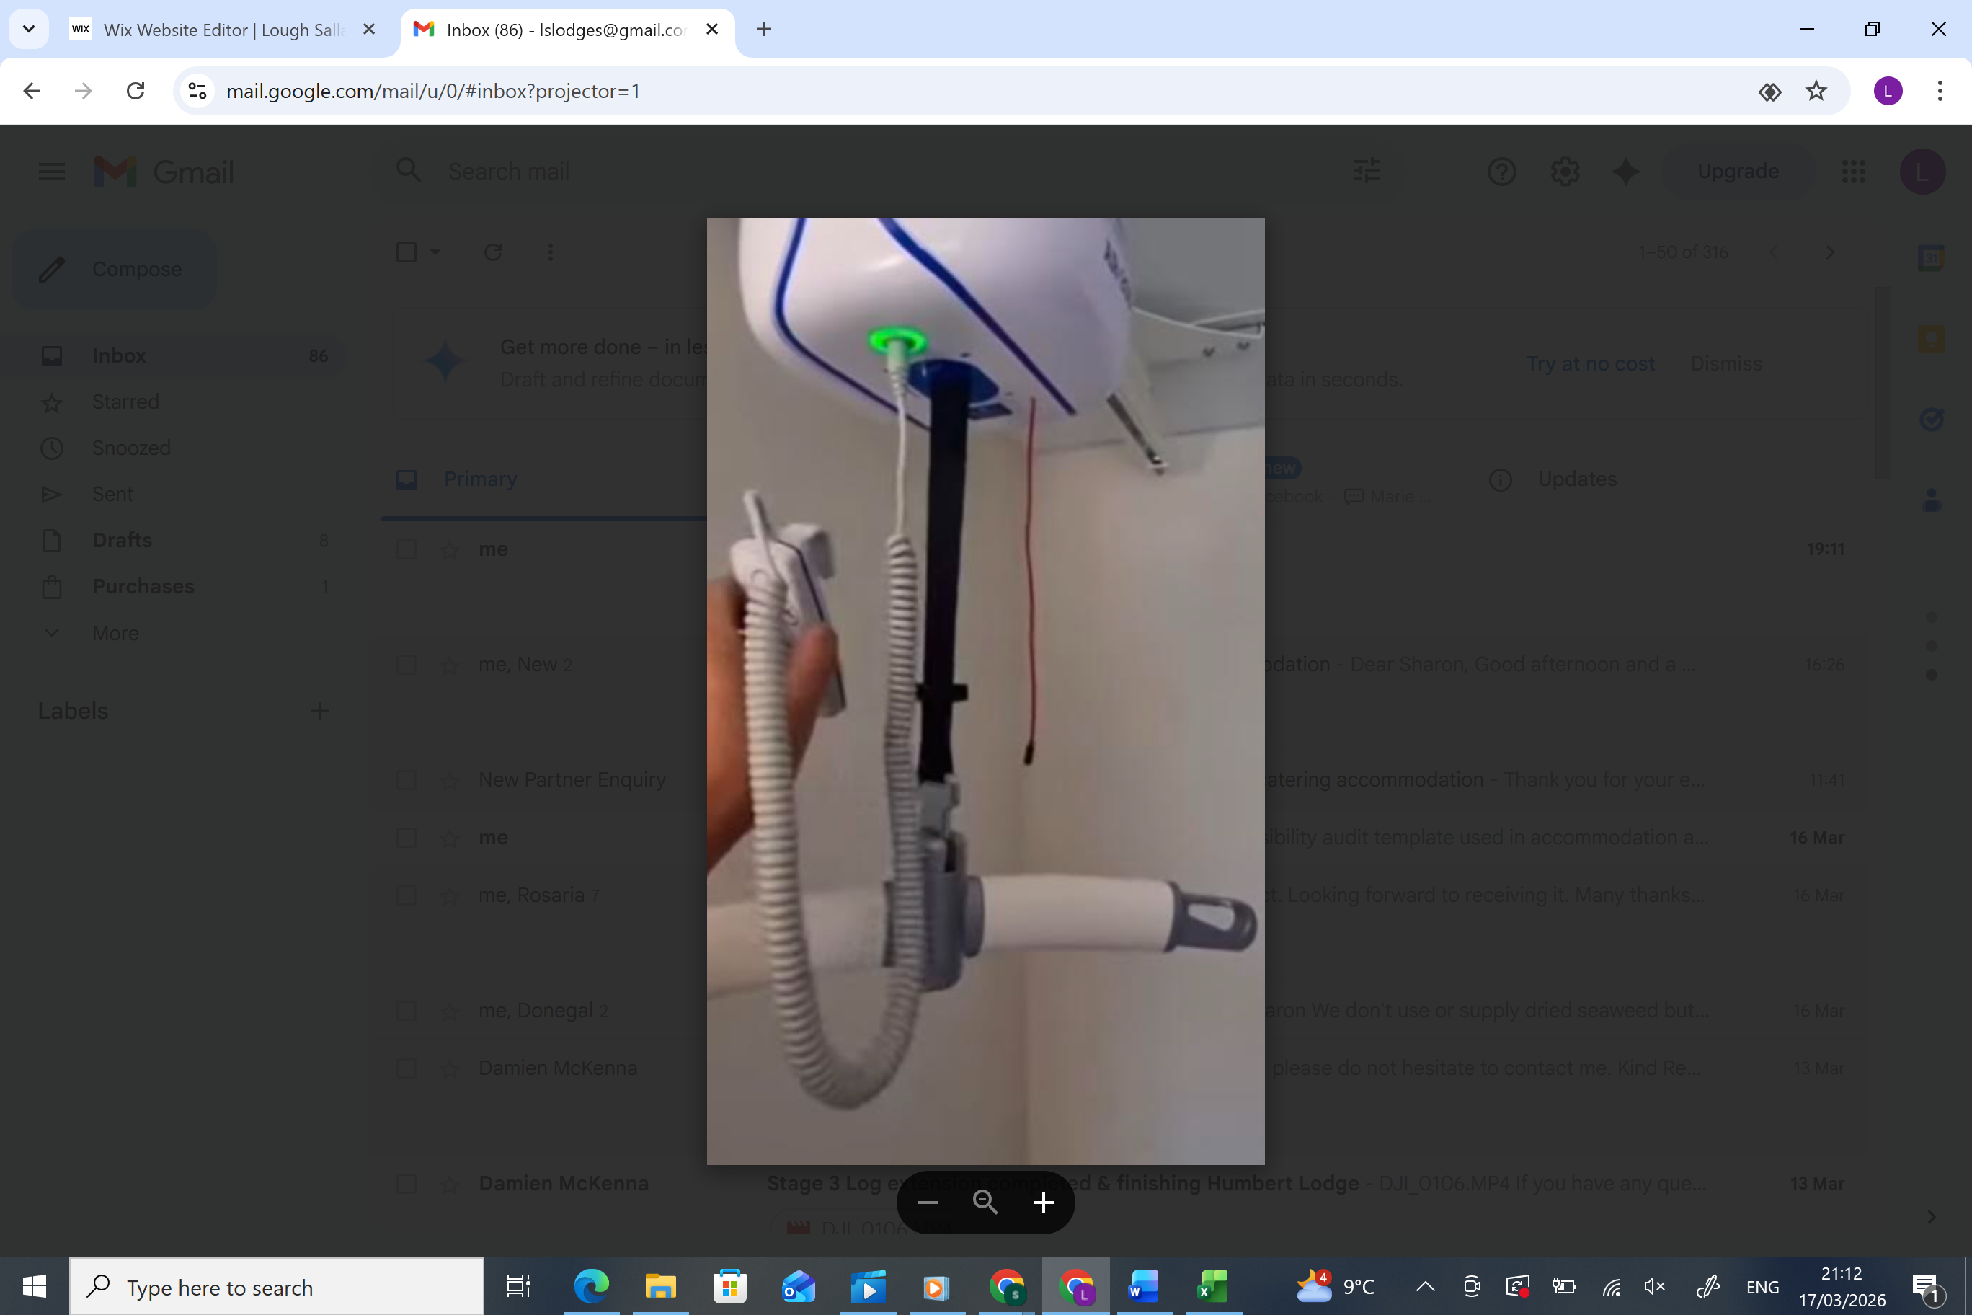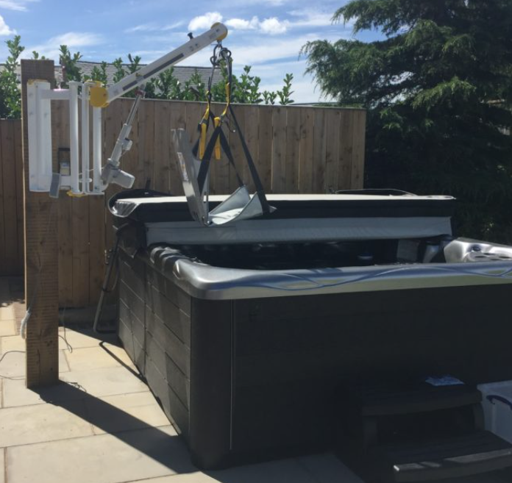

We offer the use of an accessible bicycle designed for inclusive cycling for all our guests. This is called the Fun2Go side-by-side tandem bicycle and is available to all abilities. Ideal for guests with reduced ability, where one person steers and has full control and both can pedal if they wish. The passenger seat has a swivel feature allowing the guest to be hoisted into the Fun2Go bicycle, using the mobile hoist located in our maintenance building where the bicycle is stored. Side-by-side seating allows for greater conversations and a more enjoyable experience for guest. This bicycle can be hired for the day at an additional cost. Booking in advance is advised.

Gallery of Images
___________________________________________________________________

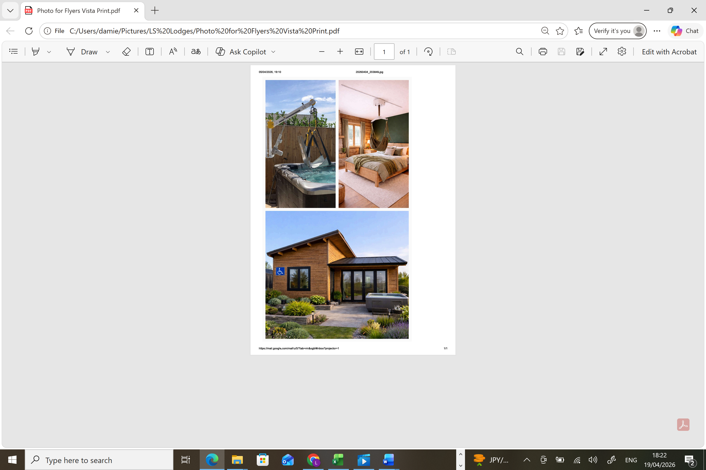
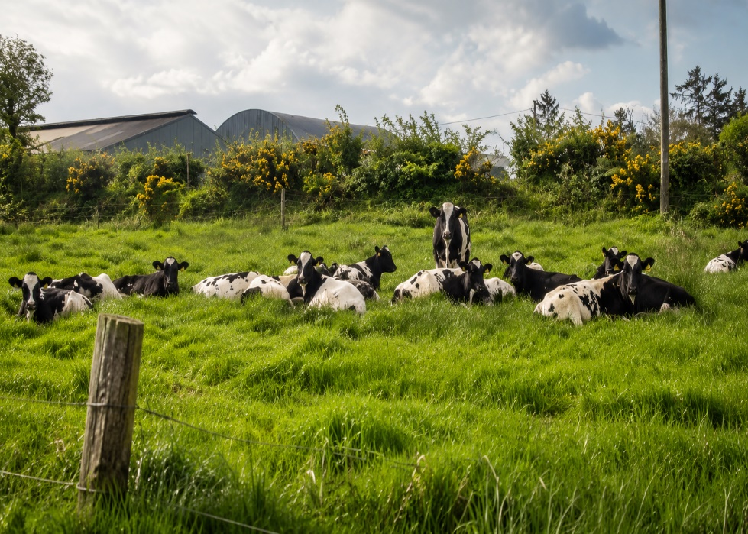

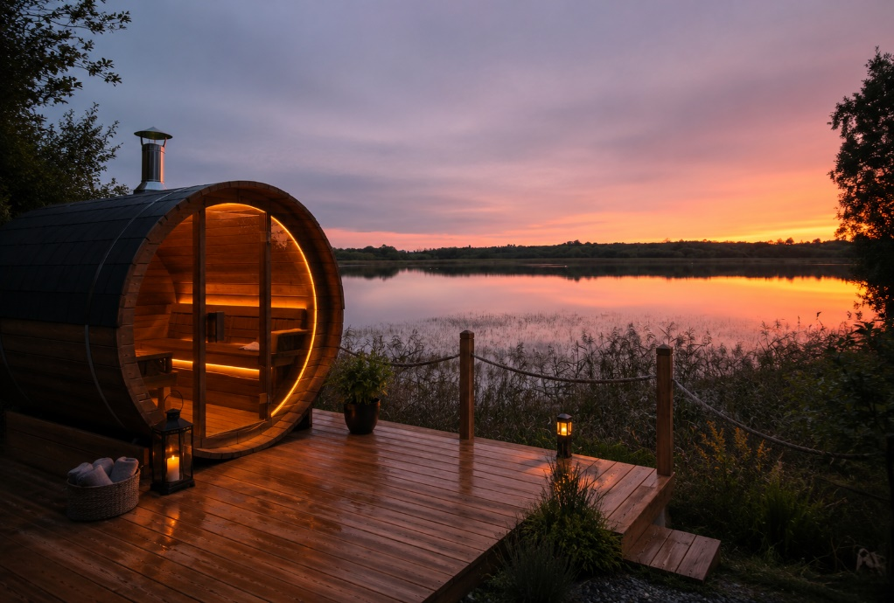
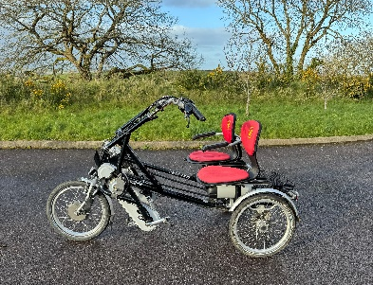
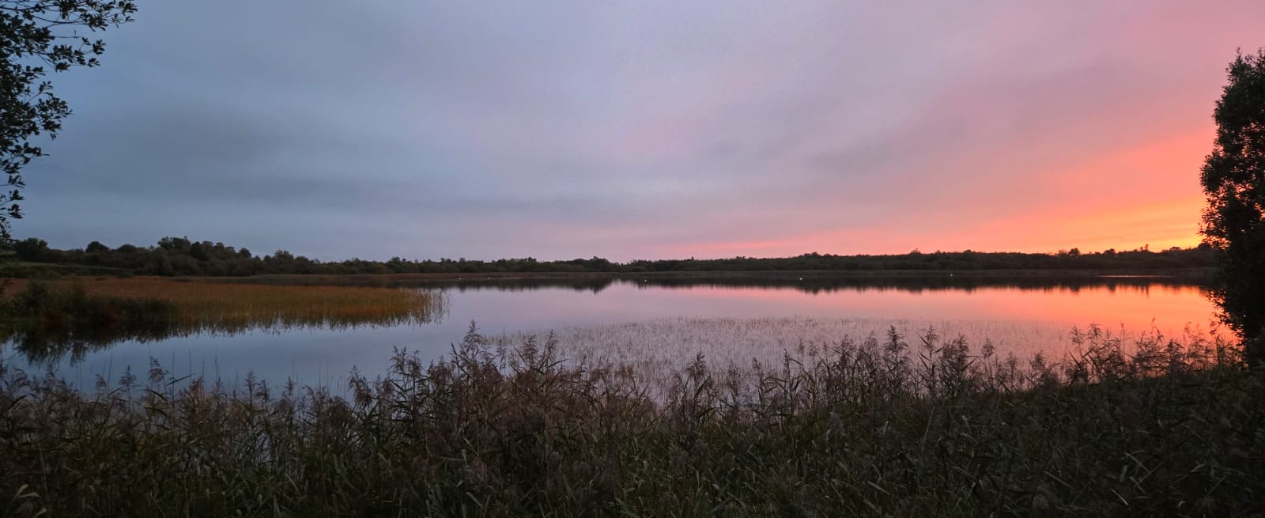

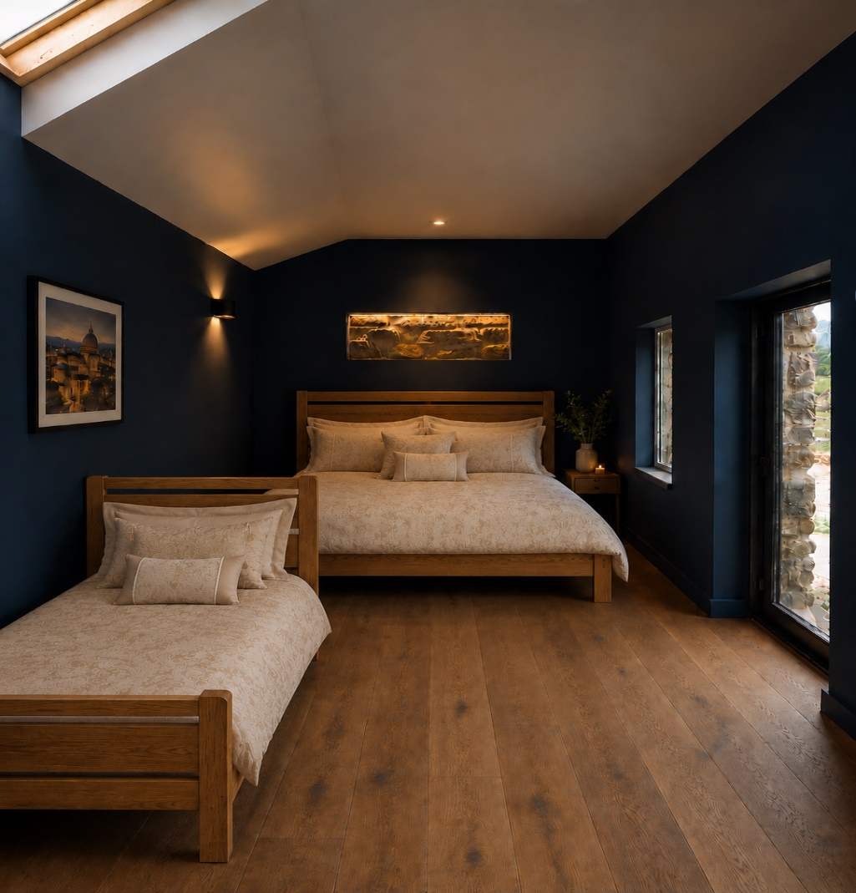

Social Story
___________________________________________________________________
Social Story
Our Easy Read Social Story is designed to help you familiarise yourself with Lough Sallagh Lodges before your visit.
Add Link to Social Story here

Accessible Destination Highlights
___________________________________________________________________
We want our guests to have an enjoyable and memorable break with us. We are located in a stunning part of North Longford with a host of things to enjoy which are accessible and inclusive. These include:
- Accessible Bicycle Hire at Lough Sallagh Lodges : hire an accessible battery powered bicycle or a mobility scooter and enjoy a scenic cycle around Edenmore Bog Walk Ballinamuck, the Ballinamuck to Drumlish cycleway, the many local lakes including Lough Sallagh or simply explore the countryside of Ballinamuck.
- Stop by Johnny’s Cottage in Ballinamuck for a photo opportunity of a traditional thatched cottage, one of few left in the country. At certain times of the year this cottage is open to the public.
- Ballinamuck Visitors Centre https://www.ballinamuck.ie/ : located at the front of the ‘98 community hall, visitors can explore the interactive screens detailing the history of the Battle of Ballinamuck.
- Wiggy’s Hair Salon Ballinamuck https://www.facebook.com/wiggyshairsalonballinamuck/photos : has a level access flooring. Advanced booking is essential. Contact 043-3329742
- Today’s Shop in Ballinamuck Village. A one stop shop for all your hot & cold food necessities for your lodge which includes breakfast hampers, trays of lasagna, cottage pie etc. All of these can be ordered in advance of your stay by contacting the shop directly on 043 3329229. If out cycling/walking you can relax in their indoor seated area and enjoy a coffee and a snack.
- The 98 Bar Ballinamuck https://www.facebook.com/The98Bar/ :Don’t miss the Traditional Irish Music night in The 98 Bar which is usually on every Thursday night from 8pm! Contact Enda on 087 9980615 to confirm entertainment.
- Dillons of Ballinamuck https://www.facebook.com/DillonsBallinamuck/ : Dillons Bar & Lounge is home to many great social events. Head over to their Facebook page to see what’s on.
- The Anvil Coffee Bar Drumlish Drumlish https://www.instagram.com/anvilcoffeebardrumlish/ : is an accessible coffee shop, which is open 7 days a week.
- The Corner House Café https://www.facebook.com/p/The-Cornerhouse-61586896415913/ : is an accessible café/restaurant that offers a wide variety of snacks/lunches & dinners throughout the day. Check out their facebook page for up to date opening hours.
- Drumlish Library https://longfordlibrary.ie/library/find-your-local-library/drumlish-library/ : is accessible via a ramp access and is open on Wednesdays, Thurdays & Fridays. There is access to a PC here and printing facilities. For further information phone +35343 332 47 60 or email drumlishlibrary@longfordcoco.ie
- The Salon No.1 Drumlish is accessible via a ramp access and is open Tuesday to Saturday. Contact Marie on 043-3329303 to make an appointment. To the rear of the Salon is Blush Beauty by Róisín offering a serene retreat for all your beauty needs. Open Tuesday – Saturday. Contact Róisín on 089-4350648 or @blush.by.roisin on Instagram.
- Corn Hill Walk - Discover one of County Longford's most rewarding scenic walks at Corn Hill, the county's highest point, standing 278 metres. The trail offers a memorable outdoor experience, with panoramic views stretching across nine surrounding counties on clear days.

Also known as Cairn Hill or Carn Clonhugh, this historic landmark lies between Drumlish and Ballinalee, in North County Longford. Rich in mythology, the hill is home to ancient cairns linked to Irish folklore. One tradition tells that one of the Cairns was in fact the resting place of Furbuidhe, slain by the followers of Queen Meabh of Connacht, while another attributes the larger cairn to the mythical Cailleach Bhéara, said to have dropped stones from her apron as she flew across the landscape over the hill.

The walking route is approximately 3.2km and follows a combination of well-laid stone paths and natural woodland tracks. Although relatively short, the trail includes some steep sections, making it a satisfying climb for walkers of moderate fitness.

Visitors can take advantage of on-site parking and enjoy designated picnic areas along the route, making Corn Hill an ideal destination for families, walkers, photographers, and anyone looking to experience the natural beauty and heritage of County Longford.
- Newcastle Wood, Newcastle, Ballymahon, Co.Longford. This Coillte-owned woodland extends across more than 500 acres of scenic forest. A network of walking trails winds through the area, offering visitors the opportunity to explore its natural beauty with a mile-long wheelchair-accessible pathway. Picnic facilities and a dedicated car park have also been added to improve the visitor experience.
- Royal Canal Greenway https://www.longford.ie/en/visit/see-and-do/royal-canal-greenway/ :Take yourself into Longford town and onto the Royal Canal Greenway where you can explore 130km of flat accessible paths. There is a wide choice of café’s along the way.
- Longford Sports & Leisure Centre, Coral Leisure Located at The Mall in Longford town has a gym, swimming pool, baby pool, sauna, steam room and ice bath. The swimming pool has an accessible pool hoist system to support wheelchair users to access the pool. There is also a changing facility to support wheelchair users after their session. Contact 043 3346536 for more info.
- The Mall Walk This scenic walk along the River Camlin in Longford Town offers beautiful scenery and is accessible to people with mobility aids. It has tarmac pathways and outdoor exercise machines, as well as many fishing points along the route.
- St. Mel's Cathedral. The newly rebuilt St. Mel's Cathedral is a significant landmark in Longford and is accessible to visitors.
- Longford MegaBowl. This bowling alley is accessible to wheelchair users. The centre also hosts arcades, pool, a play centre (with a lift) and quasar. Party packages available that include hot food, party bag, tea/coffee facilities etc contact 043 3347643.
- Longford Shopping Centre, Townsparks, Longford N39 R7R6 is home to many shops includingTesco, Penny’s, O’Heirs Bakery, Fresh Today, Paul Byrons Shoes, a barbers, a hairdressers and much more.
- The Backstage Theatre Centre for theatre & arts. The Auditorium can accommodate up to three wheelchairs spaces for each show. Additionally, we are pleased to offer access to a new range of Assisted Listening Devices for customers with hearing loss. They will also be happy to offer a quiet space for theatre attendees with special sensory needs. 043 3347888.
- Lough Ree Access for All https://loughreeboattrips.com/boat-trip/ : Enjoy an accessible boat trip/fishing trip in lovely Lanesborough, Co. Longford. This is a 35km drive from our lodges. Book in advance by contacting +353 (0)89 2625505.
- Lough Ree Distillery is a family-run business founded in Lanesborough, County Longford. They are famous for their Sling Shot Gin, Bart's blended Irish whiskey, The Bridge single malt Irish whiskey and Zesty Vodka. Bookings can be made for individuals or for groups of up to 16 people. You will make three gin & tonics that you can enjoy alongside fantastic finger food from Jack Rabbits kitchen. You are in for an experience you won't forget, with your own personalised 70cl bottle of gin to take home with you.
- The National Famine Way The 165km historical trail from Roscommon to Dublin weaves mostly along the Royal Canal and can be completed in sections or all at once. The trails start in Strokestown Park at the National Famine Museum and ends at the Famine statues in Dublin Docklands, close to EPIC the Irish Emigration Museum, Dublin. Pay a visit to the National Famine Museum in Strokestown to learn more about these historic times.
- Maria Edgeworth Centre Located in the historic old schoolhouse in Edgeworthstown, the Maria Edgeworth Centre tells visitors the story of the life and times of pioneering novelist Maria Edgeworth (1767-1849). Best known for her novels on Irish life, her work gives plentiful insight into rural and domestic life in Ireland during the time period.
At the Maria Edgeworth Centre, you will experience the life and times of Maria Edgeworth, as well as other notable figures in the Edgeworth family. The ground floor exhibition area is wheelchair accessible and has disabled access toilets. The Literary and Historical Trail is wheelchair accessible with some limitations. It should be noted that the Trail crosses the public roads in a few places.
- The Corlea Trackway, Keenagh, Co. Longford. This is one attraction that is not to be missed and it is fully accessible. In 1984 a prehistoric trackway of large oak plans were discovered by Bord na Mona peat harvesting operations, which is thought to date back to 148BD. Over the centuries, this trackway was preserved by the formation of the raised bog and is thought to be a walking surface between one farming community and another. Explore the exhibition here at Corlea and enjoy the scenic walkways around the bogs in Keenagh.
- Derrycasson Woods – Nestled along the shores of Lough Gowna, Derrycasson Woods offers a peaceful escape where you can enjoy a scenic stroll through the woodland trails and take in the flora and fauna and the natural beauty of Derrycasson Woods.

Emergency & Medical Information
___________________________________________________________________

The nearest hospital Emergency Department to Lough Sallagh Lodges is Cavan General Hospital, located 39km away.
The out of hours GP service is called Midoc and it is located on the grounds of St. Joseph’s day hospital, Dublin Road, Longford N39 PW72. Phone 1800 302 702.
The nearest pharmacy is Loughrey’s Pharmacy Drumlish. It is open Monday to Saturday. Contact 00353 433329756 for more information.
In an emergency please call 112 or 999 and give them the Eircode to the lodges which is N39 K2H9. The community first responder team will automatically be dispatched while the ambulance is onroute.
There is an AED machine located on the roadside in Fardrumman at N39 EA29. It is accessible 24hrs per day. There maybe occasions when this AED is gone for servicing and therefore the next closest AED is located on the wall of The 98 Bar.

Testimonials – What our Customers tell us
___________________________________________________________________



We are continually reviewing and improving our customer experience, and any changes will be reflected in our Access Welcome Guide.

We welcome your feedback!

If you have any questions or suggestions about accessibility at Lough Sallagh Lodges, please contact us at lslodges@gmail.com

This Access Welcome Guide was produced on the 2nd July 2026 and last updated on the 2nd July 2026.

