

YARD DUTY AND SUPERVISION POLICY

Purpose
To ensure school staff understand their supervision and yard duty responsibilities.

Scope
The principal is responsible for ensuring that there is a well-organised and responsive system of supervision in place during school hours, before and after school, and on school excursions and camps.
This policy applies to all teaching and non-teaching staff at Tongala Primary School, including education support staff, casual relief teachers and visiting teachers.
School staff are responsible for following reasonable and lawful instructions from the principal, including instructions to provide supervision to students at specific dates, time and places.

Policy

Before and after school
Tongala Primary School’s grounds are supervised by school staff from 8:30am until 3:25pm. Outside of these hours, school staff will not be available to supervise students.
Before and after school, school staff will be available to supervise the school oval and basketball area, as well as the school crossing after school.
Parents and carers should not allow their children to attend Tongala Primary School outside of these hours. Families are required to contact the school office on 58590551, if their child needs to attend school outside of the duty of care times, due to unforeseen circumstances.
If a student arrives at school before supervision commences at the beginning of the day, the principal or nominee staff member will, as soon as practicable, follow up with the parent/carer to:
- advise of the supervision arrangements before school
- request that the parent/ carer make alternate arrangements.
If a student is not collected before supervision finishes at the end of the day, the principal or nominee staff member will consider whether it is appropriate to:
- attempt to contact the parents/carers
- attempt to contact the emergency contacts
- contact Victoria Police and/or the Department of Health and Human Services (Child Protection) to arrange for the supervision, care and protection of the student.

Yard duty
All staff at Tongala Primary School are expected to assist with yard duty supervision and will be included in the weekly roster.
The principal is responsible for preparing and communicating the yard duty roster on a regular basis. At Tongala Primary School, school staff will be designated a specific yard duty area to supervise.
The designated yard duty areas for our school are the school building and oval area and the playground areas.
Zone | Area
Zone 1 | Building/Oval/Fitness Hub
Zone 2 | Playground/North end of school/Environmental Garden
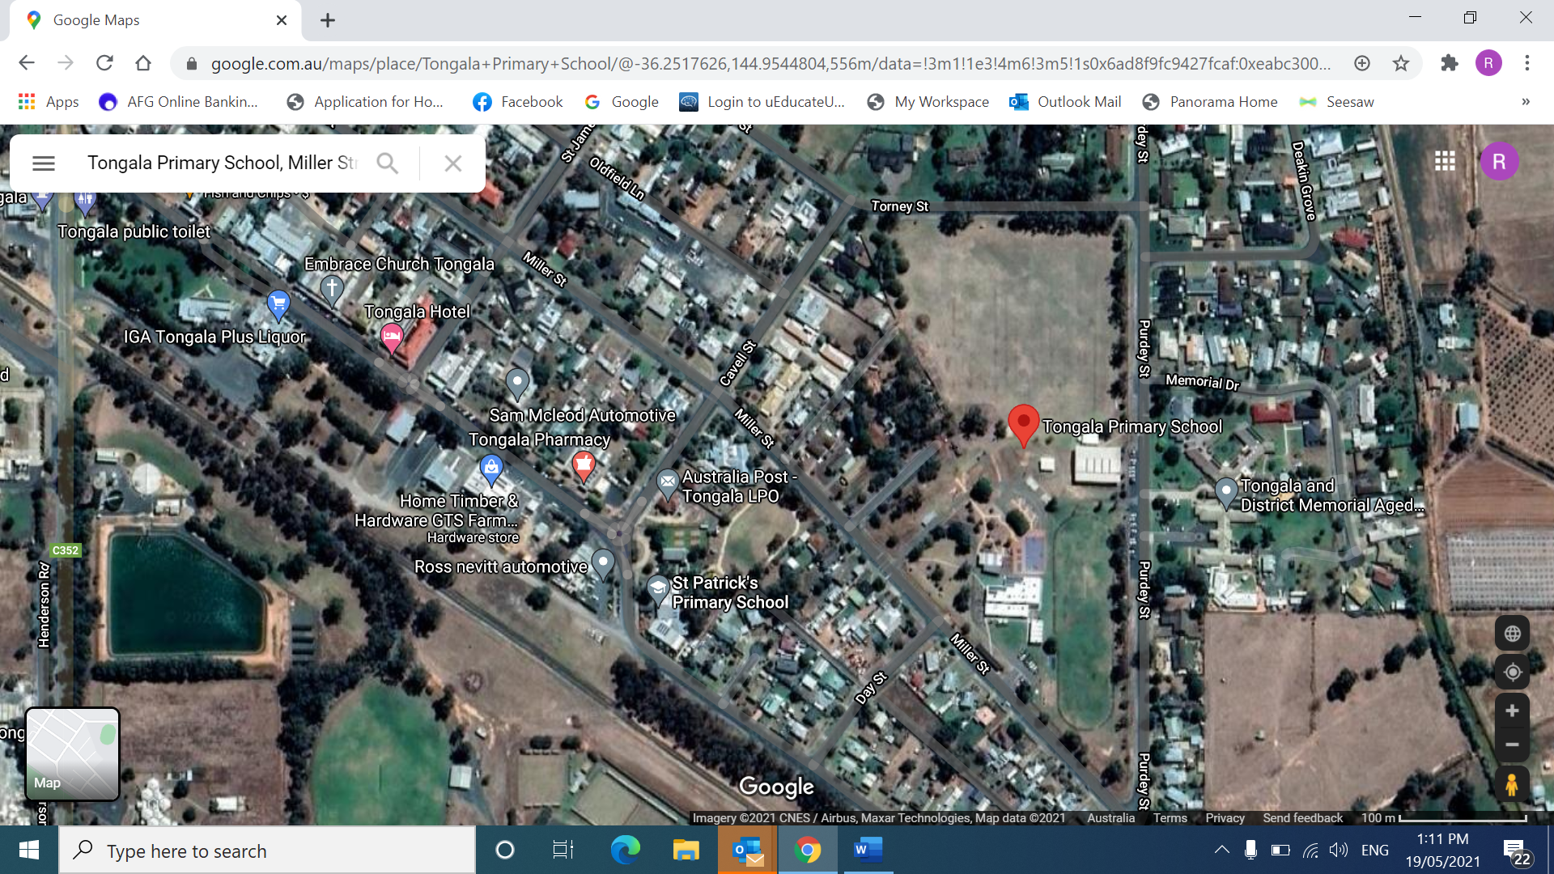

INSERT SCHOOL MAP WITH ZONES MARKED
School staff must wear a provided safety/hi-vis vest and carry first aid bag whilst on yard duty. Safety/hi-vis vests will be stored in classroom/office areas.
Staff who are rostered for yard duty must remain in the designated area until they are replaced by a relieving teacher.
During yard duty, supervising staff must:
- methodically move around the designated zone
- be alert and vigilant
- intervene immediately if potentially dangerous or inappropriate behaviour is observed in the yard
- enforce behavioural standards and implement appropriate consequences for breaches of safety rules, in accordance with any relevant disciplinary measures set out in the school’s Student Engagement and Wellbeing policy
- ensure that students who require first aid assistance receive it as soon as practicable
- log any incidents as appropriate
- if being relieved of their yard duty shift by another staff member (for example, where the shift is ‘split’ into 2 consecutive time periods), ensure that a brief but adequate verbal ‘handover’ is given to the next staff member in relation to any issues which may have arisen during the first shift.
If the supervising staff member is unable to conduct yard duty at the designated time, they should organise a swap in duty, with as much notice as possible prior to the relevant yard duty shift to ensure that alternative arrangements are made.
If the supervising staff member needs to leave yard duty during the allocated time, they should contact the Principal but should not leave the designated area until the relieving staff member has arrived in the designated area.
If a relieving or next staff member does not arrive for yard duty, the staff member currently on duty should send a message to the staff room and not leave the designated area until a replacement staff member has arrived.
Should students require assistance during recess or lunchtime, they are encouraged to speak to the supervising yard duty staff member.

Classroom
The classroom teacher is responsible and has a Duty of Care for the supervision of all students in their care during class.
If a teacher needs to leave the classroom unattended at any time during a lesson, they should first contact the Principal for assistance. The teacher should then wait until another staff member has arrived at the classroom to supervise the class prior to leaving.

School activities, camps and excursions
The principal and leadership team are responsible for ensuring that students are appropriately supervised during all school activities, camps and excursions, including when external providers are engaged to conduct part or all of the activities. Appropriate supervision will be planned for special school activities, camps and excursions on an individual basis, depending on the activities to be undertaken and the level of potential risk involved.

Digital devices and virtual classroom
Tongala Primary School follows the Department’s Cybersafety and Responsible Use of Technologies Policy with respect to supervision of students using digital devices. Tongala Primary School will also ensure appropriate supervision of students participating in remote and flexible learning environments while on school site. While parents are responsible for the appropriate supervision of students accessing virtual classrooms from home:
- student attendance will be monitored daily
- any wellbeing or safety concerns for the student will be managed in accordance with our usual processes

Students requiring additional supervision support
Sometimes students will require additional supervision, such as students with disability or other additional needs. In these cases, the principal or delegate will ensure arrangements are made to roster additional staff as required. This may include on yard duty, in the classroom or during school activities.

Supervision of student in emergency operating environments
In emergency circumstances our school will follow our Emergency Management Plan, including with respect to supervision.
In the event of any mandatory period of remote or flexible learning our School will follow the operations guidance issued by the Department.

COMMUNICATION
This policy will be communicated to our school community in the following ways:
- Included in staff induction processes
- Discussed at staff briefings or meetings, as required
- Included as a reference in our school newsletter each term
- Made available in hard copy from school administration upon request
Information for parents and students on supervision before and after school is made available with reminders sent at the beginning of each term in our school newsletter.

Further Information and Resources
- School Policy and Advisory Guide:
  - Supervision
  - Duty of Care
  - Child Safe Standards
  - Visitors in Schools

Policy REVIEW and Approval
Policy last reviewed | September 2025
Approved by | Principal
Next scheduled review date | Before August 2027 – noting 2-year review cycle

