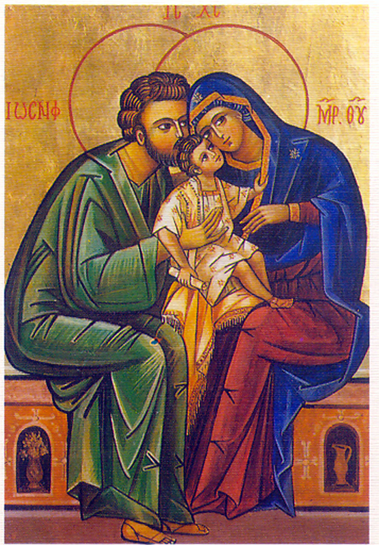
St. Olaf Catholic Church Williamsburg, Virginia
Christian Formation for children in
Pre-K (age 4) through 5th grade
2025 Registration

FAMILY NAME

Parents

Address

Email

Phone _
Received First
Name Age Grade DOB Baptized Communion

___________________ ___ ______ ________ _______ YES/ NO YES/ NO

___________________ ___ ______ ________ _______ YES/ NO YES/ NO

___________________ ___ ______ ________ _______ YES/ NO YES/ NO

___________________ ___ ______ ________ _______ YES/ NO YES/ NO

Day choice: Sun or Tues 1st_____ 2nd ______ Schooling: ___ public ___ Catholic ___ home school ___ private
Medical/ Behavioral Information: Please indicate any kind of situations, problem, or concern of which we should be aware for any of your children. This will be confidential for the teacher and office staff. ______________________________________________________________________________________

_____________________________________________________________________________________________.

I give permission for pictures and/or video of my child (names above) engaged in activities related to the parish or Diocesan event to have their picture posted in St. Olaf Catholic Church, the Diocese of Richmond publications, social media, and websites. Names of participants will not be used without expressed permission from the parent or guardian. If no box is checked below, the Diocese of Richmond assumes you give permission.
YES No Parent/ Guardian signature: _______________________ Date: ________


If unable to reach either adult listed above in an Emergency, contact:
Name______________________________________
Phone: ____________________________ Relationship to child: _________________

Registration fees is $45 per child.
Registration fees and forms are due upon registration or by August 27, 2025.
(Please see Terri Chang if this fee is difficult).

Return to: Terri Chang, or the office St. Olaf Catholic Church
Christian Formation
104 Norge Lane
Williamsburg, VA 23188

