St. Olaf Catholic Church
104 Norge Lane Williamsburg, VA 23188
Christian Formation for Children PK4 to 5th Grade for 2025-2026
Sundays 11:30 am – 12:45 pm
Tuesday of the same week 4:45-6:00 PM

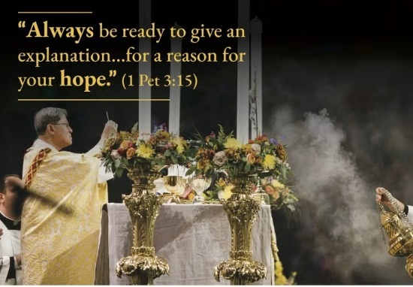
September 7 Family, Faith & Fellowship
14 Healthy Boundaries for children
21 gathering
28 gathering

October 5 gathering
12 gathering
19 gathering

November 2 gathering
9 gathering "This is my body given for you" Luke 22:19
16 gathering
23 gathering
Sacrament Prep: Reconciliation
December 7 gathering Parent meetings: October 23, 2025 at 7-8:30 PM Hall 1
14 gathering Children & Parents November 17, December 1 & 15 2 at 5-7 pm
14 Christmas Play at 2pm

2026

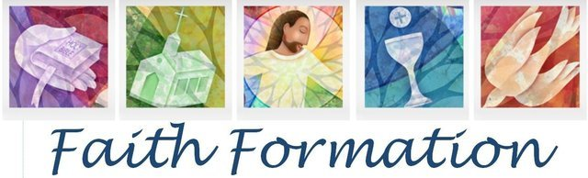
January 4 gathering
11 gathering
18 gathering

February 1 gathering
8 gathering
15 gathering
22 gathering Eucharist 2026
Eucharist Parent Meeting: March 23 at 7-8:30PM Parish Hall
March 1 gathering Parent & Children April 1, 15, 29 at 5-7 pm PH2
8 gathering
15 gathering Retreat May 1 at 6 pm
22 gathering
29 gathering Celebrate May 2 at 11 am Mass

April 12 gathering
19 gathering
26 gathering
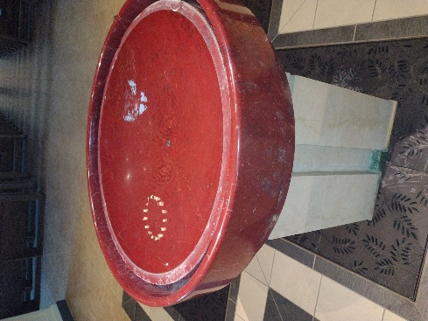
St. Olaf Catholic Church
104 Norge Lane
Williamsburg, VA 23188

Christian Formation
Grades Pre-Kindergarten 4 to 5th
July 31, 2025
Dear Parents.
We gather as people called to proclaim the Good News of the Father, Son, and Holy Spirit. I look forward to exploring the many topics of being a Christian with your child that nurtures the grace of Baptism.

I offer to you the opportunity to grow in your faith through scripture every week, parent gatherings, family gatherings or other subjects you would like to explore on your faith journey. This catechetical program is not intended to supplant parents as primary educators of their children but strengthen your ability to pass on the faith and support of Catholic home life. It is essential that the children attend some form of Catholic Formation from the parish or Catholic school.

Catechesis or Christian Formation is a form of the ministry of the Word. It continues the teaching mission of Jesus and passes on the Church’s living tradition. It is a life-long process, which invites people into a living, conscious and active faith.

The curriculum for this year is Catechesis of the Good Shepherd and scripture, both will interweave life and faith throughout each lesson to help children recognize that faith makes a difference in their lives. Please read the Bible with your older child. Being a believer really does change our outlook on everything. Each family is asked to indicate 1st choice and 2nd choice of day.

All children should be respectful of our parish space in action and word. All children are to be walked into the parish hall and picked-up from the building vie our main entrance. We will use multiple spaces for catechesis of the children.
If you answer yes to any of these questions keep your child home. - Does the child have a temperature greater than 100.3⁰F? -In the past days, has the child presented symptoms, such as a fever, chills, sore throat, cough, shortness of breath, muscle pain, loss of taste or smell, nausea, vomiting, or diarrhea?

All sacrament preparations for Reconciliation followed by Eucharist have some time separate from Sunday or Tuesday classes. A letter discussing times, fees, and materials will follow to those parents of children, in 2nd and 3rd grade that would like sacraments. All sacrament preparation happens in the parish regardless if formation is in a Catholic school or parish program. The schedule may be adjusted following State and Diocesan guidelines.

I look forward to sharing in God’s gifts,

Ms. Terri Chang
Coordinator of Christian Formation

