St. Olaf Catholic Church
104 Norge Lane Williamsburg, VA 23188
Christian Formation for Children PK4 to 3rd Grade for 2026-2027
Monday 5:30 pm – 7:00 pm

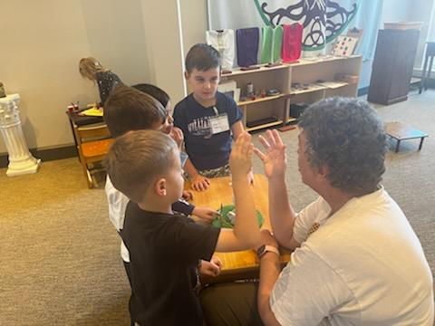
September 14 Gathering with Healthy Boundaries for children

21 Atrium gathering Monday
28 Atrium gathering

October 5 Atrium gathering
19 Atrium gathering
26 Atrium gathering

November 2 Atrium gathering
9 Atrium gathering "The Spirit of the Lord is upon me" Luke 4:18
16 Atrium gathering
23 Atrium gathering

December 7 Atrium gathering
14 Atrium gathering
20 Christmas Play at 3pm

2027
January 4 Atrium gathering
11 Atrium gathering
18 Atrium gathering
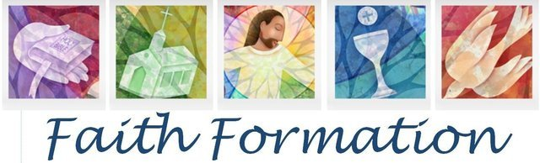
25 Atrium gathering

February 1 Atrium gathering
8 Atrium gathering
15 Atrium gathering
22 Atrium gathering Sacrament Prep: Reconciliation
Parent meeting October 7 at 7-8:30 pm Rm
March 1 Atrium gathering Children and Parent October 21, November 4, 18 at 5-7:10 pm
8 Atrium gathering
15 Atrium gathering
22 Atrium gathering
March 28 is Easter Eucharist Preparation 2027
April 12 Atrium gathering Parent Meeting March 3 at 7- 8:30 pm
19 Atrium gathering Children and Parent March 17, 31, April 14 at 5-7:10 pm
26 Atrium gathering Retreat April 30 at 6 pm
Celebrate May 1 at 11 am Mass

St. Olaf Catholic Church
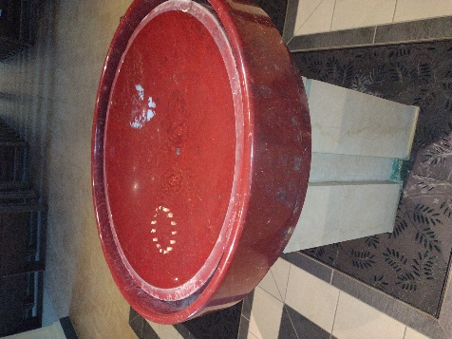
104 Norge Lane
Williamsburg, VA 23188

Christian Formation
Grades Pre-Kindergarten 4 to 5th
July 14, 2026
Dear Parents.
We gather as people called to proclaim the Good News of the Father, Son, and Holy Spirit. I look forward to exploring the many topics of being a Christian with your child that nurtures the grace of Baptism.

I offer to you the opportunity to grow in your faith through scripture every week, parent gatherings, family gatherings or other subjects you would like to explore on your faith journey. This catechetical program is not intended to supplant parents as primary educators of their children but strengthen your ability to pass on the faith and support of Catholic home life. It is essential that the children attend some form of Catholic Formation from the parish or Catholic school.

Catechesis or Christian Formation is a form of the ministry of the Word. It continues the teaching mission of Jesus and passes on the Church’s living tradition. It is a life-long process, which invites people into a living, conscious and active faith.

The curriculum for this year is Catechesis of the Good Shepherd and scripture, both will interweave life and faith throughout each lesson to help children recognize that faith makes a difference in their lives. Please read the Bible with your older child. Being a believer really does change our outlook on everything. Each family is asked to indicate 1st choice and 2nd choice of day.

All children should be respectful of our parish space in action and word. All children are to be walked into the parish center and picked up from the building vie our main entrance. We will use multiple spaces for catechesis of the children.
If you answer yes to any of these questions keep your child home. - Does the child have a temperature greater than 100.3⁰F? -In the past days, has the child presented symptoms, such as a fever, chills, sore throat, cough, shortness of breath, muscle pain, loss of taste or smell, nausea, vomiting, or diarrhea?

All sacrament preparations for Reconciliation followed by Eucharist have some time separate from Sunday or Tuesday classes. A letter discussing times, fees, and materials will follow to those parents of children, in 2nd and 3rd grade that would like sacraments. All sacrament preparation happens in the parish regardless of if formation is in a Catholic school or parish program.

I look forward to sharing in God’s gifts,

Ms. Terri Chang
Coordinator of Christian Formation

