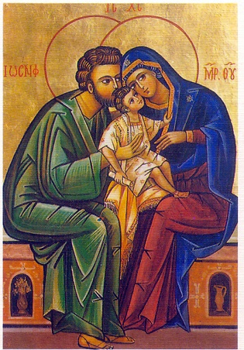
St. Olaf Catholic Church Williamsburg, Virginia
Christian Formation for children in
Pre-K (age 4) through 5th grade
2026 Registration

FAMILY NAME

Parents

Address

Email

Phone _
Received First
Name Age Grade DOB Baptized Communion

___________________ ___ ______ ________ _______ YES/ NO YES/ NO

___________________ ___ ______ ________ _______ YES/ NO YES/ NO

___________________ ___ ______ ________ _______ YES/ NO YES/ NO

___________________ ___ ______ ________ _______ YES/ NO YES/ NO

Day choice: Mon or Sun? 1st_____ you may not get the 1st choice due to limited space.
Schooling: ___ public ___ Catholic ___ home school ___ private
Medical/ Behavioral Information: Please indicate any kind of situation, problem, or concern of which we should be aware of for any of your children. This will be confidential for the teacher and office staff. ______________________________________________________________________________________

_____________________________________________________________________________________________.

I give permission for pictures and/or video of my child (names above) engaged in activities related to the parish or Diocesan event to have their picture posted in St. Olaf Catholic Church, the Diocese of Richmond publications, social media, and websites. Names of participants will not be used without expressed permission from the parent or guardian. If no box is checked below, the Diocese of Richmond assumes you give permission.
YES, No Parent/ Guardian signature: _______________________ Date: ________


If unable to reach either adult listed above in an Emergency, contact:
Name______________________________________
Phone: ____________________________ Relationship to child: _________________

Registration fee is $45 per child.
Registration fees and forms are due upon registration or by August 27, 2026.
(Please see Terri Chang if this fee is difficult).

Return to: Terri Chang, or the office St. Olaf Catholic Church
Christian Formation
104 Norge Lane
Williamsburg, VA 23188
Office #_______

Christian Formation for children in
K through 5th grade

Teaching Safety - Empowering God’s Children Program Parental Consent Form
Dear Parent/Legal Guardian, Please complete the form below to consent that your child may participate in the Teaching Safety—Empowering God’s Children Program
at St. Olaf Catholic Church Williamsburg, Virginia
September 13/ 14, 2026.
This form will provide consent for all gatherings related to this program unless the parent/legal guardian gives written notification to staff that consent has been withdrawn.

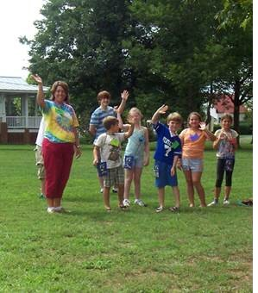
FAMILY NAME

Parents

Address

Email

Phone _

Name Age Grade

___________________ ___ ______ ________ _______

___________________ ___ ______ ________ _______

___________________ ___ ______ ________ _______

___________________ ___ ______ ________ _______

Parent/Guardian Signature: ___________________________________________________

Date: ___________________________________________________

Catholic Diocese of Richmond / Office of Safe Environment

Return to: Terri Chang, or the office St. Olaf Catholic Church
Christian Formation
104 Norge Lane
Williamsburg, VA 23188

