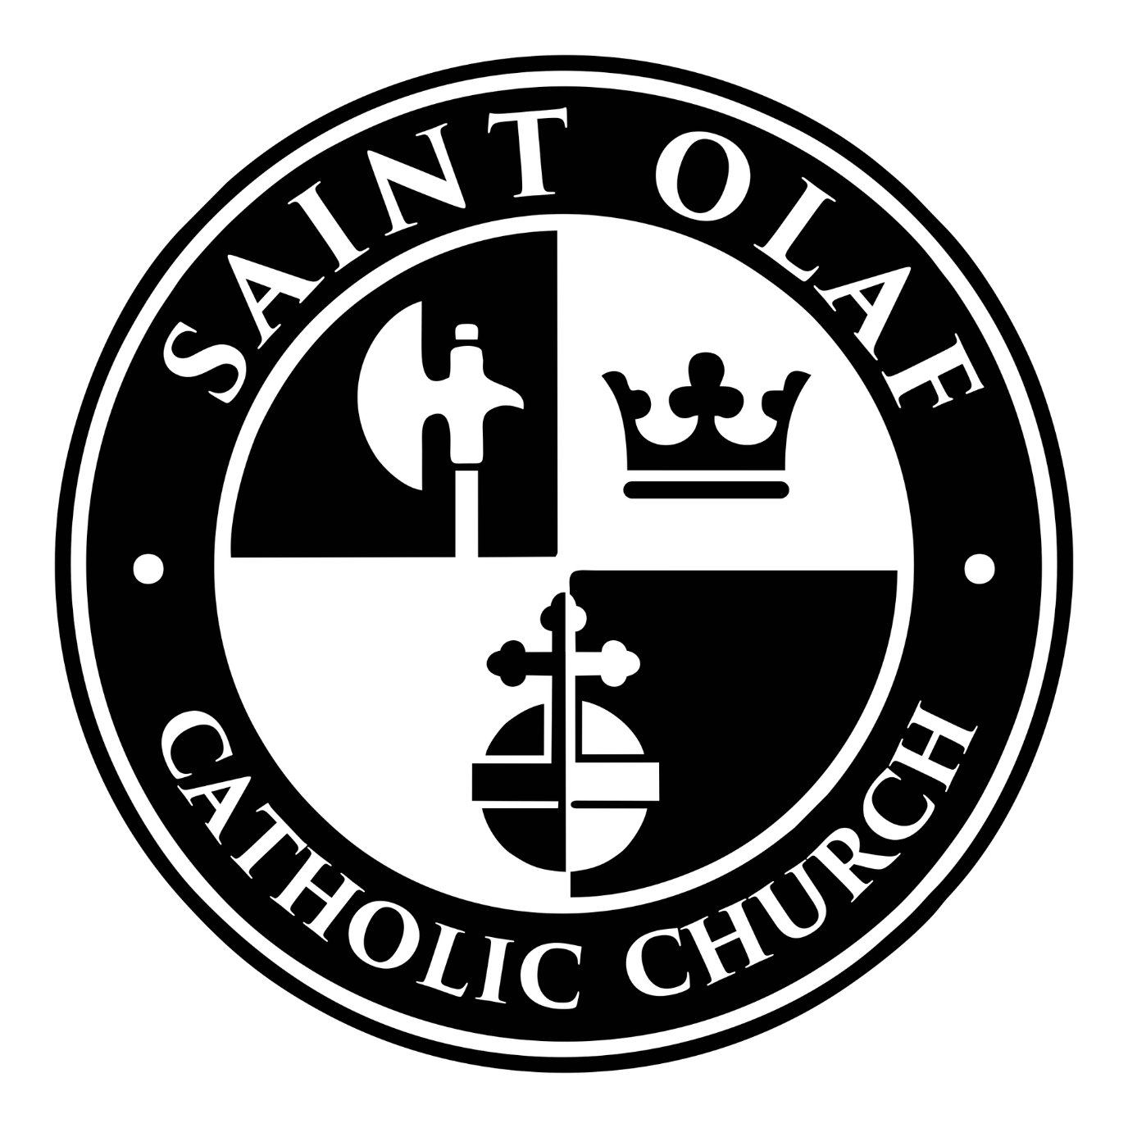
Ministry Guide

Revised on 2/12/2026

Life is better together!

Welcome to St Olaf Catholic Church. We are a community of believers and a spiritual family that is supportive and loving. It can be a place to grow spiritually, to put your faith in action, and to use your gifts of time and talent as disciples of Christ. Everyone is encouraged to seek a deeper understanding of what it means to use your time, talents and treasure by serving our ministries. We believe that each parishioner brings gifts to the parish, offering distinct talents of the body. Your presence enriches us and builds up the life of the Church.
We invite you to browse this booklet and search for opportunities to participate in our community. If you find a ministry that interests you, please email our office at ministries@stolaf.cc to express your interest or browse our website at www.stolaf.cc.

“Each one should use whatever gift he has received
to serve others, faithfully administering
God’s grace in its various forms.”
1 Peter 4:10

CONTACT INFORMATION

OFFICE INFORMATION
St. Olaf, Patron of Norway Catholic Church
104 Norge Lane
Williamsburg, VA 23188
Phone: (757) 564-3819

Food Pantry:
Monday through Friday 10am-noon
First Friday of the Month 5-7pm
757-903-2868

Website: stolaf.cc E-mail: office@stolaf.cc

PARISH OFFICE HOURS
Monday – Thursday: 8:30am-3:30pm
Friday: 8:30am-1:00pm

PASTORAL STAFF
Fr. Thomas E. Mattingly, Pastor tmattingly@stolaf.cc
Reverend Mr. Edward Handel, Deacon ehandel@richmonddiocese.org
Reverend Mr. Robert Kruse, Deacon rkruse@stolaf.cc

MINISTRY STAFF
David Fielding, Director of Liturgy and Music musicandliturgy@stolaf.cc
Terri Chang, Coordinator of Christian Formation tchang@st.olaf.cc
& Adult Formation
Ann Mattio, Coordinator of Youth, stolafteensforchrist@gmail.com
Family Relational Ministry
Madeline Sheets, Middle School Youth Leader edge@stolaf.cc

SUPPORT STAFF
Thomas Hipple; Business Manager thipple@stolaf.cc
Nancy Moran; Accountant nmoran@stolaf.cc
Karen Handel; Administrative Assistant office@stolaf.cc
Mark Sink; Facility Maintenance Coordinator msink@stolaf.cc

For more information and to contact ministry leaders, email ministries@stolaf.cc

MASS and RECONCILIATION SCHEDULE

WEEKEND MASS SCHEDULE
Saturday (Vigil) 5:00pm
Sunday 8:00am and 10:00am

WEEKDAY MASS SCHEDULE
Tuesday - Friday 10:00am

RECONCILIATION SCHEDULE
Friday 11:00am
Saturday 4:00pm
or by appointment

HOLY DAY OF OBLIGATION
12:00pm and 7:00pm

THANKSGIVING DAY MASS
FOURTH OF JULY
10:00am

CHRISTMAS SCHEDULE
Christmas Eve 4:00pm and 7:00pm
Christmas Day 10:00am

EASTER SCHEDULE
Vigil Mass 7:30pm
Easter Sunday 8:00am, 10:00am and Noon

**Virtus Training is for ALL Volunteers throughout the Diocese. **
For more information, please visit our website stolaf.cc
on the Safe Environment page under the Ministries tab.

For more information and to contact ministry leaders, email ministries@stolaf.cc
Ministry | Leader | Overview
Adult Formation | Terri Chang | The Adult Faith Formation of Saint Olaf Catholic Church recognizes the importance of the catechesis of adults and strives to promote and nourish a mature adult faith that will foster true discipleship. Parishioners are invited to encounter Jesus and grow in the fullness of their Catholic faith through a comprehensive catechetical and spiritual formation process. We strive to foster a growing Adult Ministry program to encourage evangelization through Formed, Ascension Press, Hallow, studying the books of the Bible, The Creed, Saints, and Our Lord’s Passion.
Altar Servers | Gary Sylakowski | The Altar Servers assist the priest and deacon during parish liturgies. This ministry is open to anyone who has received First Holy Communion. Servers are expected to be familiar with the flow of the liturgy and anticipate each movement.
Arts and Environment | Barbara Brown | This ministry strives to create a visually appropriate environment to encourage and stimulate the participation of the worshipping community in the liturgical celebration. Members water the live plants in the Church and Commons area and purchase and arrange the flowers for the celebration of weekend Masses. They use their talents to keep flowers relevant as the liturgical seasons and seasons of the year change, incorporating these changes into their weekly arrangements and maintaining our outdoor gardens. Those wishing to combine their love for the church and their willingness to share their artistic gifts should consider this ministry.
Children's Christian Formation | Terri Chang | Soulful activities that bring joy and encourage a relationship with Jesus, even in the youngest children. The growth of that relationship is the goal of the Elementary Christian Formation Program. The Elementary Christian Formation Program is available to Pre-school children (starting at age 4) through the 5th Grade. **In addition, twice a month during 10am Mass, Children's Liturgy of the Word (CLW) provides Sunday readings in the child’s vocabulary for children ages 4 to 7 years old. Vacation Bible School is also held every summer and is open to all elementary school children.
ChristLife | Barbara Neis | ChristLife is a three-step relational evangelization process. It consists of three courses: Discovering Christ, Following Christ, and Sharing Christ. Parishes around the United States and beyond have been using it since 2009 to evangelize and form missionary disciples.  Anyone who is wondering about the meaning of their life, seeking a personal relationship with Christ, and/or wants to grow as a disciple of the Lord is welcome to participate.
Cursillo | Frank Kowaleski | Cursillo is a short course of lectures in Christian living over a weekend. These retreats are held at St. Claire of Assisi Retreat Center in Hampton.
Divine Mercy Chaplet | Diane & Joe Battersby | The Divine Mercy Chaplet is based on prayers Jesus gave to Saint Faustina. The Chaplet is said using a Rosary. At St. Olaf, we gather to pray The Chaplet before Daily Mass on Fridays. We start at 9:30am and all are welcome to join us.
Eucharistic Adoration | Charleen Sullivan | Eucharistic Adoration is held on the first Thursday of the month and begins with exposition of the Blessed Sacrament following the 10am Mass (approximately 10:30 am) and continues until 5:30pm. You may sign up for the time you would like to spend with the Blessed Sacrament. The sign-up sheet is located on the table in the commons area closest to the Parish Hall. All are welcome even if you have not signed up!
Extraordinary Ministers of Holy Communion | Nancy Webb | An Extraordinary Minister of Holy Communion (EMOC) is a fully initiated member of the community who is committed to responding to the call of their baptism by their humble service to the community during Eucharistic celebrations. EMOC’s assist the priest and deacon in the distribution of Holy Communion under both species at all Masses.
Fellowship Committee | 5:00pm Gennie McGlynn 8:00am Cathy Sheedy 10:00am Mary Windley | Organizes the schedule for refreshments after Masses.
Food Pantry | Donna Hamilton | The St. Olaf Food Pantry will provide an emergency food supply once every 30 days to any person or family in need of food. The St. Olaf Food Pantry fulfills its mission by providing food for our friends and neighbors in need while treating them with dignity and respect during challenging times. Due to our parish generosity, the St. Olaf Food Pantry provides food for over 2,000 families in our area. Hours: Monday - Friday 10am – 12pm (Noon), First Friday of every month from 5pm to 7pm.
Grief Share | Deacon Ed Handel | Grief Share is a compassionate 13-week support program designed to provide ongoing guidance and comfort as you navigate the healing process after loss.  Sessions offer a safe and supportive environment where you can find understanding and hope. Sign up today by calling the office or visiting GriefShare.org—because you don’t have to face grief alone.
Healing Prayer Ministry | Bobbi Metzgar | St. Olaf Healing Prayer Ministry is available to anyone who is seeking physical, emotional, spiritual, or relational healing. We offer support to individuals in need of healing by praying with them personally and walking with them as companions on the journey to restoration and wholeness. Prayer Ministers are available to pray with individuals on request. * You are invited to come and meet our developing prayer community at St. Olaf Parish Hall on Tuesdays, 10:45am-12:15pm.
Knights of Columbus | Matt Kurdziolek | The Knights of Columbus is a fraternal order of practicing Catholic men who strive to serve the church, their families, and the community through the principles of Charity, Unity and Fraternity. We serve at sacramental ministries, raise funds for the parish and the community, and promote a deepening of our Catholic faith through Prayer Breakfasts, Adoration, and Small Group Ministry. With the power of an international brotherhood, we also offer outstanding financial products that are designed to help Catholic families achieve their goals. We welcome all Catholic men over 18 years of age to join our fellowship.
Knitting Ministry | Cecile Crane | The knitters provide warm blankets, hats, gloves, scarves and sweaters for the clients affiliated with organizations in the greater Williamsburg and Richmond area. They also knit prayer shawls, which are fashioned in a spirit of prayer, to offer comfort to our parishioners.
Lectors | Sylvia Mosser | Lectors proclaim God’s word at Mass by reading the Word of God from the Bible in a way that will help the congregation fully appreciate and understand the message of God. Lectors have a deep love for the Scriptures and an interest in sharing their gift with the community. Training is provided.
Linens | Colleen Kurdziolek | These volunteers launder and press altar linens used during liturgies, including altar cloths, purificators, corporals and towels.
Men's Saturday Building & Grounds | Mark Sink | This group of volunteers aid in keeping the grounds of the parish in good condition as well as maintaining and assisting with building projects and maintenance of all buildings on the parish property.
Music Ministry | David Fielding | The Music Ministry brings liturgically and spiritually appropriate music to our liturgies and invites us to full, conscious and active participation in the liturgy. Participation requires a pleasant singing voice, dedication to practice and commitment to participate when scheduled. The Music Ministry is always open to additional voices and accompanists. CANTORS provide leadership in song and prayer at the Saturday, Sunday and feast day liturgies as well as other occasional special liturgies and functions. Cantors should have basic music-reading skills and be able to lead the assembly, not only in communal song, but also to proclaim the Psalm as a soloist. INSTRUMENTALISTS proficient in wind, keyboard, strings, guitar, percussion, etc. are most welcome.
OCIA | Deacon Bob Kruse | The Order of Christian Initiation for Adults (OCIA) is an adult faith formation. Preparation is available throughout the year for those not baptized, baptized in another Christian tradition or baptized Roman Catholic in need of Confirmation.
Prayer Warriors Ministry | Elaine Cranford | Prayer requests, which are received online from parishioners, are dispersed to individual prayer warriors who offer their prayers for the requested intentions. Anyone may request prayers and/or become a Prayer Warrior.
Sacristan | Nancy Webb | This ministry prepares our altar for Mass.
Small Group Ministry | Committee - Karen Handel is the contact | SGM gathers people together to discuss our faith as it relates to real life issues, using books and study guides that are Bible-based. Groups launch two times per year, Fall and Spring. Our small groups meet in people's homes. We offer 4, 6, 8, or 10 week studies.
Sound Ministry | Curt Iverson | Sound Ministers use a remote audio mixer application loaded on an iPad to monitor and adjust sound amplification for the celebrant, deacon, readers, cantors, choir and musicians who use wired and wireless microphones during weekend Masses. Sound Ministers arrive no later than 20 minutes before Mass to turn on the sound system, check wireless microphones for batteries; and check for the proper control of all microphone channels using the iPad application. During Mass, the sound minister adjusts microphone audio levels and mutes or unmutes microphone channels as needed. Volunteers must be mature and dependable, comfortable using an iPad application; and have reasonable hearing acuity. Training and ongoing mentoring are provided.
Ushers | Charlie Purcer | Ushers welcome parishioners as they arrive for Mass, assist with seating and communion procession, take up the collection and ensure its safekeeping, invite a family to bring forth offertory gifts, distribute bulletins and assist those with special needs. This ministry is a wonderful way to meet your fellow parishioners and is a perfect ministry for families.
Welcome Committee | Lisa Packer & Rose Przybysz | This ministry assists the office in welcoming new members to our parish.
Worship Committee | David Fielding | The Worship Committee is a group of parishioners who work with the priest and deacon(s) to develop meaningful liturgies and spiritual events at St. Olaf. They also encourage participation in various liturgical ministries.
Youth Ministry | Ann Mattio  Madeline Sheets | The LifeTeen and Edge programs are comprehensive youth programs for Catholic middle and high school teens. These programs are designed to lead teens closer to Christ, as well as connect them to the entire parish and infuse the surrounding community with the light of Christ. The Life Teen program seeks to lead our youth into a personal relationship with Christ and build the foundations of strong, lifelong discipleship. The evangelization in LifeTeen and Edge reaches out to young people by meeting them where they are in their various life situations and building relationships. Our program invites young people into the life and mission of the Catholic community and calls them to be evangelizers of their families, other young people, and the community.
Youth Worship Ministry | Rob Deis | The YWM is open to all middle-and high-school-aged youth and will help serve the parish by providing music at Mass, parish adoration, and the Lenten youth retreat. Vocalists need no prior musical training-all are welcome! Instrumentalists must be able to read chord changes and/or music notation. We generally rehearse on Sundays before youth group from 4:30pm to 5:30pm with dinner provided afterward.

