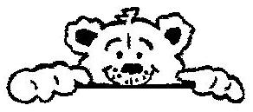

Animals in the setting

Policy statement

Children learn about the natural world, its animals and other living creatures, as part of the Early Years Foundation Stage curriculum. This may include contact with animals, or other living creatures, either in the setting or in visits. We aim to ensure that this is in accordance with sensible hygiene and safety controls.

Procedures
Visits to farms
- Before a visit to a farm a risk assessment is carried out - this may take account of safety factors listed in the farm’s own risk assessment which should be viewed.
- The outings procedure is followed.
- Children wash their hands after contact with animals.
- Outdoor footwear worn to visit farms is cleaned of mud and debris and should not be worn indoors.

Legal framework
- The Management of Health and Safety at Work Regulations 1999
Further guidance
- Health and Safety Regulation…A Short Guide (HSE 2003)
Reviewed on | (date) September 2025
Date to be reviewed next | (date) September 2026
Signed on behalf of the management | H.M.Millson
Name of signatory | Hannah Millson
Role of signatory | Pre-School Manager
Signed on behalf of the committee | G.WALSH
Name of signatory | Gary Walsh
Role of signatory | Chairperson

