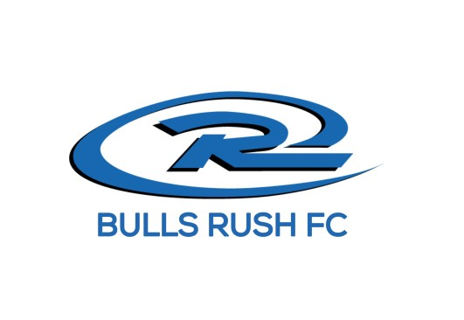
Bulls Rush FC
Payment Policy
Club and Team Fees

Club fees are essential for maintaining and enhancing the quality of our soccer programs. Unlike businesses that aim to generate profit, our primary goal is to ensure that all collected fees are invested directly back into the Club to cover the various expenses associated with delivering the highest quality soccer in the CSRA. The most significant portion of these fees is allocated to coach compensation. In addition to coach compensation, Club fees also cover a variety of other critical expenses. These include league registration fees, State registration fees, facility use expenses, insurance, and training gear for each player.
Team fees are based on budgets tailored to each team, factoring in expected tournaments and travel. Most team expenses are paid early in the season, making timely payments vital. These are paid directly to your Coach or Team Manager. These expenses are always paid in advance, so players that do not pay on time have someone else covering those expenses until payment is made.
Payment Responsibilities
All Club and team fees must be current for any Bulls Rush FC player to club pass or guest play. We understand that situations can cause payment delays, and we are willing to work with you, but this requires communication from your side to the office.
Regardless of whether reminders are sent, it is the family’s responsibility to pay fees by the due dates. This also applies to expired or non-working credit cards. If you need a different payment arrangement, please communicate this to keep your player's account out of delinquent status.
Every effort will be made to keep your player(s) on the field, but if efforts to make payments are not met, the following steps will be taken:
Consequences of Late Payments
- 15 Days Late: You will receive an email reminder. Players cannot participate with other teams as guests or club pass players.
- 30 Days Late: The player will be made ineligible until the account is up to date. Players over 30 days late on Club or team fees may not practice or play with the team.
- End of Season: Any player whose family is not current on payments will be ineligible for end-of-season events, financial assistance, or placement on a team for the next season.
If you have any questions regarding your payment plan or need assistance with making payments, please contact Kim Briggs at (706) 550-2858 or email at bullssoccerkb@gmail.com.

