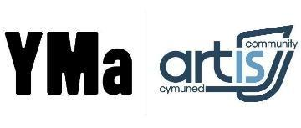
Room Hire Request Form
Contact details:
Group/Organisation
Contact name
Contact email(s)
Postal address
Contact number(s)
Contact for Invoicing: Name / email
Nature of booking |  | Numbers

Room(s):
Moondance  Studio Theatre | Shelley  Hall | Weston Workshop | Rhondda Room | Cynon Room  (MR2) | Taf Room  (select days only) | 1 to 1 room | Elai Room | Y Cwtch  Cafe  (After 5pm)

Days & Times: Dates:
Day(s) | Start time | Finish time |  | Start Date | Finish Date
Monday
Tuesday
Wednesday
Thursday |  |  |  | Dates not required:
Friday
Saturday
Sunday

Additional Information/Room set up:
Do you require teas & coffees? (£1.35 per serving)

How did you hear about Yma?
Social Media Search Engine Newsletter Directory Word of Mouth Other…



