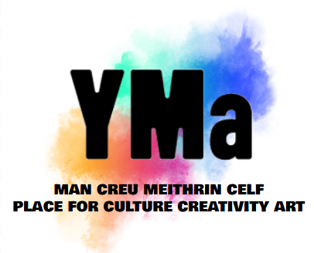

Freelancer Arts & Crafts Tutor Call Out

Rate: £25 - £35 per hour - negotiable.
Job type: Freelancer
Location: YMa Pontypridd.
Hours: Every Tuesday: 4:00 - 5:00pm. With potential to increase classes.

Closing date: December 8th
Informal chat date: Mid December
Start date: Early January 26

To apply: Please send a CV or letter of interest to Linzi Rumph, Development Officer to linzi@artiscommunity.org.uk
This role comes with a probationary/review period of 3 months.

We are seeking a creative and enthusiastic arts and crafts tutor to join our team in delivering an engaging and inclusive weekly arts and crafts sessions to children aged between 6 - 10 years. As a community tutor, you will have the opportunity to share your passion for arts and crafts and make a positive impact on people's lives.
Whilst initial requirements are a Tuesday 4pm-5pm we are looking to expand our arts and crafts program so further opportunities exist subject to your availability.
Responsibilities:
- Plan and deliver art sessions (materials provided)
- Develop and adapt arts and crafts programs to meet the needs of diverse groups
- Provide a safe and supportive learning environment
- Encourage creativity and self-expression
- Assess and evaluate participant progress
Requirements:
- Experience working with community groups or teaching arts and crafts
- Excellent communication and interpersonal skills
- Ability to work flexibly and adapt to changing needs
- Enhanced DBS Check
- Ability to speak Welsh preferable
What we offer:
- Competitive hourly rate
- Opportunities for professional development
- Supportive team environment
- Chance to make a difference in your community
- The opportunity to develop the Arts and Crafts programme with additional classes
If you are passionate about art and crafts and community, we encourage you to apply!

We operate an Equal Opportunities Recruitment Policy and welcome applications from all sections of the community in Welsh or English. We particularly encourage applications from Black, Asian and culturally diverse communities and D/deaf and disabled people, who are currently under-represented within our organisation.

