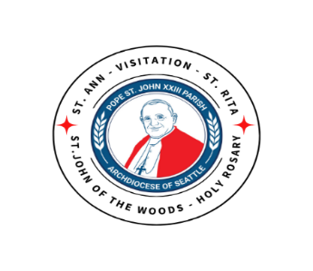

On July 1, 2024, the 136 archdiocesan parishes became 60 parish families, with eight stand-alone parishes under the leadership of a pastor or pastoral coordinator. Through Partners in the Gospel, each parish family is working together to articulate their gifts, their hopes for the future and to set a vision and plan for how they will re-invigorate parish life while continuing to form one new canonical parish.

Parish Family #38 (Pope St. John XXIII) Recap & Update:
At the beginning of the fiscal year in July 2024, the Archdiocese of Seattle brought together the parishes of St. Ann, St. John of the Woods, Visitation, and St. Rita to form Parish Family #38, Pope St. John XXIII (PSJ23) parish. In addition to these churches, Pope St. John XXIII STEM Academy is also part of our parish family. Fr. Tuan Nguyen was appointed Pastor of our parish family, and Fr. Hendry Arockiasamy serves as Parochial Vicar.

We as PSJ23 parishioners are encouraged to strengthen our unity by attending Masses and participating in events across all the churches. We have already been sharing resources where possible such as the bulletin, website, Facebook page and parish calendar.

Over the past year our clergy, staff, and church communities have been growing together as one family in faith, continuing to know one another as one parish family. Fr Tuan has been eager to have a long-range plan for our parish that will guide us in furthering our unity and to set a vision and plan for how we will re-invigorate parish life. We are using some of the tools in Partners of the Gospel to assist us. Using some of these resources, in January Father formed the Parish Family Advisory Council (PFAC) composed of representatives from all four churches
to assist him, working with the parish-wide Pastoral Council and Finance Council and parishioners in developing this plan. Some of the Parish staff leaders have been organized into a single Parish Family Leadership Team (PFLT).

The PFAC’s work up to this point: conducted the Demographic survey in September and continued with Brainstorm sessions in November to answer, “What are our gifts?” In early 2026, PFAC will share the results of those sessions with our church communities. Additionally, we will share important information regarding the metrics and viability of our church buildings and ministries.

As with all that we do, we are grounded in prayer focused on being open to what Christ is calling us to be – faith-filled People of God placing our trust and Love in Him.

