One Parish Plan – Building our Future Together

Partners in the Gospel’s One Parish Plan is a comprehensive, strategic initiative designed to guide parish families over the next one to five years. Pope St. John XXIII Parish Family has been one parish family since July 1, 2022. We are using various Partners’ resources to further our efforts in working toward the shared goal of creating a sustainable and thriving parish family. At its core, the process focuses on discerning and responding to God’s call for our community, seeking to understand who we are meant to be and how we can accomplish that purpose.

To develop thoughtful and realistic Action Items, it is essential we have a clear understanding of our present circumstances. The Parish Family Advisory Council (PFAC), in collaboration with Fr. Tuan, Fr. Hendry, and the Staff Leadership Team has compiled the State of the Parish Family Report. This report draws on information from diocesan reports and our own parish records to provide detailed data about our community. The following are specific highlights from that report. The report can be found on the Pope St. John XXIII webpage under the “button” One Parish Family.

1. Evangelization – How do we continue to welcome people into our parish family?
Archdiocese Goal – reach out to our community to grow parishioner registration and receive sacraments.
In 2024-2025, our parish family had 262 people receive Baptism, First Communion, and/or Confirmation. We had 247 individuals participating in Faith Formation and preparing for initiation into the Catholic faith.

As of April 2026, our parish family has 1,221 registered families. This is a 2.69% registration increase since the end of the year 2025.

2. Worship Space – How can we utilize our current church locations (worship spaces) better?
Archdiocese Goal – Each worship space should be at 50% to 80% capacity.

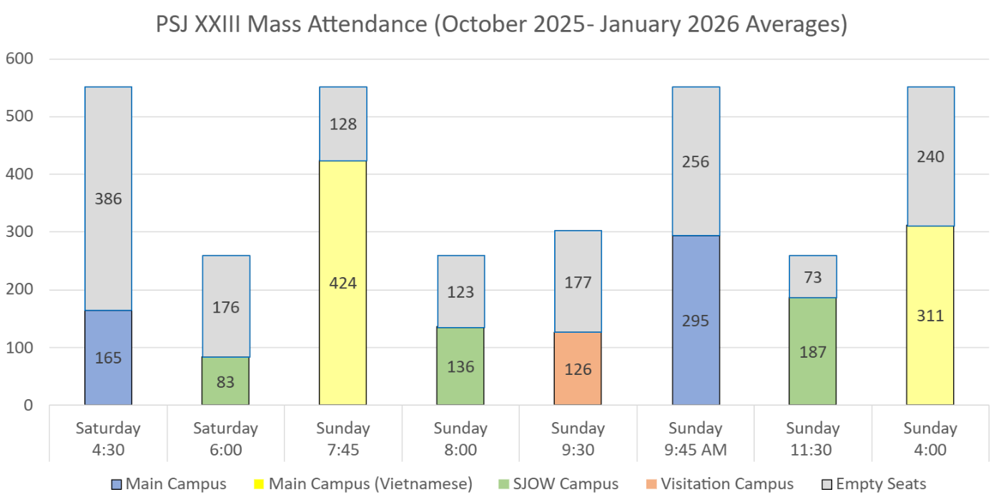
3. Weekend Mass Attendance – Action Plan: identify how to modify the Weekend Mass schedules to create a sustainable plan and to relieve our priests of overload.
Archdiocese Goal – Priests should preside at no more than 3 weekend Masses. (Currently, due to pastoral necessity, Archbishop Etienne gave permission per canon law to extend this to 4 Masses per weekend.)

4. Finances – the overall health of our financial picture.
Action Plan – generate a plan to combine finances of all five locations.
Archdiocese Goals – see each section below

Parish Debt:
As of June 30, 2025, our parish family carries a total debt of $449,415. This amount includes a loan that is accruing interest. The loan was originally contracted by Holy Rosary through the diocese before the 5-parish merger that took place in 2022.
Archdiocese Goal: Parish families should plan to reduce debt.

Parish Revolving Funds (PRF), these are our saving accounts:
As of June 30, 2025, our parish family had $2,181,146 in our PRF accounts which is 4.6% of the insured value of our buildings. This total includes unrestricted funds (money we can transfer to our checking account if needed to pay expense) and restricted funds (money earmarked for other purposes). The PRF savings account (money we can use for expenses) is $1,373,505.
Archdiocese Goal - Percentage to insured value of building > 6%. To reach that goal, we need to add $669,900 to the Parish Family Saving account (PRF).

Parish Revenue, as of June 30, 2025:
- Ordinary Income is revenue from Sunday and Holy Day collections and online giving. Our parish family’s Ordinary Income is $1,035,560.
- Total Parish Revenue includes Ordinary Income plus rental income, special bequests, and other sources. Our parish family’s Total Revenue is $1,574,720.
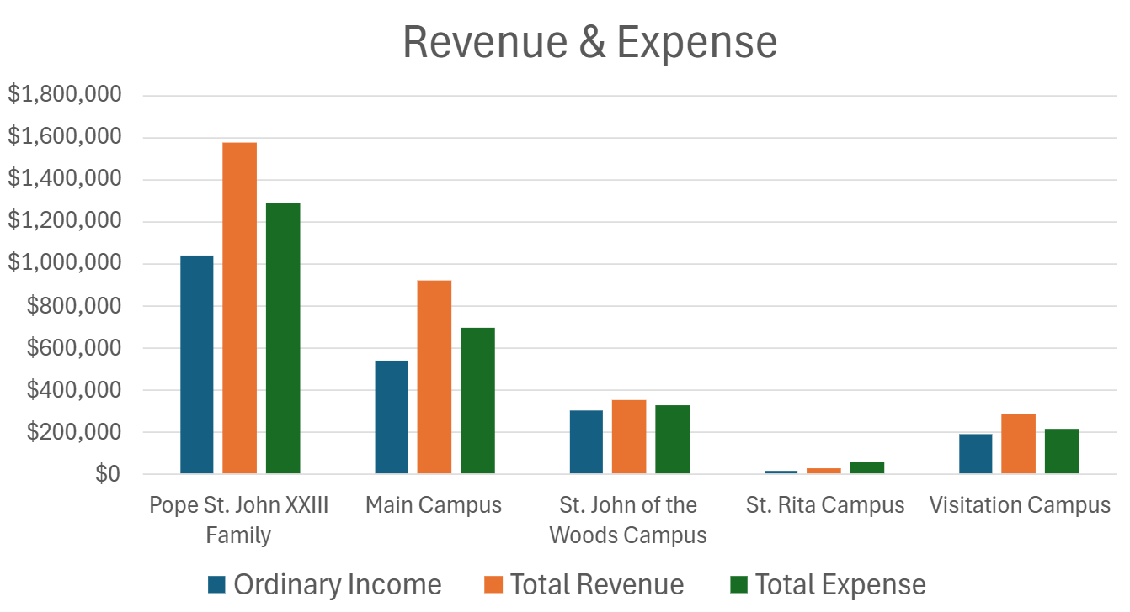
Archdiocese Goal: Ordinary Income should cover Total Expenses
Archdiocese Goal: Ideally the parish expenses should be less than Ordinary Income. Our Expenses are $248,650 more than our Ordinary Income (Sunday/Holy Day collections and online giving).

Breakdown by campus: the numbers are from our fiscal year ending June 30, 2025
Financial Viability | Pope St. John XXIII | Main Campus | St. John of the Woods Campus | St. Rita  Campus | Visitation  Campus
Debt – Holy Rosary  Target = reduce debt | $449,415 | $162,825
PRF (Savings):  Restricted and unrestricted funds  Unrestricted funds  Target = a PRF balance sufficient to reach the PRF insured value ratio | $2,181,146  $1,373,505 | $1,206,783  $639,658 | $497,845  $313,068 | $228,454  $228,454 | $248,064  $192,325
Ordinary Income  Target = greater than $1.0M | $1,035,560 | $536,910 | $297,620 | $15,910 | $185,120
Total Revenue  Target = greater than 1.2M | $1,574,720 | $919,870 | $347,470 | $25,350 | $282,030
Total Parish Expense  Target = less than Ordinary Income | $1,284,210 | $690,420 | $327,700 | $53,570 | $212,520
Our parish PSJXXIII depends on our generous contributions to support our various sacramental programs and ministries. What can we do to increase Ordinary Income and Saving account funds and decrease Expenses?

5. Buildings – How are our buildings doing?
As of October 2024, our parish family has 4 buildings in “Black” status which means that they should be evaluated. We have 7 buildings in the “Red” status which means that critical repairs may be needed. Action Plan – conduct reassessment of buildings.
Archdiocese Goal - No buildings should be in black or red status.

Building Data | Pope St. John XXIII  (includes STEM) | Main Campus | St. John of the Woods  Campus | St. Rita  Campus | Visitation  Campus | PSJXXIII STEM Academy @ Vis Campus
Black Status –  Target = 0 | 6 | 3 | 0 | 0 | 2 | 1
Red Status –  Target = 0 | 6 | 1 | 1 | 2 | 0 | 2
Yellow Status –  No set target | 2 | 0 | 2 | 0 | 0 | 0
Green Status –  No set target | 0 | 0 | 0 | 0 | 0 | 0
Insured Value of Buildings | $47,892,435 | $19,170,330 | $5,600,800 | $3,160,200 | $19,961,100 | Included in Vis Total

Building Key:
What does the color status mean -
Building in Black – likely unrepairable without extreme investments
Building in Red – requires major repairs
Building in Yellow – requires some repairs but not at risk of entering Black status
Building in Green - well-maintained building with ongoing maintenance

Location of Buildings:
Black buildings: Main Campus: Church, Classroom, and Office; Visitation: Church, Rectory, and Hall (used by STEM and by church for coffee hour)

Red buildings: Main Campus: Rectory; St. John of the Woods: Rectory; St. Rita: Church and Rectory; STEM: School and Collier (ELC for school)

Yellow buildings: St. John of the Woods: Church and Hall

Several of our buildings have had different levels of repair/maintenance since the diocese’s assessments. For example, the school has made several upgrades in the past 2-3 years. These statuses may change when a reassessment is made.

6. Staffing
Archdiocese Goal – The One Parish Plan needs to demonstrate sufficient staffing capacity to meet the needs of the parish in Administration, Faith Formation and Facility roles.
Currently we are understaffed. We are discerning the needs of our parish family to determine what additional staffing needs are required. To view the current parish family staff, go to our website at psj23.org, click on the About Us button. Scroll down and click on Staff.

Questions:
If you have questions, please submit them to: psj23parish@psj23.org.
We will gather and publish both the questions and the answers once we have compiled all the information.

