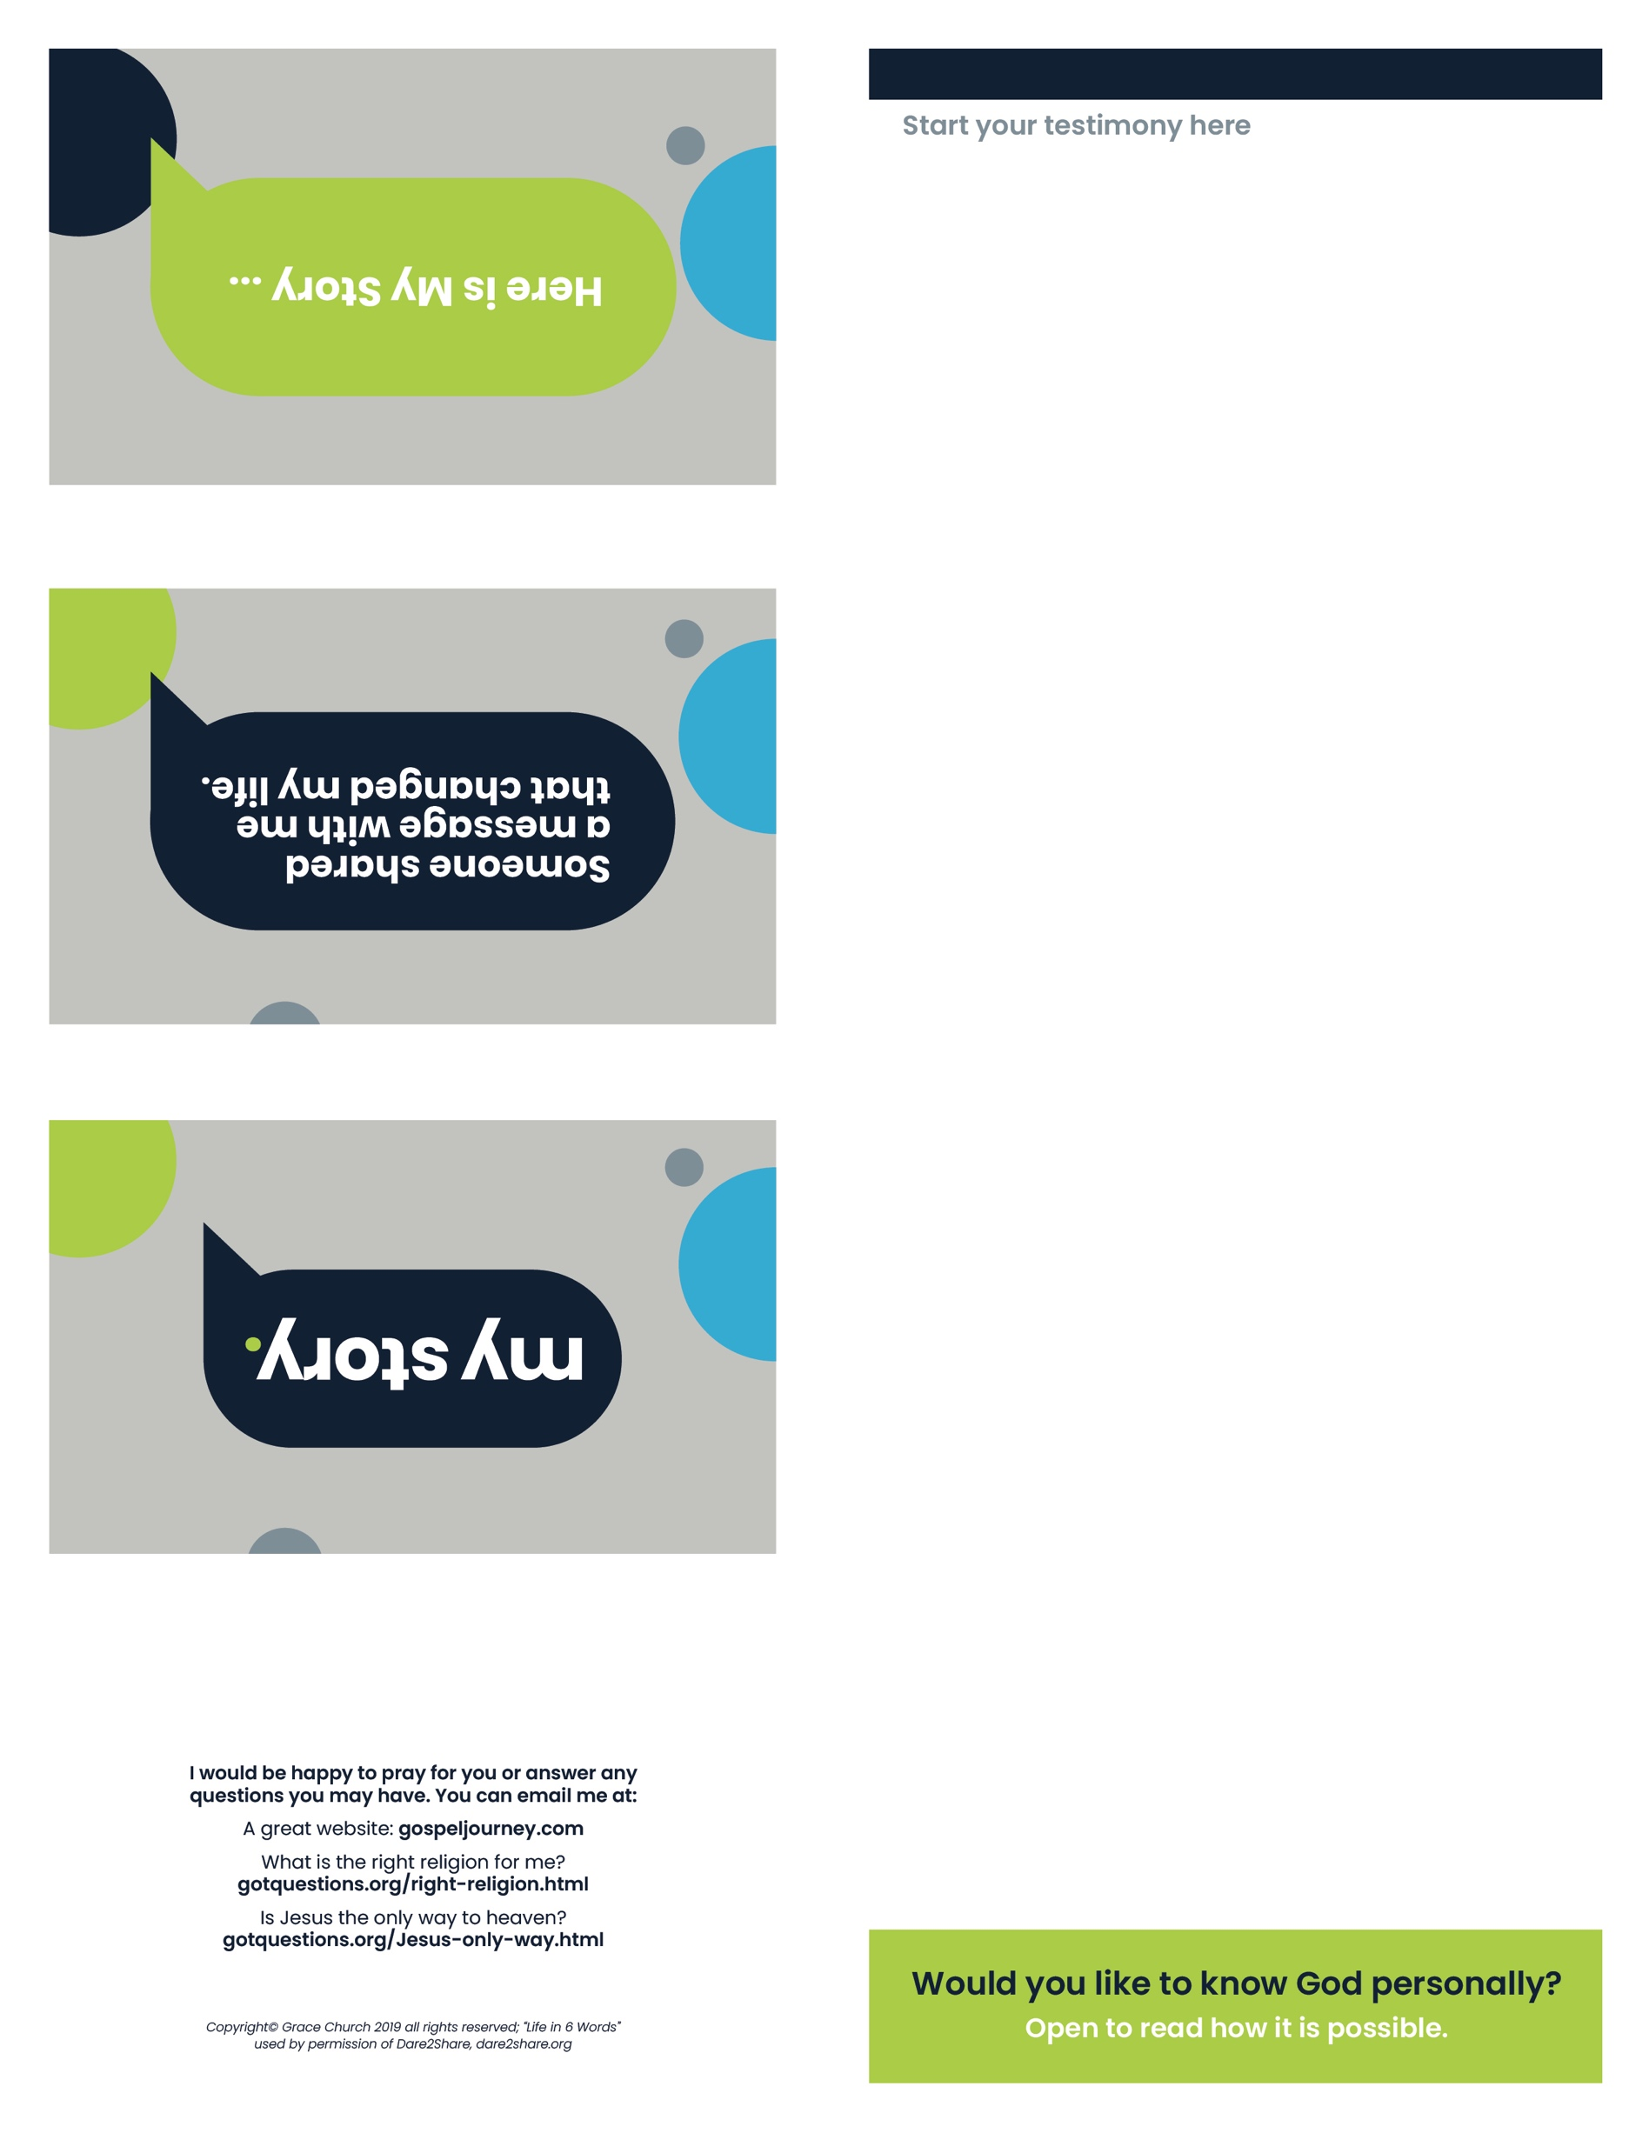

Knowing God Personally
KnowGod.com
Lifein6Words.com

Questions
EveryPerson.com
Got Questions.org
Growing in Your Faith
Step 1-SomethingAmazing.net
Step2 -StartingWithGod.com
Step3 -MovingCloser.org

Bible Apps
Bible.com (with plans & devos)
Bible.is (in many languages)
I would be happy to pray for you or answer any questions you may have.
Email Here
Website Here

