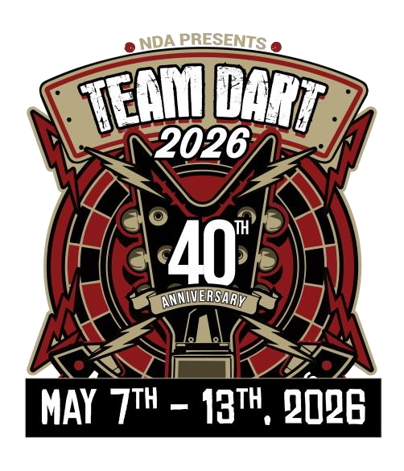

Team Dart Las
Vegas Playoffs
2026
Feb 27 & 28, 2026 @ Legends
Sports Bar & Pub
W Main St Shelby, OH
63
44875
Friday starts at 7pm sharp!
Saturday starts at 10am sharp!
Teams must be registered by
Feb 01, 2026 4pm.
Qualifying Teams
must
have played Fall 2025 and
be playing Winter 2026
session on either
Monday
Travel, Wed Remote or
Friday remote teams
. Only 1
sub allowed per team and
all players must have 96
games by 2/26/26. All
players must have signed
Vegas Contract to
participate. Teams will not
be allowed to split the win.
Winning teams receive 4
paid flights, 1 paid hotel
room and paid entry into
Team 01 and Team Cricket
event at Team Dart 2026
Las Vegas

