
Resort and Second-Home Property Specialist (RSPS)

Resort and Second-Home Property Specialist (RSPS)
I would like to share and bring to your attention that I am nationally certified Resort and Second-Home Property Specialist.

What is it?
This certification is for REALTORS® who specialize in buying, selling, or management of properties for investment, development, retirement, or second homes in resort, recreational, and/or vacation destinations. By earning this certification I have demonstrated the expertise in the second home and resort market.

What does it mean to be an RSPS?
RSPS is recognized as an official NAR Certification, and allows buyers and sellers to have confidence in my ability of a REALTOR® who specializes in buying, selling or management of properties for investment, development, retirement, or second homes in a resort, recreational and/or vacation destination, to assist them with their search.


Why this is important?
The resort and second-home market in South Padre Island, TX differs in a number of ways from primary residential market. Buyer interest ranges from small, rustic getaways to luxury properties. It often includes an international clientele and the investment and retirement markets.
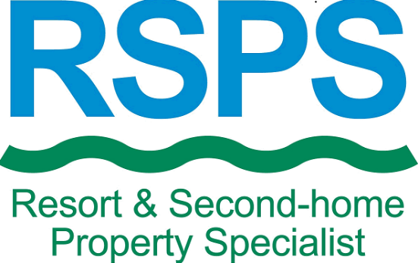
As a result buying, selling, or managing second homes in a resort, recreational, and/or vacation destination requires understanding of:
- the recreation and lifestyle market
- tax treatment of vacation and second homes
- real estate investments
This certification allowed me to receive specialized training , skills and knowledge that are needed in this niche to successfully help buyers and sellers on their investments.
Purchasing an investment property or second home is usually more complex transaction. Therefore, you should ensure that your Realtor® has adequate knowledge and certification like RSPS.

Contact Me
Contact me today via email, contact form or 956-500-0507 to discuss your investment property or second home in South Padre Island, TX. If you own a property in South Padre Island, TX please contact me to receive FREE market analysis.


