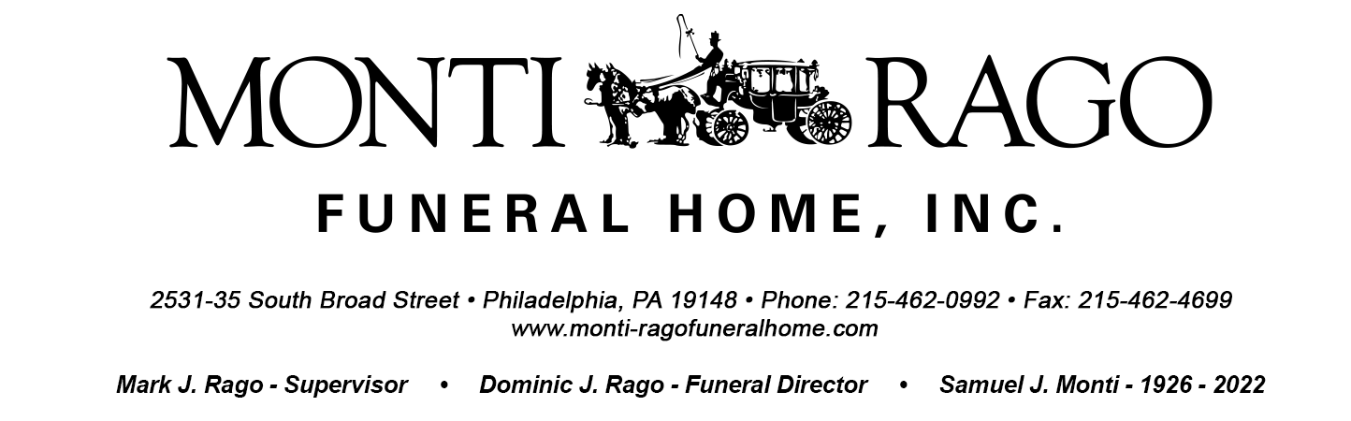
Number of Death Certificates Needed:_________________

1. Decedent’s Legal Name______________________________________________________________________________

1a. Social Security Number____________________________________________________________________________

2. Sex_________ 3. Date of Death_______________________ 4. Age___________ 5. Date of Birth___________________________

6. Place of Birth (City and State)________________________________ 7. Place of Birth (County)____________________________

8. Decedent’s Address______________________________________________________________________________________________

9. Was decedent in the U.S. Armed Forces? (Circle one) YES or NO 10. Branch Served________________________________

11. Marital Status (Circle one): MARRIED WIDOWED DIVORCED NEVER MARRIED UNKNOWN

12. Name of Surviving Spouse_________________________________________________________________

13. Father’s name_____________________________________ 14. Mother’s name (First, Maiden)___________________________________

15. Informant’s Name__________________________________________________________________

16. Informant’s Relationship_____________________________________________

17. Informant’s Address____________________________________________________________________________________________

17a. Informant / Family Email Address______________________________________________________________________

18. Informant’s Telephone Number(s)______________________________________________________________________

19. Place of Death______________________________________________________________________________________

20. City, State and Zip of Death__________________________________________ 21. County of Death___________________________
Name of Doctor: _________________________________ Phone Number of Doctor: _____________________________________

Name of Hospice: ______________________________________ Phone Number of Hospice: __________________________________

22. Decedent’s Education _____________________________________________________________________

23. Decedent’s Occupation______________________________________________________

24. Kind of Business/Industry__________________________________________________

25. Last Place of Employment (FOR NJ DC ONLY)______________________________________________________________________

26. Method of Disposition (Circle one): BURIAL ENTOMBMENT CREMATION DONATION

27. Place of Disposition_________________________________________________________________________________________

28. Section____________ Range____________ Lot___________ Grave___________ Owner_____________________________________

29. Prayer Card Selected__________________________________ 30. Prayer(s) Selected____________________________________________

