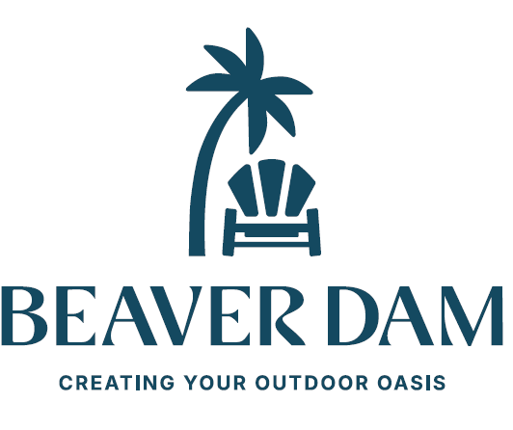
Fabric Colors
(Solid Colors)

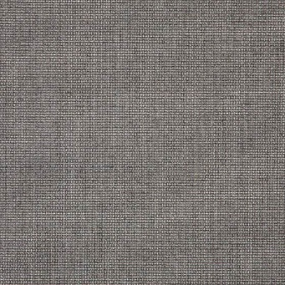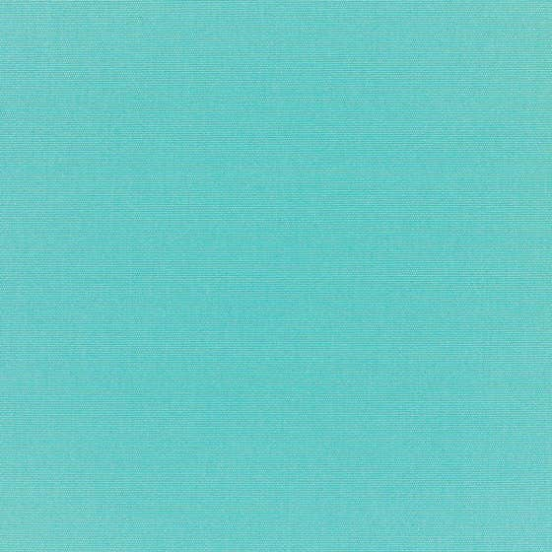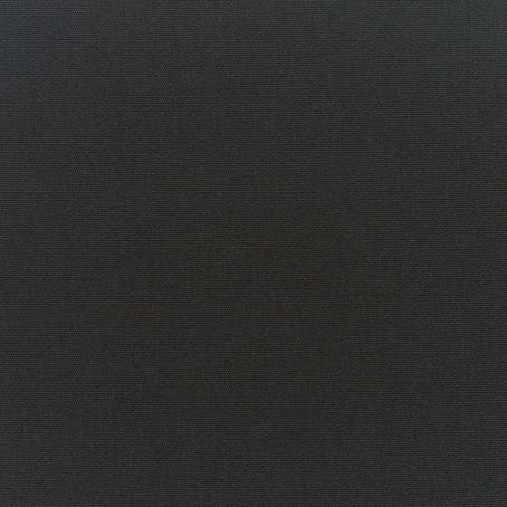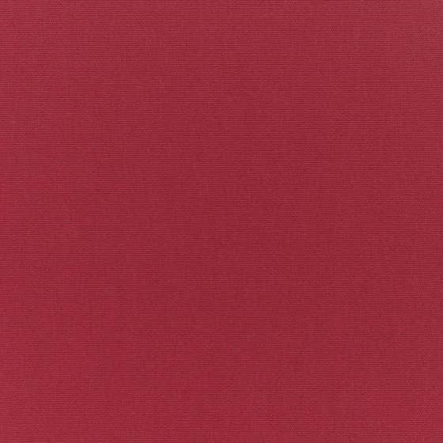
Bliss Smoke Canvas Aruba Canvas Black Canvas Burgundy

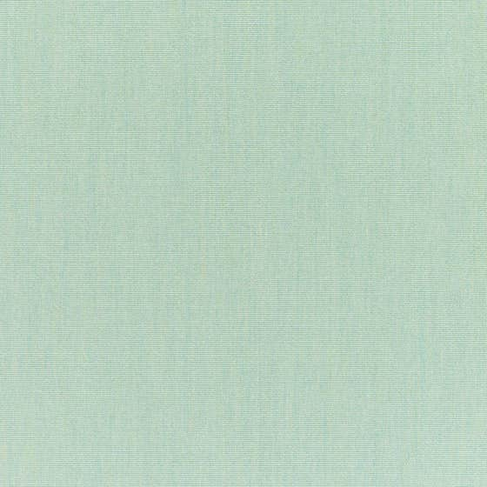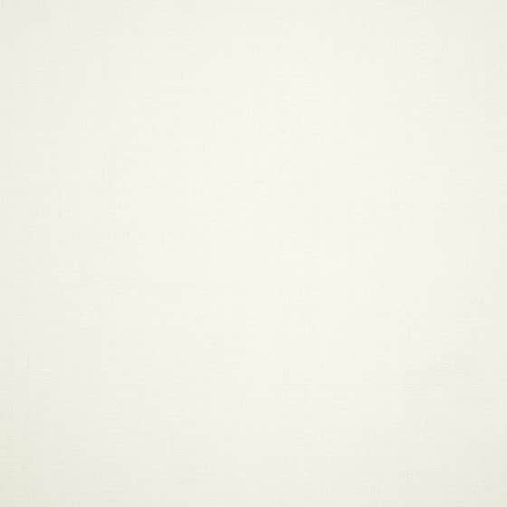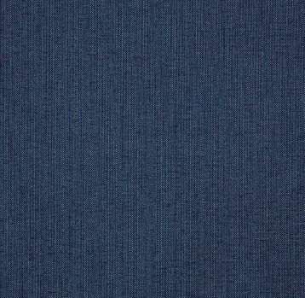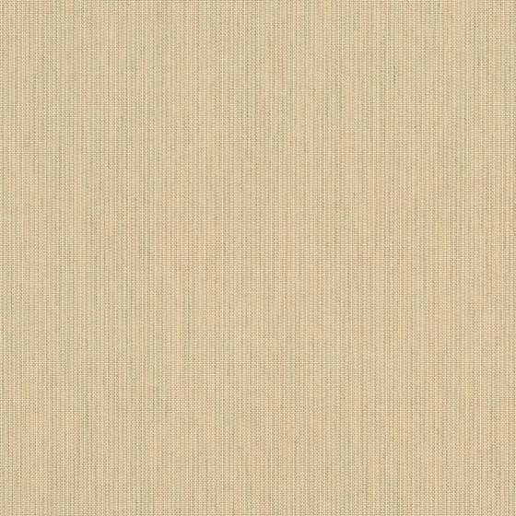
Canvas Spa Canvas White Spectrum Indigo Spectrum Sand

(Striped Colors)
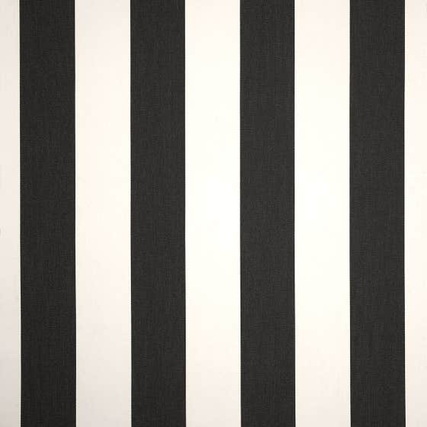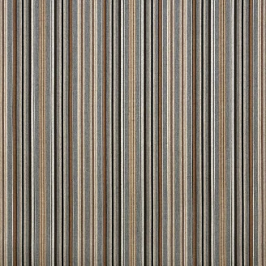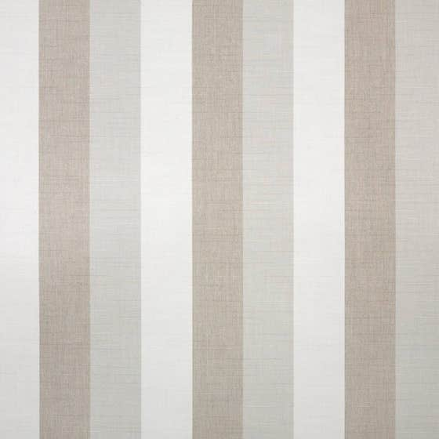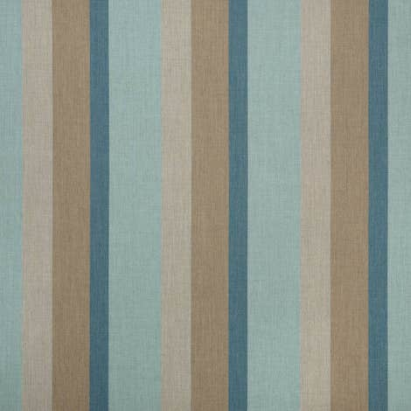
Cabana Classic Cultivate Stone Direction Linen Gateway Mist

 See more colors on www.sunbrella.com Cushion Specs: Poly Urethane Foam with 2.5 lb. Density & 35 lb. ILV
NOTE: Any colors chosen that are not on this chart will have a $45 surcharge per set which includes one seat bottom & one back!!

