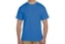
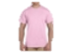

T-Shirts For Sale
Women’s (pink)
and
Men’s (blue)

M, L and XL - $10.00

XXL and XXXL - $12.00

Purchase in the office

