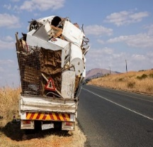
Scrap Man Guidelines 2024

Items he WILL accept:
- Tires on rims Metal bed frames
- Grills Bicycles
- Lawn Mowers Propane tanks
- Copper tubing or wiring Appliances
- Metal & aluminum doors Aluminum
- Metal or aluminum patio sets
- Aluminum window frames (can leave glass in the window)
- Car parts Batteries
- Old golf carts Metal fire pits
- Metal wheelbarrows Metal wagons
- Metal shelving
- Lamps, florescent lights
Items NOT ACCEPTED:
- Mattresses Wooden chairs
- Living room chairs, couches
- Paint cans Tires off rims
- Shingles

Cardboard and plastic items are to be placed into the regular recycle bin.
LARGE ITEMS
If you have a large item that you can’t get to the trailer next to the brush pile, put your information on the list in the clubhouse for a pickup.
If you are not sure if something is acceptable, get in touch with Ed
Thank you for your items,
Walter Woolever

