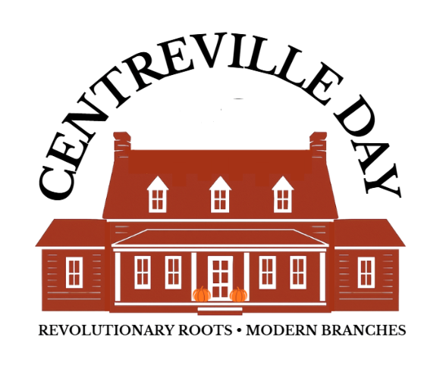
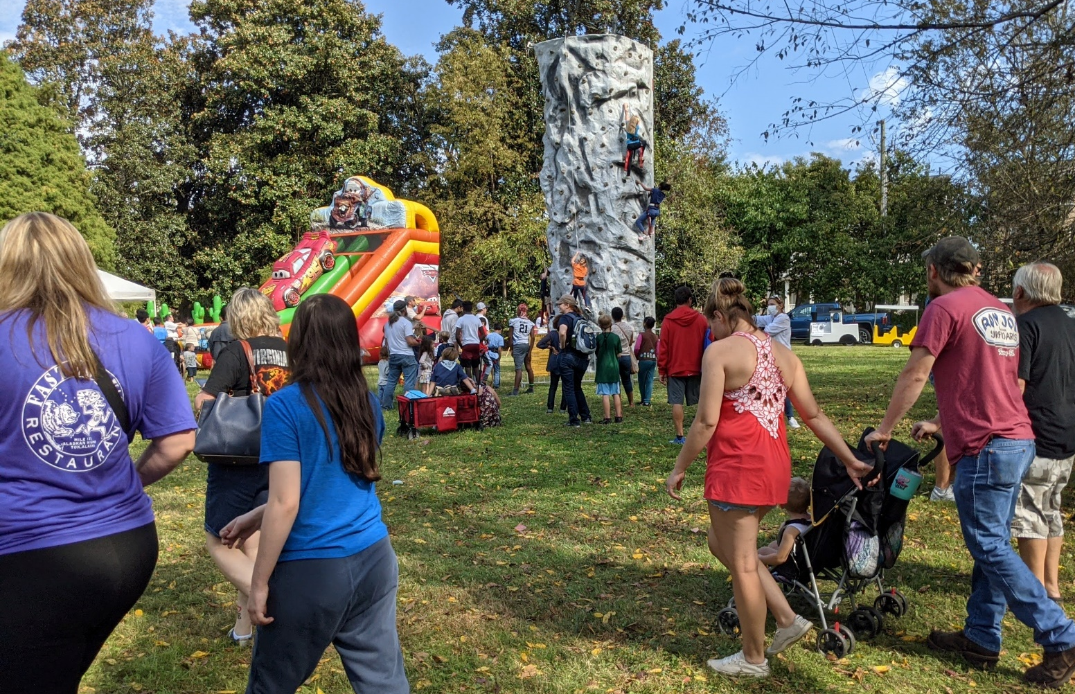
WWW.CENTREVILLEDAY.ORG
Friends of Historic Centreville
2026
Centreville Day
Sponsorship
Opportunities
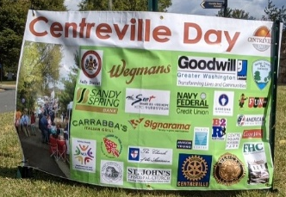
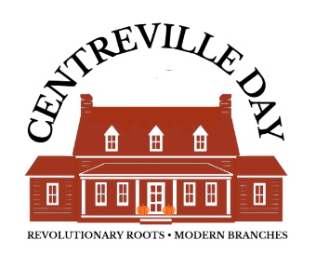
The first Centreville Day was held on July 4, 1992, as a celebration of the 200th anniversary of the chartering of Centreville in 1792. This year we are proud to celebrate the 34th Annual Centreville Day and 234 years of community.
Be a community leader. Support your community - make new friends - meet new clients! Help us create a one-day, family-friendly festival that celebrates Centreville’s rich history and cultural diversity, & supports Historic Centreville Park. Located in the heart of the Centreville Historic District, the event attracts 3000 people and is organized by the Friends of Historic Centreville in partnership with the Fairfax County Park Authority. Proceeds benefit the Friends of Historic Centreville, a 501(c)(3) non-profit.

What: 34th ANNUAL CENTREVILLE DAY 2026
When: SATURDAY, OCTOBER 17, 2026 (No rain date!)
Where: HISTORIC CENTREVILLE PARK & HISTORIC DISTRICT
(near intersections of Routes 28, 29 and I-66)

Attendance: 3,000⁺ (more in great weather)
Contact: Cheryl at centrevilleFHC@gmail.com
Websites: www.HistoricCentrevilleVA.com;
& Find us on Facebook at Centreville Day
Who Organizes: The Friends of Historic Centreville, Inc.

Admission: FREE
Parking: FREE
Honoring: 250th ANNIVERSARY activities
Features: *AMERICAN LEGION PARADE* *ROTARY PETS in the PARK* *ECO EXPO* *COMMUNITY SAFETY EXPO* *MARKETPLACE with LOCAL BUSINESSES, CHURCHES, CRAFTS, and NONPROFITS* *PET VILLAGE* *ZEN ZONE* *LIVE LOCAL ENTERTAINMENT* *FOOD COURT* *FREE HISTORY TRAIN* *CHILDREN’S TRICK or TREAT TRAIL* *FREE CHILDREN’S RIDES* *HANDS ON HISTORICAL ACTIVITIES & CRAFTS* *HISTORICAL TOURS*
SPONSORSHIP LEVELS

WHY YOU SHOULD SPONSOR CENTREVILLE DAY :

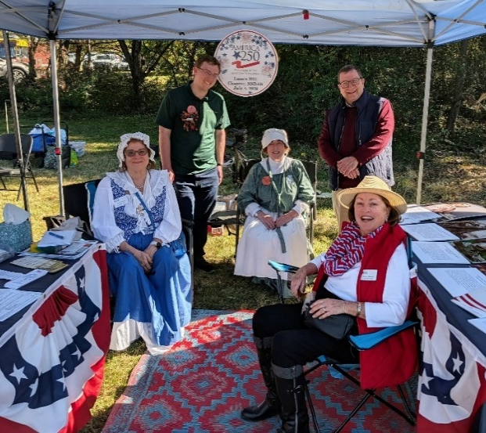
- Premium placement in Centreville Day’s high volume locations to meet and greet your clientele

- Showcase your leadership and community support

- Collaborate with other leaders to a maintain a community-building tradition

- Support an inclusive and equitable event open to all

Sons & Daughters of the American Revolution

Sponsors are located in Centreville Day’s Main Marketplace, Eco Expo, Safety Expo, or Mount Gilead Lawn. Centreville Day features a diverse mix of business exhibitors, non-profit organizations, crafters and retailers.

All Centreville Day sponsors are welcome to participate in the “Trick or Treat Trail” and give away treats or provide activities for children.

Sponsors may also reserve a place in the American Legion Centreville Day Parade or participate in the Rotary Club Pets On Stage pageant and other activities.

Spaces at Centreville Day are exactly that: a 10 by 10 space without furnishings or electricity. This allows each sponsor to customize their space to suit their needs and branding. However, we are happy to provide a canopy, table and two chairs to you upon request.

Our best measure of success is the number of returning sponsors and business exhibitors each year who tell us that Centreville Day is a productive event they want to support again.

Sponsorships begin at the modest $300 for the Business Level.

The goals of Centreville Day are:

To celebrate Centreville’s rich history, cultural diversity, and vibrant business community.
To be an inclusive event without significant cost barriers.
To build and support community networks through collaboration.
To raise funds for the Friends of Historic Centreville (FHC), a non-profit 501(c)(3) charity, and its mission to support Historic Centreville Park and preserve Western Fairfax historic resources.
Presenting Sponsor (limit 1) $10,000
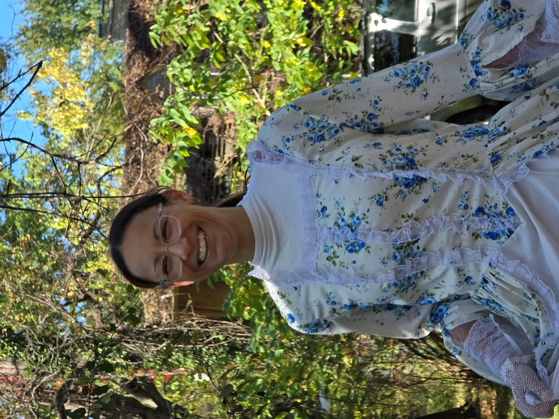
- Recognition as Honorary “Mayor of Centreville” at Opening Ceremony with faux keys to the city, and sponsor’s plaque
- Logo on entryways (2)
- Up to two 10’x10’ exhibition spaces in preferred location
- Full page acknowledgement in program.
- Logo on Centreville Day posters and sponsor’s banner.
- Linked logo on Centreville Day website.
- Company name associated with mention of event (e.g., “Centreville Day sponsored by Your Company Name”) in press releases.

250th on the Lawn (limit 1) $7000 - $10,000

A unique oppportunity to celebrate our nation’s 250th Birthday in our own town of Centreville, where George Washington frequently stopped when traveling from Mount Vernon.

- Exclusive banner on lawn with logo;
- Up to two 10’x10’ exhibition spaces on lawn
- Full page acknowledgement in program;
- Logo on Centreville Day posters and sponsors’ banner;
- Linked logo on Centreville Day website;
- Prominent recognition during opening ceremonies with presentation of appreciation certificate;
- Logo or company name in press releases.
- Additonal marketing targeted for Lawn area
- Upgrade possibilites include adding History Trail sponsorship and/or Stage sponsorship
- For more information, email Cheryl Repetti at centrevilleFHC@gmail.com.
Children’s Area Sponsor (limit 1) $5,000
- Exclusive banner with company logo at location of children’s area with rides.
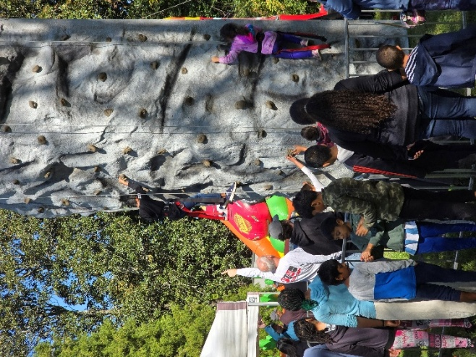

- Up to two 10’x10’ exhibition spaces at Centreville Day in location opposite children’s rides
- Full page acknowledgement in program.
- Logo on Centreville Day posters and sponsor’s banner.
- Company name associated with mention of free children’s rides (e.g., “free children’s rides courtesy of Your Company”) in press releases, flyers
- Linked logo on Centreville Day website.
- Prominent recognition during opening ceremonies with presentation of appreciation certificate.

Gold Sponsor (limit 1) $5,000

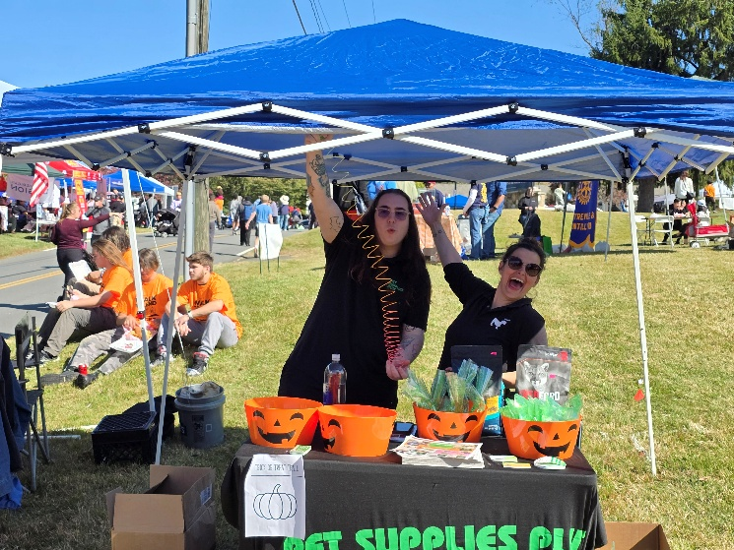
- Prominent placement of company logo on entry banners, website, and flyers.
- Company name associated with mention of Centreville Day (e.g., “Your Company, Centreville Day Gold Sponsor”) in press releases.
- Up to three 10’x10’ exhibition spaces at Centreville Day Marketplace
• Full page acknowledgement in program.
• Linked logo on Centreville Day website.
• Recognition during opening ceremonies with presentation of appreciation certificate.

Centreville Day Stage Sponsor (limit 1) $2500
- Exclusive banner with company logo at stage.
- Up to two 10’x10’ exhibition spaces at Centreville Day in preferred location
- Half page acknowledgement in program.
- Logo on Centreville Day posters and sponsor’s banner.
- Linked logo on Centreville Day website.
- Recognition during opening ceremonies with presentation of appreciation certificate.
- Company name associated with mention of stage (e.g., “Your Company Name Stage at Centreville Day”) in press releases.

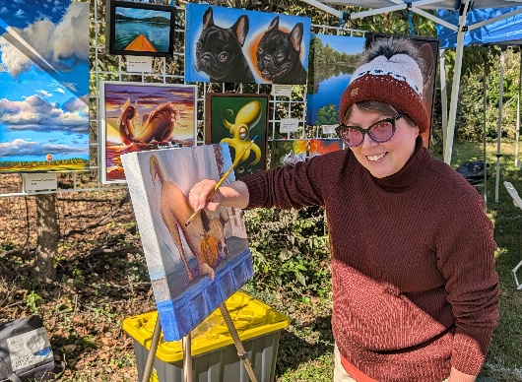
Pop-Up Artists (limit 1) $2000
Support up to five local artists who will demonstrate their artistic talents at historic sites around the venue using the natural and historic surroundings of Centreville Day. Artists will complement other activities honoring the 250th Celebration and Historic Trails.

- Exclusive signage with logo at the site of each artist.
- Up to two 10 x 10 exhibition spaces in a premiere location
Pop-up artist Rebekah Keener
- Half page acknowledgement in program

- Logo on Centreville Day posters and sponsor’s banner.
- Linked logo on Centreville Day website.
- Canopy, 6’ table, 2 chairs upon request.
- Recognition during Opening Ceremony with presentation of appreciation certificate.
- Company name associated with mention of “Pop-Up Artists” (e.g., “‘Pop-Up Artists’ sponsored by Your Company”) in press releases and social media posts.

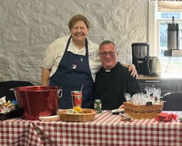
Hospitality Food Court Sponsor (limit 1) $1800

The Hospitality Sponsor is a unique opportunity to stand out at Centreville Day.

- Exclusive logo on table runners and on napkin dispensers on all food court tables
- Opportunity to place your staff as food court hosts*
- Opportunity to place literature within the food court
- Up to two 10 x 10 exhibition spaces
- Half page acknowledgement in program.
- Logo on Centreville Day posters, and sponsor’s banner.
- Linked logo on Centreville Day website.
- Recognition during opening ceremonies with presentation of appreciation certificate.
- Company name associated with mention of the food court (e.g., “the Your Company Food Court at Centreville Day”) in press releases, programs, etc.
*Hosts are welcome to wear branded aprons/clothing, meet and greet people in the food court, facilitate cleaning tables, replenish supplies, and point out your Marketplace space. They may not conduct sales, gather customer data, or prostylize.

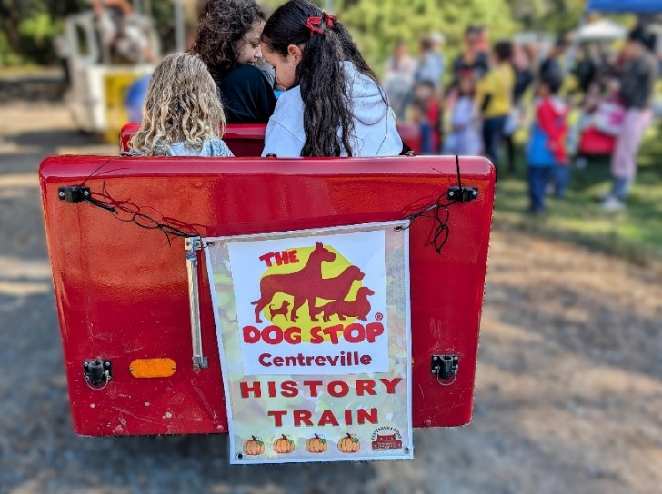
History Train Sponsor
(limit 1) $1,500
- Exclusive banner on FCPA History Train that runs through venue.
- Up to two 10’x10’ exhibition spaces at Centreville Day in preferred location
- Half page acknowledgement in program.
- Logo on Centreville Day posters, and sponsor’s banner.
- Linked logo on Centreville Day website.
- Recognition during opening ceremonies with presentation of appreciation certificate.
- Company name associated with mention of History Train rides (e.g., “free History Train rides courtesy of Your Company”) in press releases.
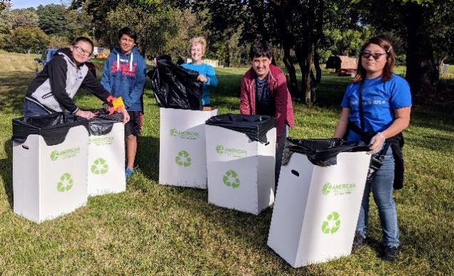
Eco Expo Sponsor
Be a Community Leader in Recycling & Sustainability Education!

(limit 1) $1500

- Be a visible leader in recycling education, exclusive banner at the Eco Expo
- Two 10’x10’ exhibition spaces
- Half page acknowledgement in program.
- Linked logo on Centreville Day website.
- Logo on Centreville Day posters, website, and sponsor’s banner
- Company name associated with mention of Eco Expo
- Recognition during opening ceremonies with presentation of appreciation certificate.

Safety Expo Sponsor (limit 1) $1500
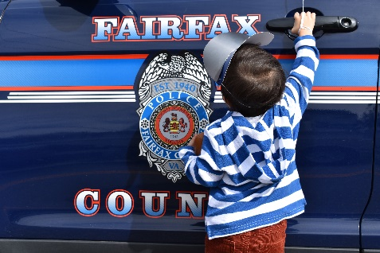
Support Our First Responders
- Recognition for providing lunch for first-responders working to keep everyone safe at Centreville Day
- Prominent place in parade
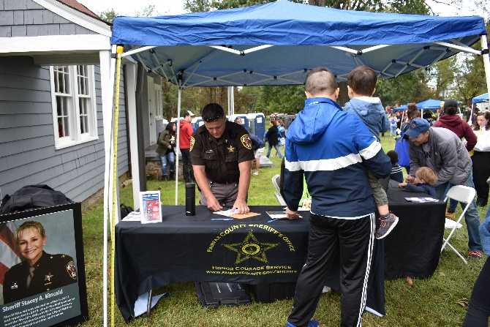
- Exclusive banner with company logo at location of Safety Expo
- Two 10’x10’ exhibition spaces at Centreville Day in Safety Expo area
- Half page acknowledgement in program.
- Logo on Centreville Day posters and sponsor’s banner.
- Company name associated with mention of Safety Expo (e.g., “Safety Expo courtesy of Your Company”) in press releases.
- Linked logo on Centreville Day website.
- Recognition during opening ceremonies with presentation of appreciation certificate.

Pets in the Park: The Village (limit 1) $1500

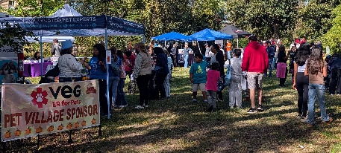
We’re excited to have the second year expansion of Pets in the Park with the vibrant Pet Village! The Pet Village features pet-centered businesses, activities, & non-profits that connect pets to their forever homes and improve awareness of animal welfare issues.

- Exclusive banner with logo at the Pets in the Park: The Village area.
- Up to two 10’x10’ exhibition spaces at Centreville Day in The Village.
- Half page acknowledgement in program.
- Logo on Centreville Day posters and sponsor’s banner.
- Linked logo on Centreville Day website.
- Recognition during Opening Ceremony with presentation of appreciation certificate.
- Company name associated with mention of Pets in the Park: The Village (e.g., Pets in the Park: The Village sponsored by Your Company”) in press releases and social media posts.

History Trail (limit 1) $1500
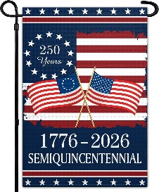
Help to support Centreville Day’s salute to the 250th anniversary of the American Revolution. The History Trail is a fun scavenger hunt featuring 5 historic sites from the 1700s to the 20th century within the Centreville Historic District. Content is divided so that adults and children can participate at their own levels. Participants who participate are given an award.

- Logo on History Trail map
- Up to two 10’x10’ exhibition spaces at Centreville Day Lawn or Marketplace
- Half page acknowledgement in program.
- Logo on Centreville Day posters and sponsor’s banner.
- Linked logo on Centreville Day website.
- Recognition during Opening Ceremony with presentation of appreciation certificate.
- Company name associated with mention of the History Trail (e.g., “History Trail sponsored by Your Company”) in press releases and social media posts.
- Add your company swag to the History Trail reward.

Silver Sponsors (limit 3) $1000
- Up to two 10’x10’ exhibition spaces at Centreville Day
- Half page acknowledgement in program.
- Logo on Centreville Day posters and sponsors’ banner.
- Linked logo on Centreville Day website.
- Recognition during opening ceremonies with presentation of appreciation certificate.
- Optional opportunity: Select a specific area in the event to sponsor, such as the Zen Zone, Recycling Art Creations, or 1776 Skills Make ‘n’ Take.
Bronze Sponsors $500
- One 10’x10’ exhibition space at Centreville Day in preferred locations
- Quarter page acknowledgement in program.
- Logo on Centreville Day posters and sponsors’ banner.
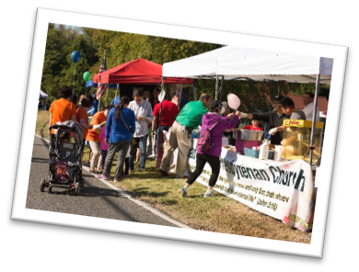
- Recognition during opening ceremonies and appreciation certificate.

Business Sponsors $300

● Business card acknowledgement in program.
● Logo on Centreville Day posters and sponsors’ banners.
● One 10’x10’ exhibition space at Centreville Day.
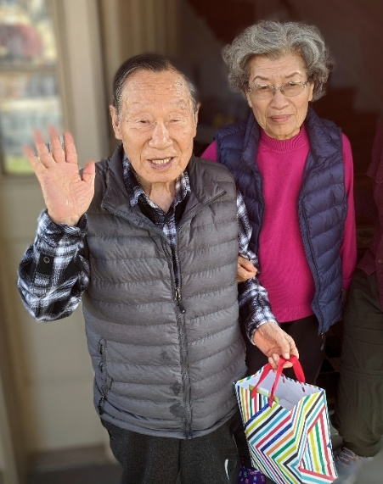
● Appreciation certificate.

Can’t Attend? Be a Marketing Sponsor! $150
● Business card acknowledgement in program.
● Logo on Centreville Day posters and sponsors’ banners.

In-Kind Sponsors
● Acknowledgement and logo in program.
● Logo on Centreville Day posters and sponsors’ banner.
● One 10’x10’ exhibition space at Centreville Day.
● Appreciation certificate.
treville Day: Event Map (Example) and LOCATION
Mr. Yom C. Kim, representative of Korean Central Presbyterian Church, Silver Sponsor
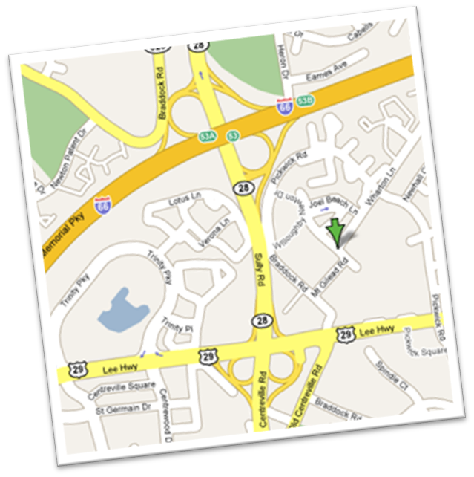

Historic Centreville Park is located at 5714 Mt. Gilead Road, conveniently near Routes 28, 29 and Interstate 66.
Centreville Day 2025 Sponsors & Partners
Centreville Day sponsors and partners are community leaders.
Centreville Day and the Friends of Historic Centreville are proud to have your support.

Wegmans Navy Federal Credit Union Luck Stone
Southwestern Youth Association Dog Stop VEG Veterinary
Centreville Chiropractic Korean Central Presbyterian Dan Helmer Shirley Contracting Lord of Life Church Kids World Montessori Woofies Garby Fun Enterprises Signarama Centreville Aquarium Trinity Center Cushman-Wakefield Pohanka Cat Hustler
Five Star Painting Western Fairfax Christian Ministries
American Legion Post 1995 Rotary Club of Centreville-Chantilly
Scouting America: Order of the Arrow, Troops 7369, 44, 577, 1859
Lane’s Mill DAR Centreville Immigration Forum
Church of the Ascension Mount Olive Baptist Saint John’s Episcopal
Sully District Supervisor NCS Sully Police Park Authority

EVENT DESCRIPTION: Centreville Day is a one-day, outdoor festival that celebrates the historical heritage and diverse cultural heritage of the greater Centreville area community. Scheduled in October, Halloween activities are included, such as the Trick or Treat Trail and Ghost Tour, in addition to historical activites and tours. Centreville Day also features a marketplace with businesses, crafters, and nonprofits; a community safety expo with police and fire agencies, public utility companies, businesses; the American Legion parade; children’s activities; live entertainment; international foods; and presentation of the Centreville Day Citizen of the Year Award. Proceeds support the Friends of Historic Centreville a nonprofit supporter of Historic Centreville Park.

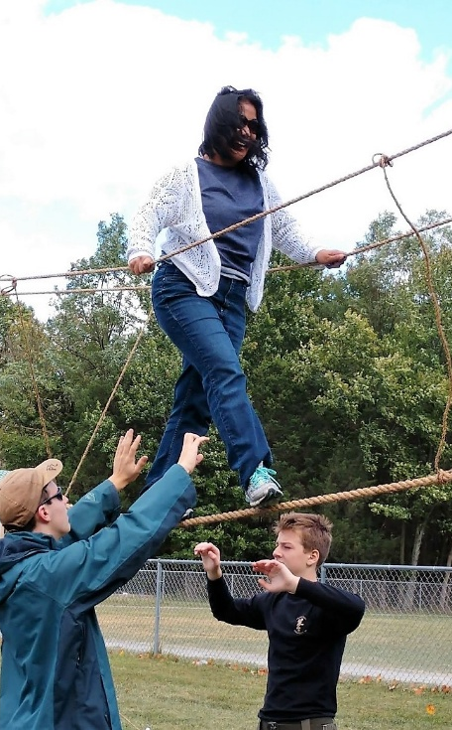
PARADE & PET PAGEANT: Sponsors are welcome to join the American Legion Centreville Day Parade. Please contact Steve Hunter at geoshunter@aol.com for further information. The Rotary Club Pets in the Park event is growing by leaps and bounds, meows and barks. Join the pageant as a judge or bring your pet, or your mascot, and join the pageant onstage! Pre-registration is not required – your awesome pet is your ticket to the event!

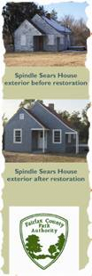
MARKETING: One critical advantage of Centrevile Day is the opportunity to make hundreds of face-to-face encounters with relaxed, happy clients and potential clients. In addition, Centreville Day is well-covered by the local press. Facebook and website provide a strong presence on social media. Large color posters featuring sponsor logos are distributed in the community in the weeks leading to the event. Sponsor logos with links are featured on the CentrevilleDay.org website. A sponsors’ banner is displayed during the parade and at the event. Centreville Community calendars, PSAs, the Fairfax tourism bureau, Festival.net and other services are also used to publicize the event. Paid advertising on Facebook and other social media is purchased with an eye to maximizing effectiveness.

SPONSORS & THE CENTREVILLE DAY PLANNING COMMITTEE: Sponsors are welcome to help shape the event. Centreville Day is planned by a committee made up of community volunteers, many of whom are community leaders representing key civic organizations and businesses. Our regular planning partners include the Fairfax County Park Authority, the office of Sully District Supervisor Kathy Smith, the Fairfax County Police Department, American Legion Post 1995, the Centreville-Chantilly Rotary Club, the Dulles Regional Chamber, the Historic Centreville Society, the Daughters of the American Revolution, Western Fairfax Christian Ministries, and local churches including the Korean Central Presbyterian Church, Mount Olive Baptist Church, the Church of the Ascension, and St. John’s Episcopal Church.

THE FRIENDS OF HISTORIC CENTREVILLE: The Friends of Historic Centreville (FHC) is a 501(c)(3) nonprofit dedicated to the preservation of Centreville’s unique heritage, especially the resources in Historic Centreville Park and the Centreville Historic District. We are overseen by a volunteer Board of Directors. With the help of our sponsors, Friends of Historic Centreville has been growing a fund to educate school children, preserve historic sites, support research, develop facilities at Historic Centreville Park, and share Centreville’s rich history with the public. FHC began in 2005 and has actively worked to expand the Centreville Historic District, supported the acquistion of parkland in the Centreville Historic District and the creation of Historic Centreville Park. Our website is www.HistoricCentrevilleVa.org.

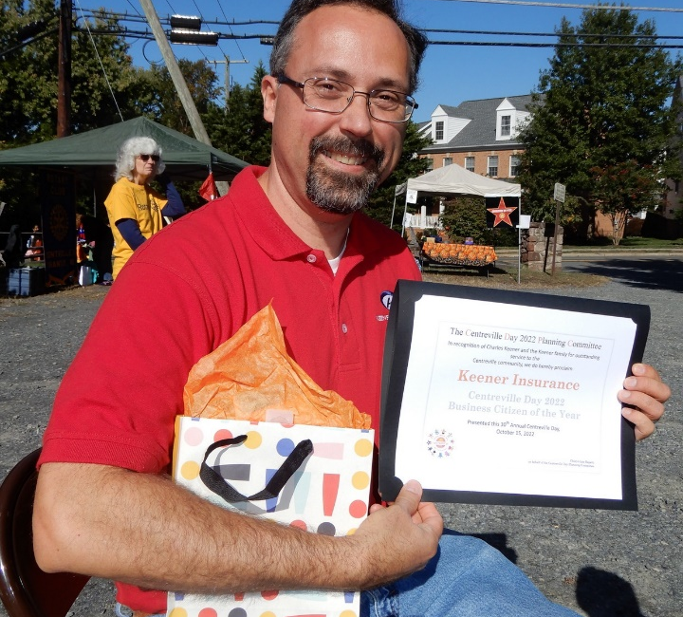
THE CENTREVILLE COMMUNITY : Settled in the mid-18th century and originally known as Newgate, Centreville was chartered in 1792. The town was famously fortified and occupied by Confederate and Union forces during the Civil War. Historic Centreville Park includes a significant portion of the original town and is situated within the Centreville Historic District. The park features Mount Gilead, built as Federal era tavern (circa 1785), fortifications and earthworks built in the Civil War, and a Sears Catalogue House (1934). Ten additional buildings, dating from 1796 to the 1950s, are included in the Historic District, which is the largest of its kind in Fairfax County.

Today, Centreville maintains a small-town community spirit despite its population of more than 70,000. Centreville’s population is ethnically diverse (29% Asian, 14% Hispanic, 7% African-American), affluent (median income over $118,000, family household income is over $144,000), highly educated (57% have college degree or higher) and family-oriented (62% of households are married).
Business Citizen of the Year 2022,
Keener Insurance

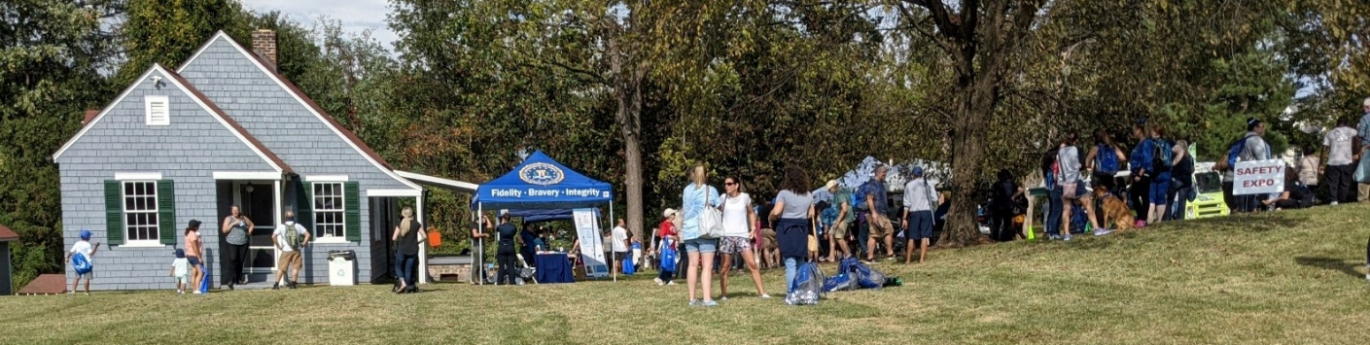
Contact us today to discuss your sponsorship: centrevilleFHC@gmail.com

SPONSOR APPLICATION
Questions? E-mail us at centrevilleFHC@gmail.com
Mail application and payment to:
Friends of Historic Centreville, PO Box 1573, Centreville, VA 2122
Name of Organization/Business: ___________________________________________________________________________________
Mailing Address:
__________________________________________________________________________________
__________________________________________________________________________________
The name of the person you want us to contact about your space: __________________________________________________________________________________
Day Phone Number _________________________________________________________________
Evening Phone Number _____________________________________________________________
Email Address _____________________________________________________________________
SPONSORSHIP LEVEL: __________________________________________________________________________________

See SPONSOR INFORMATION PACKET for more details regarding additional sponsor benefits. Apply early to maximize your inclusion in printed media and exposure on our website.

Total $ Enclosed: ___________________________________________________________________

Web address:
__________________________________________________________________________________

YES! I WANT TO PARTICIPATE IN TRICK or TREATING (see Terms below) check here:

I have read and agree to abide by all the Terms and Agreements (below).

Signed:
__________________________________________________________________Date:_____________

Committee Use Only: Date Rcvd __________ Payment Rcvd __________ Action_______________________________

Centreville Day Sponsorship Application
The Friends of Historic Centreville thanks you sincerely for your generous donation. FHC is a 501(c)(3) nonprofit. Once you complete the SPONSOR APPLICATION and submit payment you and your company will be a donor to FHC and a sponsor of Centreville Day. A receipt will indicate what portion of your sponsorship is a tax-deductible contribution. Upon request, FHC will send an invoice to you at the address specified. W9 forms are also available upon request.
Please note that to acknowledge your donation on any signage, program, advertising, and on our website, we need timely payment. Centreville Day cannot occur without your support!
Please e-mail us your logo when you submit your sponsorship application. High resolution j-peg or similar graphic picture format is the most convenient.
Sponsors may use canopies and other materials with their logos. We also have a supply of furnishings - please contact us if you need canopies, tables, or chairs. Sponsors may arrange to bring quiet generators at their spaces, but please let us know in advance.
Note that Centreville Day may be cancelled or may end early in case of inclement weather. There is no rain date and no refunds for inclement weather. We incur event expenses regardless of rain or other inclement weather and cannot offer refunds for weather cancellation. A rain date is impractical because of the number of homes, churches and businesses affected by road closures. We do try to go forward with Centreville Day in light rain, but we must consider the condition of the park grounds and the comfort of our vendors and visitors.
Please read the terms of agreement on the last page.
Your contributions support Historic Centreville Park, local historic preservation and public education, and benefits all the citizens of the greater Centreville area.
Mail application and payment to:
Friends of Historic Centreville, PO Box 1573, Centreville, VA 20122

Checks are the preferred form of payment for sponsorships.
However, if you email the application to CentrevilleFHC@gmail.com, we can send you a link to pay by credit card.
APPLICATION: The Friends of Historic Centreville (FHC), organizer of Centreville Day, and the SPONSOR agree that an application for a space will not be complete until full payment is received and accepted by the FHC. FHC reserves the right to refuse any applicant. If an application is refused, FHC will refund the fee and donation.
All SPONORS applying by Sept 30 will be listed in the printed program.

EXCLUSIVITY: FHC does NOT promise exclusive representation as a class of business (e.g., home improvement contractors, banks, real estate brokers, etc.) to its sponsors.

UNFURNISHED SPACES NOT BOOTHS: FHC provides unfurnished spaces without electricity, each 10 foot by 10 foot. Please contact us if you wish to use a generator.

Spaces are outside and subject to weather. Sponsors are welcome to bring their own branded canopies, tables, chairs, display props and other appropriate furnishings. Contact us if you need a canopy, table, or chairs. All tables, chairs, canopies, props, and merchandise must fit within the space or spaces assigned. Nothing may obstruct the free flow of pedestrian traffic in walkways adjoining booth space or intrude into other vendor’s areas.

REFUNDS: The event occurs Saturday, October 18 2025, from 10am to 4 pm. There is NO rain date and no refunds for inclement weather.

USE OF GENERATORS ONLY BY PERMISSION: Both to meet county regulations and to provide a pleasant atmosphere conducive to interacting with the public for all vendors, FHC allows the use of generators only by special permission. Please bring some form of fencing around the generator to prevent accidental contacts.

COUNTY REGULATIONS: Furnishings brought by sponsors are subject to Fairfax County regulations and inspection by county marshals. FHC will not refund fees to any sponsor that cannot participate because of failing inspection. Sponsors are responsible for knowing and meeting County regulations. As a courtesy, we note the following regulations:
- Canopies must be anchored against the wind either by stake or weights. (Stakes may be prohibited in some areas or not practical on paved sites.)
- Canopies should meet NFPA701 standards (flame retardant).
- No open flame or smoking beneath a canopy.

NO FOUR-WALLED TENTS: FHC does not permit the use of four-walled tents at Centreville Day.

TRICK or TREAT TRAIL: Sponsors will receive a pumpkin template to copy and display if they wish to participate in the Trick or Treat trail for children. Sponsors may give away promotional items, water, stickers, small toy, or candy items. Children are looking for the signs, and their parents come with them!

NOISE: The Sponsor agrees to refrain from using loud music, video, microphones with amp, or similar presentations in a manner that interferes with the capacity of other vendors to conduct business.
Port-a-Johns and food vendors will be available at the event.

SET UP & TEAR DOWN: Sponsors are required to set-up and tear-down their own spaces. Set up will occur between 7 am and 9:30 am. All vehicles must be moved to the designated parking area by 9:30 am. Tear down will begin at 4:00 pm. As a courtesy to other vendors, please do not break down before 4:00 pm. For the safety of pedestrians, no vehicles will be allowed into or out of the area before 4:00 pm. Police will enforce!

The event venue has narrow streets. FHC may send out a schedule of set-up times to limit congestion.

PARKING: A specified area for parking Sponsor/Vendor vehicles will be provided. Vehicles may not be parked adjoining or within your space. During the event the streets will be closed to all vehicles and parking is not allowed except in designated parking areas. Shuttle service will be provided to off-site parking.

SALES TAX: The collection and payment of sales taxes for any items sold at Centreville Day are the responsibility of the Sponsor.

SUBLETTING & DISPLAY CONTENT: Sponsors may share space with a favorite non-profit or other vendor by permission only. Requests must be received two weeks (10 business days) prior to Centreville Day. FHC reserves the right to reject or restrict the content of any exhibit FHC deems inappropriate for Centreville Day.

MAINTENANCE & SECURITY: The Sponsor is responsible for staffing their space and for maintaining it in a clean, orderly and secure fashion. The Sponsor is also responsible for leaving a clean area at the end of the day. FHC will provide containers for trash.

FHC does not guarantee the security of Sponsor merchandise or property.

INSURANCE & HOLD HARMLESS: All sponsors are expected to carry general liability insurance. The Sponsor will indemnify, defend, and hold harmless the Friends of Historic Centreville, other Centreville Day sponsors, the Fairfax County Park Authority, the County of Fairfax, or any of the officers, employees, successors, and assigns of any of the above, from any claims, damages, liabilities, losses, government proceedings, or costs and expenses including attorney’s fees, arising out of any or all aspects of this Agreement and Sponsor’s activities hereunder. Third parties will look solely to the Sponsor for any payment or claim arising from this event, or any act of omission in the performance of the Sponsor’s activities outlined in this Agreement.
