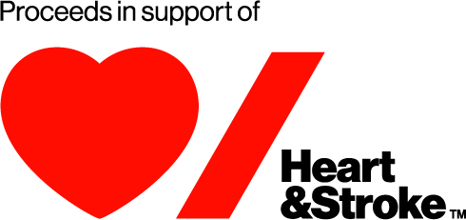

[Organization Logo]

NEWS RELEASE

For Immediate Release
[Headline with catchy title in bold writing – one sentence, no more than 100 to 150 characters, brief and to the point and stating that event is in support of the Heart & Stroke.]
[Optional subhead to expand on headline and provide context. Written in italics. Heart & Stroke mention may be placed here instead.]

[Date, City, Prov] – Lead paragraph should grab attention and contain a summary of the relevant 5 W’s: what, who, when, where, why. Remember what is important to journalists: impact, unusualness and current content, (water cooler topics of the week). Write in the third person.

Second paragraph develops story and provides background information. Write in an inverted pyramid style, with the most important information up top. This means that if someone were to only read the opening paragraph, they would have a basic understanding of your event.

Third paragraph may include a quote from event organizer, further developing the story and making the above information more personable. The call-to-action (ie. Visit this website to donate, register today, tell a friend, etc) may be included here if it is not in the paragraph above.
Fourth paragraph may be necessary to provide further details and expand on the quote from the event’s organizer. Ensure clear, concise writing.
Fifth paragraph should be a supporting quote from the Heart & Stroke. You may use this:
“We are delighted that [organization name] has chosen Heart & Stroke as their charity of choice,” says Anne Guilfoyle, VP, Community Programs and Engagement. “Support from organizations like [organization’s name] helps make our mission to beat heart disease and stroke possible by funding critical advances that prevent heart disease and stroke, save lives and enhance recovery.”
About
[Boiler Plate – description of the organization holding the event. Write in italics]

About Heart & Stroke

Life. We don’t want you to miss it. That’s why Heart & Stroke has been leading the fight to beat heart disease and stroke for more than 70 years. We must generate the next medical breakthroughs, so Canadians don’t miss out on precious moments. Together, with the generous support of our donors, partners and volunteers we are working to prevent disease, save lives and promote recovery through research, health promotion and public policy. Heartandstroke.ca
Media Contacts:

[Contact information for organization holding event] | Averie Hunt  Heart & Stroke Communications Advisor  Averie.Hunt@heartandstroke.ca  647-426-6864

