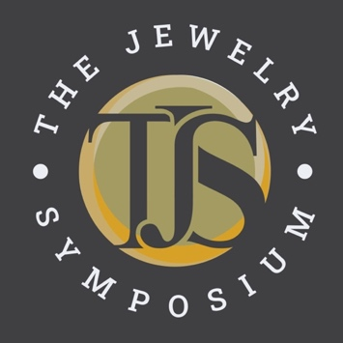
Application for Scholarship
For the 2026 Jewelry Symposium, scholarships are
available for aspiring jewelry industry applicants.
The deadline for submissions is January 26, 2026.
Qualified applicants include students, interns, apprentices, or those
who are early in their career in any field of the jewelry industry.
Each scholarship includes
- attendance of the Symposium
- three nights’ stay at the Detroit Marriott Troy hotel, May 16, 17 & 18 (booked by TJS)
- meals catered by TJS, a book, and a flash drive
Note: Awardees are responsible for their own travel arrangements and expenses.
Requirements: Applicants must be 18 years of age or older.
Please email your completed application along with your resumé
and a letter of recommendation from your teacher, employer, or mentor.
www.thejewelrysymposium.com

Applicant Name (Please Print) |  | Applicant Signature | Date
Address
City | State | Zip/Postal Code | Country
Phone Number | E-mail Address | School or Company Name
On a separate document, answer the following questions in 250 words or fewer. Include that document with this application, your resumé, and a letter of recommendation.
Email application submissions and queries about scholarships to jessa@thejewelrysymposium.com.

- Please tell us about yourself.
- What’s your area of study and/or level of experience in the jewelry industry?
- Why should you be considered for a scholarship?
- How will attending TJS assist with your education or career in the jewelry industry?

The Jewelry Symposium’s mission is to continually help advance the jewelry industry. That vision includes helping students or those in the fledgling stage of their career to gain exposure, education, and networking opportunities within their field. This scholarship program is open to anyone training to be or just starting out as a bench jeweler, a caster, a technician in a manufacturing firm, a designer, an educator, or any number of other facets of jewelry manufacturing.

The TJS Scholarship Committee will review applications and notify the awardees early February 2026.

