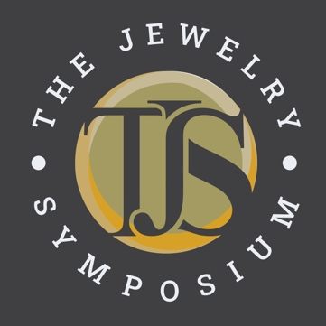
Abstract Submittal for 2027
The Symposium for the Advancement of Jewelry Manufacturing Technology is a passionate, collaborative, non-commercial, global community inspiring creativity, fostering innovation, and encouraging the further development and advancement of all facets of the jewelry making family.
----------------------------------------------------------
Being a TJS speaker means your paper will also be published in a hardbound book. Because we need adequate time to edit, format, lay out, and get your review and approval before printing, we have a hard deadline of January 15th for finished papers. We realize your paper must be done months in advance of the conference, but this also means your work will be published.
Please review the following deadlines for being a speaker for 2027 to make sure you can commit.
Abstracts due August 1st, 2026
Finished papers due January 15th, 2027
PowerPoint Presentations due April 15th, 2027.
Symposium event dates May 15-18, 2027, Detroit, Michigan, USA
If you can commit to these dates, please sign here: __________________
(If you are unable to commit to these dates for 2027, consider submitting your abstract for TJS 2028.)
Email completed form to jessa@thejewelrysymposium.com or linus@thejewelrysymposium.com
Full name:

Contact email and phone:

Website:

Company Name

City, State, Country

Paper Title:

Please write an abstract (summary) of the content of your proposed paper (150 words or fewer).

How will your presentation contribute to the advancement of the jewelry industry? Please list three benefits the audience will receive from your presentation.

To what areas of the jewelry industry does your presentation most closely apply? List as many as you like. (Examples: metallurgy, jewelry design, research, casting, finishing, history, bench techniques, health & safety, manufacturing, etc.)

Any additional notes:

www.thejewelrysymposium.com

The TJS board will review all abstracts submitted by August 1, 2026 and will respond to you once speakers have been selected.
Thank you for your interest in speaking at the Jewelry Symposium
and for your support of professional education
within the jewelry manufacturing industry!

