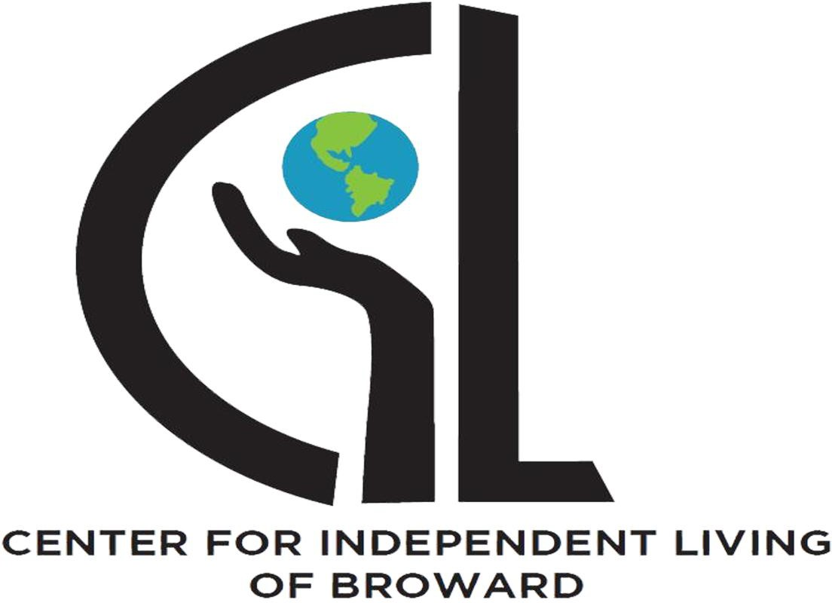

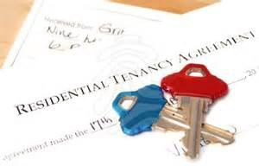
HOUSING & RESOURCES DIRECTORY

RENTAL ASSISTANCE
WEBSITE
www.browardconnections.org: The mission is education, prevention, advocacy, research, and empowerment. Provide programs and services in Broward County since 1957. To meet the needs in Miami-Dade County, expanded service area to build partnerships and resources.

CITIES/MUNICIPALITIES
Davie: contact - Angel Hamilton @ 954-797-1152

Pompano Beach: contact - Miriam Carrillo @ 954-786-4659. The city offers limited income-based rental assistance, at this time there is no funding for this service.
COMMUNITY AGENCIES / NON-PROFIT ORGANIZATIONS
- Broward County Family Success Centers offer emergency assistance with rent & utilities when funds are available. Contact 954-357-5001

- Broward County Elderly & Veterans has a HUD funded Supportive Housing Program designed to encourage chronically homeless people with substance abuse or co-occurring mental health issues to actively engage in the transition from homelessness to living as independently as possible. Clients share an apartment with another program participant, each paying 30% of their income toward half of the rent. Contact 954-357-6622.

- Broward Regional Health HOPWA provides assistance with late short-term rent, mortgage and utility payments and with move-in assistance in the form of first and last month’s rent for Broward County residents who qualify. Contact 954-561-9681.

- Care Resource, Inc. is a housing (mortgage or rent delinquency) moving expense and utility assistance program for people diagnosed with HIV diagnosis who are experiencing a temporary financial emergency, Contact 954-567-7141.

- Catholic Charities offer emergency assistance with rent when funds are available. Contact 954-357-5000.

- Consolidated Credit Counseling Services, Inc. provides financial mortgage assistance to anyone that has become unemployed or under-employed by paying arrears and monthly mortgage payments. Contact 1-888-269-2040.

- Ease Foundation Inc. provides financial assistance by appointment to qualified residents of Davie. To qualify for financial assistance, clients must be working and earning enough to pay their monthly bills. Contact 954-797-1077.

2

- Gateway Community Outreach is a low-income resource for senior citizens suffering from financial hardship. Contact 954-725-8434
- Hallandale Human Services can provide one-time rental and utility assistance. Contact 954-457-1460

- Healthy Mothers, Healthy Babies Coalition of Broward provides one-time emergency financial assistance for rent/mortgage to help individuals and families in crisis to meet their basic needs and receive navigation to other resources for long-term stability. Contact 954-765-0550, x 303.
- Hope Outreach Center provides final notice partial rent assistance. Contact 954-321-0909.

- Hope South Florida assists with tenant based rental assistance for homeless veterans. Consumers must be referred by 211 Broward and be homeless as defined by HUD. There is assistance for homeless families. They must be living on the street, in a shelter or a victim of domestic violence. They will be placed on a prioritized waiting list if they meet criteria: Contact 954-566-2311.
- Junior Welfare Society offers one-time emergency cash assistance for: rent, FPL, glasses, clothing, medical supplies, furniture, groceries, or car repairs. Individuals must be referred by a qualified social services agency. Contact 954-926-2667.
- Salvation Army provides move in costs and rental assistance to families with minor children residing in Hollywood who are homeless. Also provides emergency rent and mortgage financial assistance. Contact 954-524-6991.

- The Mount Bethel-Family Resource Center Program may have funds for rent. Contact 954-763-5011
- Urban League-Project BRAIVE provides emergency financial and supportive case management services to people in need of help. Services offered to military members include assistance with paying rent, housing expenses, mortgage or utilities, bus passes, and emergency car repairs and maintenance. Contact 954-625-2583

- Volunteers of America provide emergency rental or deposit assistance. Contact 305-644-033
- Broward County Housing Authority (BCHA) Manages the BCHA Housing Choice Voucher Program and public multifamily complexes. Reach their office at (954) 739-1114. https://bchafl.org/

3

https://www.findhelp.org/provider/broward-county-housing-authority--lauderdale-lakesfl/4702492140503040?postal=33093
- Deerfield Beach Housing Authority: Serving parts of North Broward. Reach them at (954) 428- 0678 or check status updates.
https://www.Affordablehousing.com https://www.broward.org/homeless

- Florida Housing Search: A free 24/7 online inventory tool to locate open, income-restricted rental apartments. You can search listings by calling 1-877-428-8844. https://www.floridahousingsearch.org/
https://www.adrcbroward.org/housing-rental-assistance/

- My Housing Search Directory: Filter rental choices by ZIP code, public transit access, and senior
or disability accommodations using the My Housing Search Tool. https://www.myhousingsearch.com/tenant/fl/Search.html?type=rental&region_id=31091

Emergency Funds / Utility Assistance
CITIES/MUNICIPALITIES
Miramar: contact - Milda @ 954-889-2722; City offers program called (Miramar Assisting Seniors in Their Homes) that assists seniors 60 + living in Miramar with one-time emergency financial assistance.

Community Agencies/ Non-Profit Organizations
  - Broward County Family Success Centers offer emergency assistance with rent & utilities when funds are available. Contact 954-357-5001.
  - Broward Regional Health HOPWA provides assistance with late short-term rent, mortgage and utility payments and with move-in assistance in the form of first and last month’s rent for Broward County residents who qualify. Contact 954-561-9681.
  - Care Resource, Inc. is a housing (mortgage or rent delinquency) moving expense and utility assistance program for people diagnosed with HIV diagnosis who are experiencing a temporary financial emergency, Contact 954-567-7141.

  - Ease Foundation Inc. provides financial assistance by appointment to qualified residents of Davie. To qualify for financial assistance, clients must be working and earning enough to pay their monthly bills. Contact 954-797-1077.

4

  - Hallandale Human Services can provide one-time rental and utility assistance. Contact 954-457-1460.
  - Urban League-Project BRAIVE provides emergency financial and supportive case management services to people in need of help. Services offered to military members include assistance with paying rent, housing expenses, mortgage or utilities, bus passes, and emergency car repairs and maintenance. Contact 954-625-2583.

  - Light of the World Clinic: Mission is to provide quality culturally sensitive healthcare to uninsured low-income residents of Broward County! https://www.lightoftheworldclinic.org/

  - St. Paul de Vincent South Florida: Provide quality healthcare to the uninsured, low-income residents of Broward County. Services provided to anyone in need are: Food programs, Emergency financial assistance, Transportation programs for seniors, Disaster relief and victim
services, Rent / mortgage assistance and help with low-cost housing, Twinning with shelters for the homeless, Thrift stores, Employment services, Job training, Counseling / information, Referral service, budget counseling, Youth programs, Social Justice programs, Advocacy, Twinning, foreign and domestic, Hospital ministry, Burial of the indigent, Embracing the lonely, forgotten, and alienated.
https://svdpsouthflorida.org/

  - National/ South Florida St. Vincent de Paul Society: While the National SVDP Society provides the above services and programs, the South Florida St. Vincent de Paul Society and its Community Good Works programs currently do not provide all of them. https://ssvpusa.org/contact-us/

  - TLC DME: Trusted Durable Medical Equipment Delivered to Your Doorstep 24/7. Our Mission is to serve your success by implementing a comprehensive DME program that enhances patient care while increasing profitability.
raven@tlcdme.com

  - Parakletos Therapeutic Services and Discipleship: Provide counseling and therapeutic support tailored to individual needs. Facilitate workshops or group sessions for students. Offer discipleship resources to encourage academic growth and resilience. Christine Bennett, (786) 967-7873, https://parakletostherapeutic.com

HOMELESS ASSISTANCE
5

Broward Outreach Center
Broward Outreach - Homeless Recovery Program - Pompano - NHAC
Website: http://www.miamirescuemission.com/browardoutreach.htm Address: 1700 Blount Rd, Pompano Beach, FL, 33069
Phone: (954) 979-6365
Intake: Monday-Friday 7:30am-4:30pm; Shelter operates 365/24/7

Broward Outreach Center
Broward Outreach - Homeless Recovery Program - Hollywood - S Website: http://www.miamirescuemission.com/browardoutreach.htm Address: 2056 Scott St, Hollywood, FL, 33020
Phone: (954) 926-7417
Intake: Monday-Friday 7:30am-4:30pm; Shelter operates 365/24/7

Broward Outreach Center
Broward Outreach - Overnights – Hollywood/Pompano Beach – NHAC/SHAC Homeless program that provides emergency overnight shelter assistance to individuals. This program targets clients who without this assistance would spend the night on the streets.
Website: http://www.caringplace.org
Address: 2056 Scott St, Hollywood, FL, 33020 Phone: (954) 926-7417
Hours: Monday-Sunday 5pm-8pm; walk in: by 3:30pm; can start to line up at 3:00pm

Broward Partnership for the Homeless Inc.

Broward Partnership for the Homeless - CHAC
60-day emergency homeless shelter; services immediately available to shelter residents include case management; substance abuse, mental health, dental & psychiatric services; housing placement and workforce development/employment assistance
Website: http://www.bphi.org
Address: 920 NW 7th Ave, Fort Lauderdale, FL, 33311 Phone: (954) 779-3990 Ext: 1111
Hours: Monday-Friday 8:00am - 6:00pm

Covenant House Florida Inc.

Covenant House - Emergency Shelter
6

Provides emergency shelter with 24-hour intake, food, clothing, health services, substance abuse treatment, parenting education, pregnancy prevention, counseling, school, street outreach and case management to runaway/homeless youth.
Website: Address: Phone: Hours:
http://www.covenanthousefl.org
733 Breakers Ave Covenant House Florida, Fort Lauderdale, FL, 33304 (954) 561-5559
24-hour/7 day

Salvation Army Inc., The
Emergency Overnight Shelter Program
Open door shelter with 45 cots nightly for adults (men and women, NO children) experiencing homelessness.
Website: Address: Phone:
http://www.salvationarmyflorida.org/fortlauderdale 1445 W Broward Blvd, Fort Lauderdale, FL, 33312 (954) 524-6991
Women in Distress of Broward County Inc.
Women in Distress - Emergency Shelter
Provides a 132 bed, 24-hour emergency shelter, food, clothing and limited transportation, as well as supportive services; such as advocacy, counseling, children’s services, therapy for domestic violence survivors.
Website: Address: Phone: Hours:
http:/ / / www. womenindistress. org Call for location
(954) 761-1133
24 Hours/7 Days

7

Affordable Online Rental Housing Locators

Broward County Homeless Helpline: Call 211 or (954) 563-4357. This is the mandatory entry point to access the county’s emergency shelters and transitional housing networks.

https://www.unitedwaybroward.org/news/housing-support-where-go-help
https://www.fortlauderdale.gov/Government/Departments/Community-Services/Housing-Community-Development-and-Homelessness/Homeless-
Resources-Guide https://www.broward.org/homeless
Broward County Homeless Services (HOSS-D): Located at 115 S. Andrews Ave., Fort Lauderdale. Call (954) 357-6167 or visit the
Broward County Homeless Services Portal.

www.broward.org/BrowardHousingCouncil/HousingResourcesServices/
www.socialserve.com
www.floridahousingsearch.com
www.rent.com
https://www.apartments.com
https://www.trulia.com/
https://www.realtor.com/
https://www.airbnb.com/

8

Shared Housing Resources
Kaola King –
954-624-2040 – Cell
kola@graceforallfl.com
Have both male and female homes, starting at $700.00. Ms King has multiple residences.

Bernadette Waisome –
954-347-4763 - Cell
waisbern@yahoo.com
Have both male and female homes, starting at $900.00, Wi-Fi included, if the renter receives Food Stamps, they will give $150.00 per month (5.00 a day for food). She is also a licensed realtor, so she can help with finding apartments.

Chacora Beasley-
954-955-6975 or 912-820-6432
Shared Rooms - Have both male and female homes starting at $850.00, private room w/bathroom starting at $1200.00.

Realtor Housing Resources

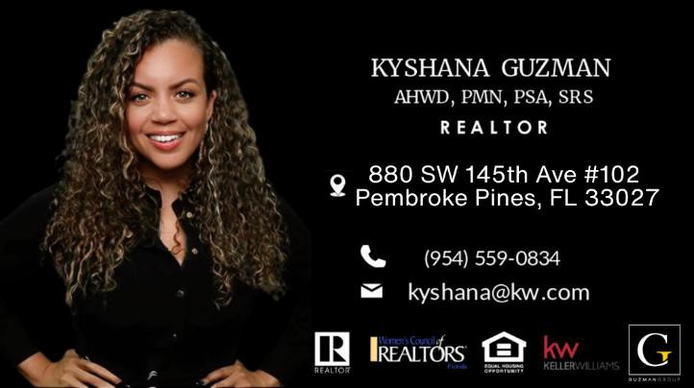

9

Julie Harris, P.A. REALTOR®, Broker-Associate (formerly Julie Van Pelt, P.A.)
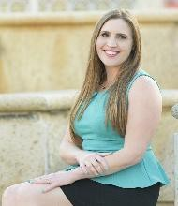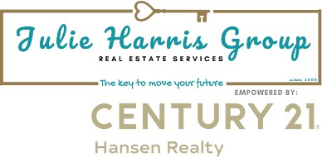
CENTURY 21® Hansen Realty 3010 E. Commercial Blvd.
Fort Lauderdale, FL 33308 Call or Text: 954-240-8074 Direct Fax: 888-540-5906

E-Mail: JulieVanPeltPA@gmail.com E-Mail: Julie@JulieHarrisGroup.net

Website: http://www.GotRealEstateNow.com/ Facebook: www.facebook.com/GotRealtorJulie
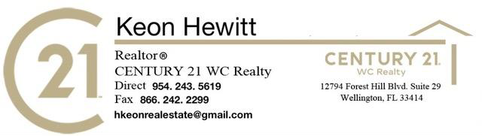

ADANICE VILLAFUERTE
Licensed Real Estate Professional, GRI, RENE, PSA Beaches MLS Broward, Palm Beach & St Lucie Realtors LoKation Real Estate |954.242.5938 Direct
www.niceehomes.com| nicevada@gmail.com | www.lokationre.com
"Your Dreams, Our Inspiration"

10

Homebuyer Assistance & Foreclosure Prevention
Broward County Housing and Urban Planning Division Offers first-time homebuyer down payment programs, water/sewer connections, and mortgage credit certificates.
Contact them at (954) 357-4900
Broward Housing and Urban Planning Division
Housing Foundation of America Provides free HUD-certified homebuyer workshops and down payment matching alerts. Contact them at (954) 923-5001 or download their mobile application via the Housing Foundation of America Portal.

Urban League of Broward County: Offers dedicated housing advice and foreclosure intervention counseling. Reach their counseling office at (954) 584 0777 or learn more via Findhelp Broward.
https://www.broward.org/housing https://www.homeapproved.org/Broward-County-Resources
https://www.findhelp.org/housing/help-pay-for-housing--fort-lauderdale-fl

Specialized Housing Support
Veterans Mission United (United Way) provides targeted financial services, legal aid, and employment-to-housing placements for military veterans.
(954) 4-UNITED (486-4833)

Mental Health & Former Foster Youth Broward Housing Solutions offers permanent supportive housing models for young adults aging out of foster care and individuals living with mental illness. Learn about eligibility on Broward Housing Solutions

https://www.fortlauderdale.gov/Government/Departments/Community-Services/Housing-Community-Development-and-Homelessness/Homeless-Resources-Guide

https://browardhousingsolutions.org/

11

Affordable Available Listings
Property Address | Layout | Monthly Rent | Key Features & Source
591 NW 40th Ct #A  Fort Lauderdale, FL 33309 | 2 Bed, 1 Bath (Shared space/Room) | $950 | Power/water included, borders Lloyd Estates Elementary. View on Trulia.
1400 NE 56th St  Fort Lauderdale, FL 33334 | 1 Bed, 1 Bath | $1,250 | Isles of Coral Ridge, 1 month free rent promotion, pet-friendly. View on Apartments.com.
100 NW 30th  Ave #8  Fort Lauderdale, FL 33311 | 2 Bed, 1 Bath | $1,399 | 1 month free with 13-month lease, tile floors, wall A/C. View on Trulia.
3700 NW 21st  St #203-1  Fort Lauderdale, FL 33311 | 1 Bed, 1 Bath | $1,425 | Open kitchen, walk-in closet, balcony with canal view. View on Trulia.
3121 NW 47th  Ter #212  Fort Lauderdale, FL 33319 | 1 Bed, 1.5 Bath | $1,575 | Screened patio with water view, in-unit washer/dryer, pool, gym. View on Trulia.

12

Broward County, FL
0 List a Property Log In

Map

Max $1,500 Pets Move-In Date Save Search
2 Beds
All Rental Listings in Broward County, FL
68 Rentals Available Sort by: Price (Low to High)
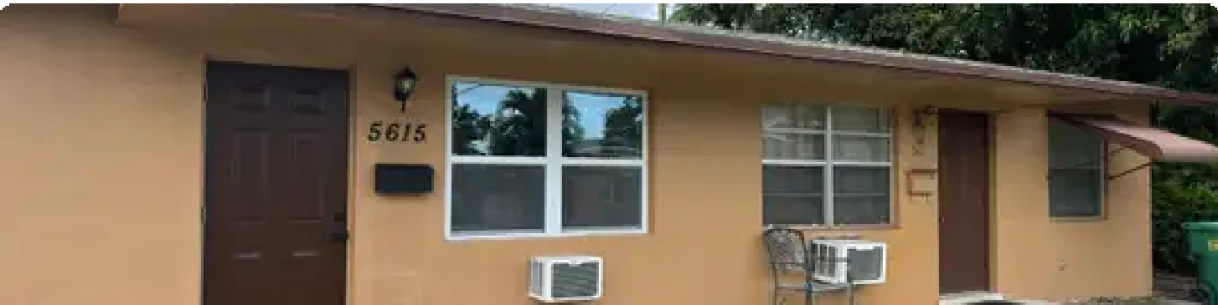
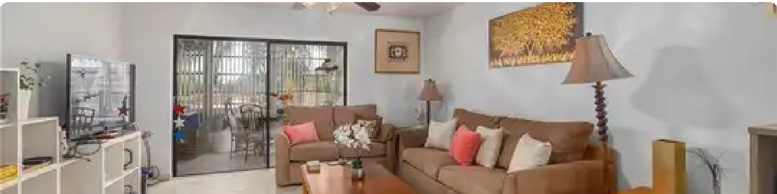
$850/mo
Save
2 Beds 1 Bath 800 Sqft
Outdoor Parking • Ceiling Fans • Stove 5615 NW 14th St, Lauderhill, FL 33313

(301) 660-3104
Send Message
$1,000+
2 Beds 2 Baths 1,102 Sqft Available Now
3990 NW 42nd Ave, Lauderdale Lakes, FL 33319
View Available Units

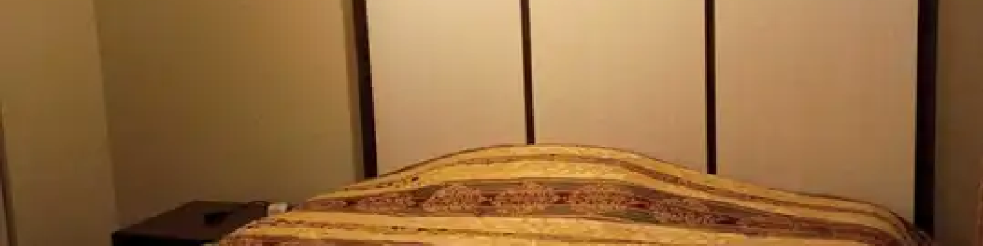
2 Beds 2 Baths 1,103 Sqft
Availability 24 Hours • Fitness Center • Laundry
Fairways of Inverrary 4200 Inverrary Blvd, Lauderhill, FL 33319
$1,000+
2 Beds 2 Baths 865 Sqft Available Now
2871 Somerset Dr, Lauderdale Lakes, FL 33311
View Available Units
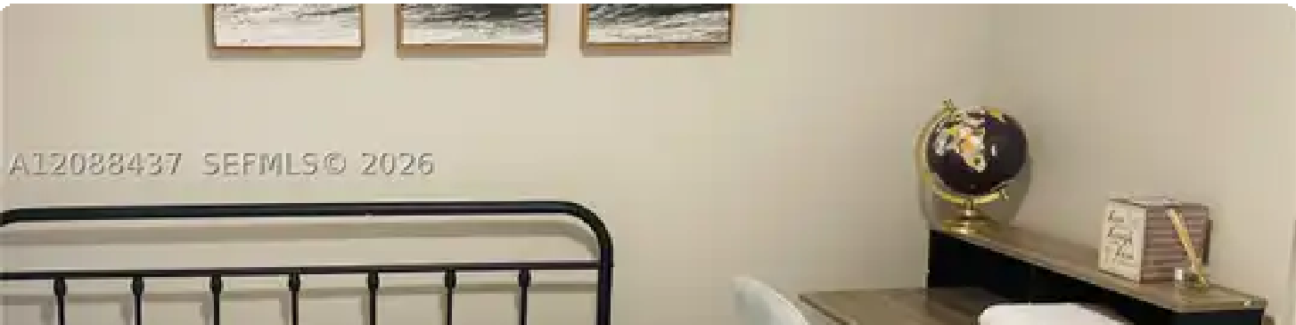
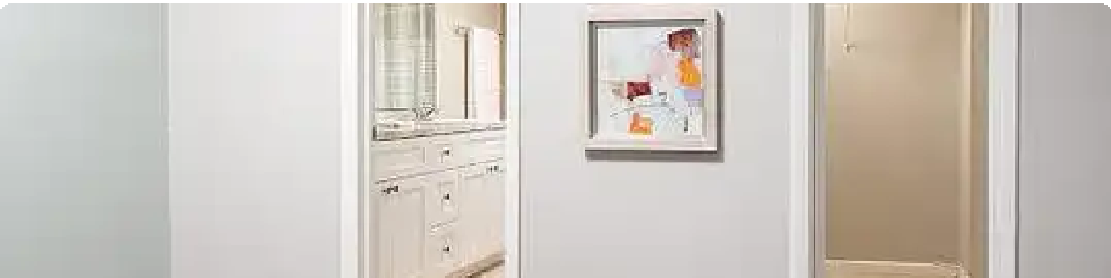
$1,100/mo
2 Beds 1 Bath 1,062 Sqft
Private Yard • Pet Friendly • Centrally located 6104 NW 74th Ave unit 6104, Tamarac, FL 33321
Save
(347) 579-4976
Send Message
$576 Price Drop
$1,299
Save

$1,350+
(754) 755-4363
Send Message
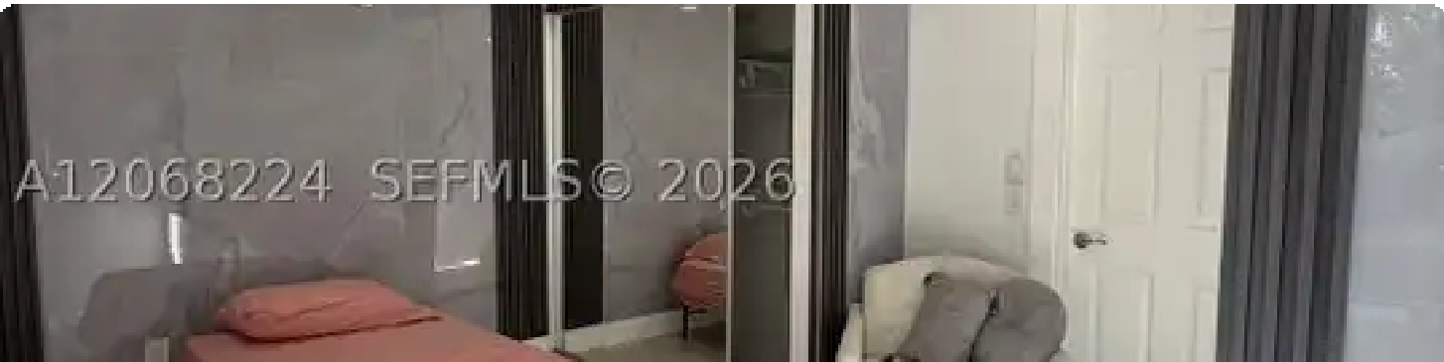


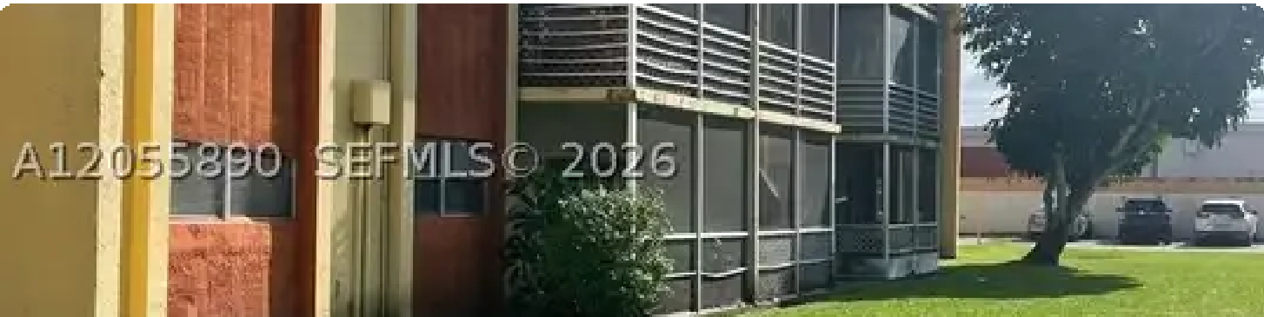
$1,300/mo
Save
2 Beds 1 Bath
Outdoor Parking • Comfortable efficiency • Two rooms available 1140 N Douglas Rd #0, Pembroke Pines, FL 33024

(305) 809-8085
Send Message
Best Small Dog Breeds for Apartments
Find the perfect pup for your next apartment. Visit our blog to get the scoop!
Learn More
Sponsored

2 Beds 1 Bath 800 Sqft
Available Now
3610 NW 21st St, Lauderdale Lakes, FL 33311
View Available Units
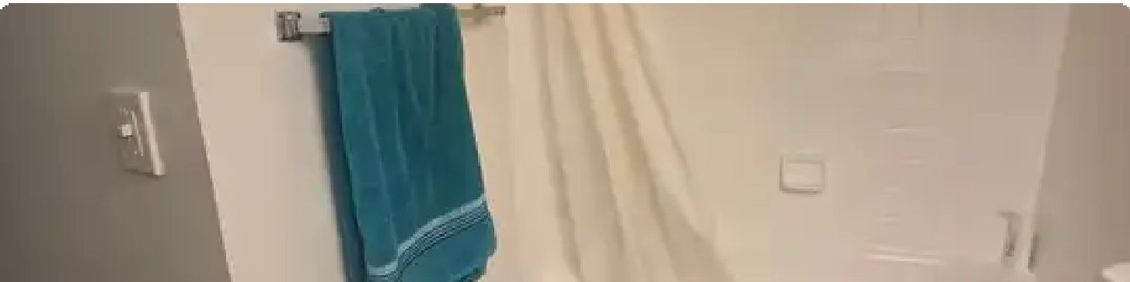
Available Oct 1

$1,365/mo
Save
2 Beds 2 Baths 1,200 Sqft
Pool • Fitness Center • Washer & Dryer In Unit
7940 Hampton Blvd unit 604, North Lauderdale, FL 33068
Send Message
Best Small Dog Breeds for Apartments
Find the perfect pup for your next apartment. Visit our blog to get the scoop!
Learn More
Sponsored

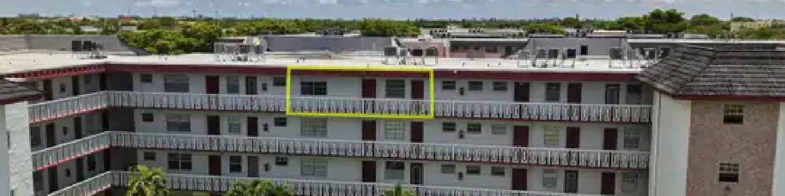
Garage • Outdoor Parking • Extra Storage
100 NW 30th Ave #1, Fort Lauderdale, FL 33311
$1,375
2 Beds 2 Baths 1,044 Sqft Available Now
4140 NW 44th Ave, Lauderdale Lakes, FL 33319
View Available Units
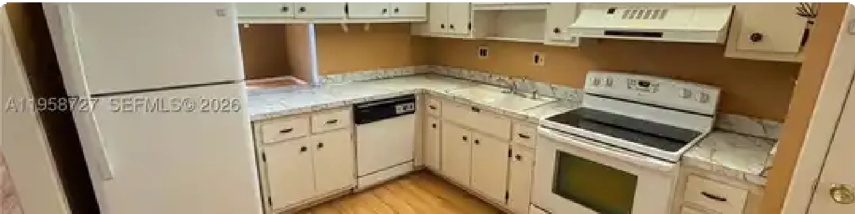
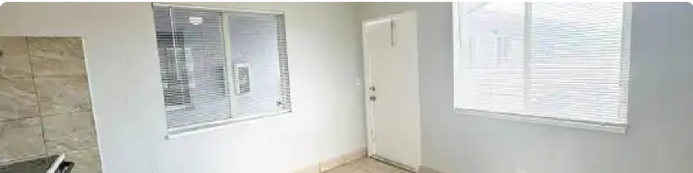
$1,395
2 Beds 2 Baths 960 Sqft Available Now
2060 NW 48th Ter, Lauderhill, FL 33313
View Available Units
$1,399/mo
2 Beds 1 Bath 5,025 Sqft
Save

$1,400
2 Beds 2 Baths 920 Sqft Available Now
(954) 260-2923
Send Message
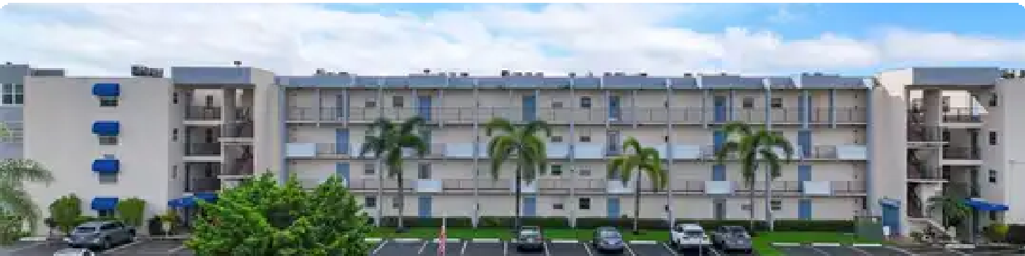
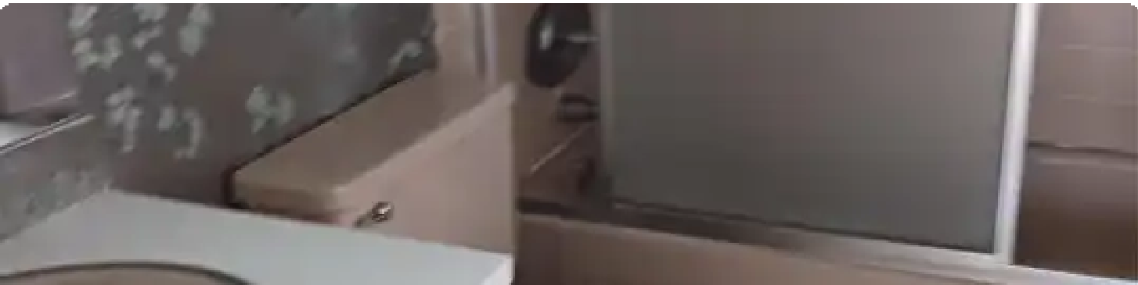
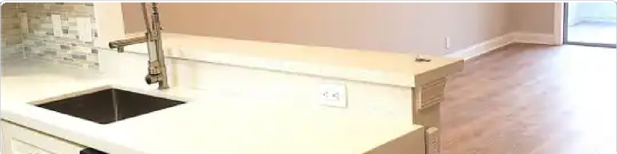
$1,399+
2 Beds 2 Baths 946 Sqft Available Now
7500 NW 30th Pl, Sunrise, FL 33313
View Available Units
$1,400
2 Beds 2 Baths 990 Sqft Available Now
7505 NW 5th Ct, Margate, FL 33063
View Available Units

$1,475/mo Save
7897 Golf Circle Dr, Margate, FL 33063
View Available Units
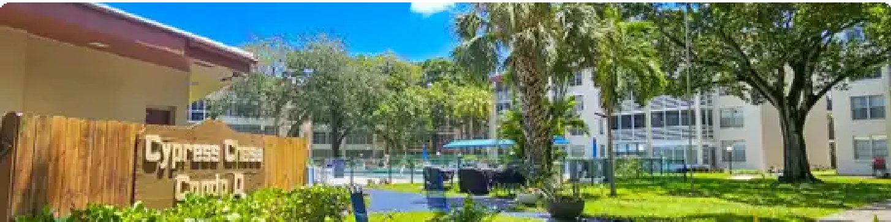
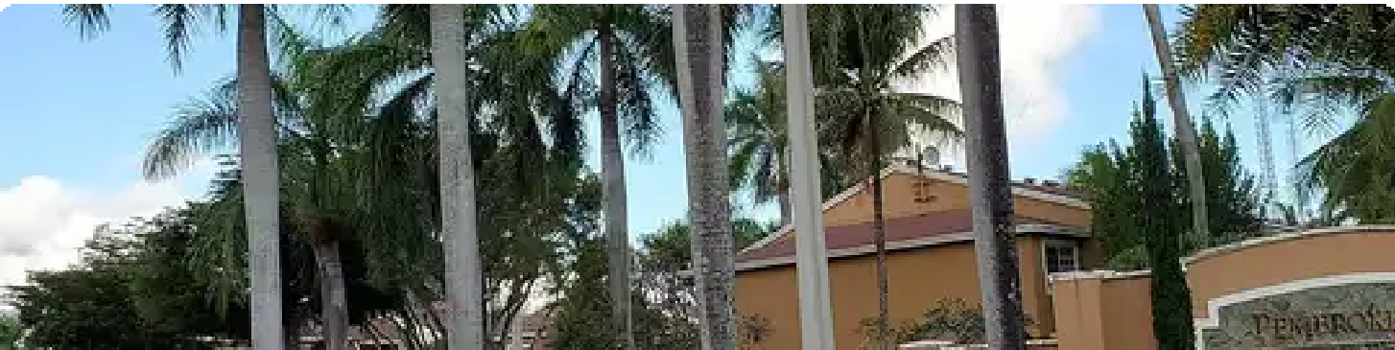
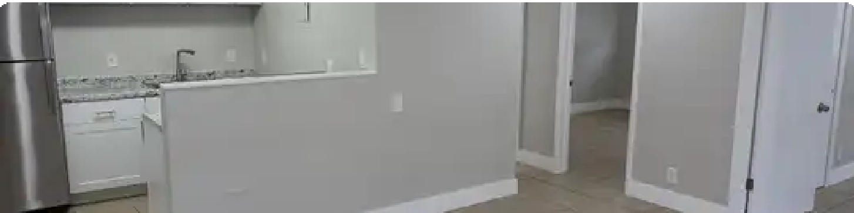
$1,400
2 Beds 2 Baths 960 Sqft Available Now
2650 NW 49th Ave, Lauderdale Lakes, FL 33313
View Available Units
Popular
Income Restricted

$1,446
Save
2 Beds 2 Baths 850 Sqft
Club House • Pool • Volleyball Court
Pembroke Park Apartments 3700 SW 52nd Ave, Pembroke Park, FL 33023

(754) 732-7868 Send Message

Landlord/Property Manager

Iushmainoffice@grnail.com jacksonarms(iuaol.com info_@prernie-holdi11gs�<;.PIJ�l kenesha@cooperprope,ties.com
�,;_;fJr)\<:J.[)iJJr:il webergrnL_1R.m0r.E1gernen t.com motif.lease(Q)fpirnpt. co ni nshep�1erd@westp;ateu.com leasing.cnda@ariumliving.com k�asing3@lvivaIuxapts.corn www.tamaracvillage_.com
lakevilla6-vmslrentals.com Interstate Rentals Property Manager
Phone Number

954-777-3313
954-924-4446 X500
305-501-0024
954-462-4234
754-223-5427
954-686-8140
954-787-5308
954-400-1531
954-715-6685
833-568-4701
954-961-8900
954-246-4123
Complex

Lush Properties Jackson Arms LLC
Van Buren St Apartments II LLC Cooper Properties
City View Apartments Motif At Flagler Village Westgate at University Centro at Davie
VIVA Apartments Tamarac Village
Lake Villa Apartments
Several
Address

5971 NW 17 Place Sunrise, FL 33313
2421 Hollywood Blvd Hollywood, FL 33020
1027 NE 46 Street Oakland Park, FL 33334
515 NE 13 Street Fort Lauderdale, FL 33304
1440 NW 2 Street Fort Lauderdale, FL 33311 500 N. Andrews Avenue Fort Lauderdale, FL 33301
5475 N University, Lauderhill, FL 33351
2750 SW 73 Way Davie, FL 33314
3700 Pacific Point PL Fort Lauderdale, FL 33309 9141 W. Commercial Blvd Tamarac, Fl 33351 2450 S Park Road Hallandale, FL 33009
Wilton Manors

BROWARD COUNTY FLORIDA
Affordable Rental Properties Listing - 2024

LINKS TO VIEW PROPERTY LISTINGS BY CITY

Coconut Cieek. FL Coral Sprinas FL Dania. FL
Dania Beach. FL Davie. FL
Deerfield Beach. FL Fort Lauderdale. FL Hallandale. FL
Halianda!e Be2.c!, FL Hoi!vwood. FL. Lauderdale Lakes. FL Lauderhil! FL Margate FL
Mi1·amar. FL
Ncrtr7 Lauderdale. F: Oakland Park. FL
Pembroke Park. FL Pembroke Pines. FL Plantation. FL Pompano Beach. FL Sunrise. FL
Wilton Manors. FL

COCONUT CREEK
Banyan Bay
4303 West Atlantic Boulevard Coconut Creek, FL 33066 954-979-8788
1 and 2 Bedroom Apartments

Banyan Pointe
3597 Wiles Road Coconut Creek, FL 33073 954-883-9390
1, 2, and 3 Bedroom Apartments

CORAL SPRINGS
St. Andrew Towers
2700 Northwest 99th Avenue Coral Springs, FL 33065 954-388-8962
Studio and 1 Bedroom Apartments

DANIA
Gulfstream at Dania Beach 10 Northwest 10th Court Dania, FL 33004
954-927-1355
2 Bedroom Apartments

DANIA BEACH
Emerald Palms
5331 Southwest 43rd Terrace Dania Beach, FL 33314
954-584-1009
1, 2, and 3 Bedroom Apartments

Landings at Coconut Creek 4854 Fisherman's Drive Coconut Creek, FL 33063 954-979-8088
1 and 2 Bedroom Apartments

Saratoga Crossings
1105 West Dania Beach Boulevard Dania Beach, FL 33004
954-404-7117
1, 2, and 3 Bedroom Apartments

See next page for more listings

2024 Broward County Affordable Rental Properties Listing Revised 03 25 2024 Page 1 of 8

BROWARD COUNTY FLORIDA
Affordable Rental Properties Listing - 2024

Saratoga Crossings II
705 West Dania Beach Boulevard Dania Beach, FL 33004
954-404- 7117
1 Bedroom Apartments
Saratoga Crossings Ill
840-850 West Dania Beach Boulevard Dania Beach, FL 33004
954-404-7117
1 Bedroom Apartments

DAVIE
East Village
7481 Northwest 33rd Street Davie, FL 33024
954-923-7118
1, 2, and 3 Bedroom Apartments

Federation Davie
5701 Southwest 82nd Avenue Davie, FL 33328
954-434-9666
Studio and 1 Bedroom Apartments

DEERFIELD BEACH
Highland Gardens ii 331 NE 48th Street
Deerfield Beach, FL 33442 954-596-5977
1 and 2 Bedroom Apartments

Palms of Deerfield
407 Northwest pt Terrace Deerfield Beach, FL 33441 954-428-0678
Studio and 1 Bedroom Apartments

Palms of Deerfield Beach Townhouses
411 Northwest 1st Terrace Deerfield Beach, FL 33441 954-425-8449
2 and 3 Bedroom Apartments

FORT LAUDERDALE
Broward Gardens Apartments
2960 Northwest 19th Street Fort Lauderdale, FL 33311 954-7330605
2 and 3 Bedroom Apartments

Stirling Apartments
7350 Stirling Road
Davie, FL 33024
954-430-5996
2 and 3 Bedroom Apartments

Summerlake Apartments
5941 Summerlake Drive
Davie, FL 33314
954-419-5652
2 and 3 Bedroom Apartments

Praxis of Deerfield Beach ii & ill 1111 Southwest 15th Street Deerfield Beach, FL 33441
954-584-1009
1 and 2 Bedroom Apartments

Stanley Terrace Apartments 400-414 Southwest 2nd Street Deerfield Beach, FL 33441 954-425-8449
2 and 3 Bedroom Apartments

Tallman Pines i & ii
700 NE 4pt Street Deerfield Beach, FL 33064 954-574-9210
2 and 3 Bedroom Apartments

Dixie Court Apartments i, I!&. m
306 West Dixie Court
Fort Lauderdale, FL 33311 954-280-6284
1, 2, and 3 Bedroom Apartments

See next page for more listings

2024 Broward County Affordable Rental Properties Listing Revised 03 25 2024 Page 2 of 8

BROWARD COUNTY FLORIDA
Affordable Rental Properties Listing - 2024

Dr. Kennedy Homes
108 Southwest 11th Avenue
Fort Lauderdale, FL 33312 754-354-4609
2 Bedroom Apartments
Eclipse West Apartments
307 Northwest 1st Avenue Fort Lauderdale, FL 33301
954-524-5246
Studio, 1 and 2 Bedroom Apartments

Falls at Bonaventure
201 Racqwet Club Road Fort Lauderdale, FL 33326 954-389-1003
1 and 2 Bedroom Apartments

Northwest Gardens
645 Northwest 10th Avenue Fort Lauderdale, FL 33311 754-666-7478
1, 2, and 3 Bedroom Apartments
Northwest Gardens ii 1230 Northwest 8th Street Fort Lauderdale, FL 33311 754-219-9119
1 and 2 Bedroom Apartments
Northwest Gardens m
824 Northwest 14th Avenue
Fort Lauderdale, FL 33311 754-247-1502
2, 3, 4, and 5 Bedroom Apartments

Northwest Gardens IV
915 Northwest 6th Street
Fort Lauderdale, FL 33311 954-516-1397
2, 3, 4, and 5 Bedroom Apartments

Northwest Gardens V
100 Southwest 18th Avenue Fort Lauderdale, FL 33312
754-219-2170
1 Bedroom Apartments

2024 Broward County Affordable Rental Properties Listing
Pinnacle at Tarpon River
805 SE 3rd Avenue
Fort Lauderdale, FL 33316 954-324-2342
1, 2, and 3 Bedroom Apartments

Poinciana Crossing
1801 Southwest pt Avenue Fort Lauderdale, FL 33315 954-892-5798
1 and 2 Bedroom Apartments

Progresso Point
619 North Andrews Avenue Fort Lauderdale, FL 33301 954-463-9110
Studio and 1 Bedroom Apartments

Prospect Park
5500 Northwest 3pt Avenue Fort Lauderdale, FL 33309 954-731-8400
2 and 3 Bedroom Apartments
Regal Trace
540 Northwest 4th Avenue Fort Lauderdale, FL 33311
754-465-9995
1, 2, and 3 Bedroom Apartments

Rock Island
2340 Northwest 16th Street Fort Lauderdale, FL 33311
954-556-4134
1 and 2 Bedroom Apartments

Sailboat Bend
425 Southwest 4th Avenue Fort Lauderdale, FL 33315 786-839-6773
Studio and 1 Bedroom Apartments
Sailboat Bend U
437 Southwest 4th Avenue Fort Lauderdale, FL 33315
954-287-1208
1 and 2 Bedroom Apartments

See next page for more listings

Revised 03 25 2024 Page 3 of 8

BROWARD COUNTY FLORIDA
Affordable Rental Properties Listing - 2024

Sailboat Bend Artists' Lofts 1310 Southwest 2nd Court Fort Lauderdale, FL 33312 954-728-3484
1, 2, and 3 Bedroom Apartments

Seven on Seventh
900 Northwest 7th Avenue Fort Lauderdale, FL 33311 786-762-5273
Studio, 1 and 2 Bedroom Apartments

Venice Cove Apartments 711 Northwest 19th Street Fort Lauderdale, FL 33311 954-758-4531
1, 2, and 3 Bedroom Apartments

HALLANDALE
Chaves Lakes
201 Northwest 8th Street Hallandale, FL 33009
954-455-3335
2 and 3 Bedroom Apartments

HALLANDALE BEACH
Harbour Cove
100 Northwest 9th Terrace Hallandale Beach, FL 33009 954-248-3972
1, 2, and 3 Bedroom Apartments

HOLLYWOOD
Crystal lakes
3100 North 24th Avenue Hollywood, FL 33020
954-920-2620
1, 2, 3, and 4 Bedroom Apartments

Gardens at Driftwood]
7350 North Davie Road Extension Hollywood, FL 33024
954-983-5051
1 and 2 Bedroom Apartments
Village Place
720 Northeast 4th Avenue Fort Lauderdale, FL 33304 954-760-9401
1 and 2 Bedroom Apartments

Village View
640 North Andrews Avenue Fort Lauderdale, FL 33311 754-755-5250
1 and 2 Bedroom Apartments

Wisdom Village Crossing 615 North Andrews Avenue Fort Lauderdale, FL 33311 954-626-8144
Studio, 1 and 2 Bedroom Apartments

Hudson Village
901 South Federal Highway Hollywood, FL 33020
754-702-8500
1 and 2 Bedroom Apartments

Meridian - Hollywood 2900 North 26th Avenue Hollywood, FL 33020
954-927-5433
1 and 2 Bedroom Apartments

See next page for more listings

2024 Broward County Affordable Rental Properties Listing Revised 03.25 2024 Page 4 of 8

BROWARD COUNTY FLORIDA
Affordable Rental Properties Listing - 2024

Monterra
2601 Solano Avenue
Hollywood, FL 33024
754-200-8507
1, 2, and 3 Bedroom Apartments

Pinnacle at Peacefield
2314 Adams Street
Hollywood, FL 33020
954-329-0250
1 and 2 Bedroom Apartments

LAUDERDALE LAKES
Caravel Arms
4844 Northwest 24th Court Lauderdale Lakes, FL 33313 954-733-0872
1, 2, and 3 Bedroom Apartments

St Croix Apartments
4150 NW 34th Street Lauderdale Lakes, FL 33319 954-535-7666
1, 2, and 3 Bedroom Apartments

LAUDERHILL
Cypress Grove
4200 Northwest 19th Street Lauderhill, FL 33313
754-704-6724
Studio, 1 and 2 Bedroom Apartments

MARGATE
Arbor View
3100 North State Road 7
Margate, FL 33063
954-960-2064
1 and 2 Bedroom Apartments

MIRAMAR
Casa Sant'Angelo
16800 Miramar Parkway
Miramar, FL 33027
954-231-1937
1 Bedroom Apartments
Town Park Crossing
7843 Davie Road Extension Hollywood, FL 33024
754-400-9928
1, 2, and 3 Bedroom Apartments

Woodsdale Oaks
2573 Northwest 49th Avenue Lauderdale Lakes, FL 33313 954-485-0392
1, 2, and 3 Bedroom Apartments

Lauderhiii Point
3146 Northwest 19th Street Lauderhill, FL 33311
954-485-2335
2, 3 and 4 Bedroom Apartments

Colonial Park
1300 Banks Road
Margate, FL 33063
954-979-2440
1 and 2 Bedroom Apartments

Heron Pointe
2260 Sherman Circle North Miramar, FL 33027
954-433-4303
1, 2, and 3 Bedroom Apartments

See next page for more listings

2024 Broward County Affordable Rental Properties Listing Revised 03 25 2024 Page 5 of 8

BROWARD COUNTY FLORIDA
Affordable Rental Properties Listing - 2024

Sorrento at Miramar
8991 Southwest 41st Street
Miramar, FL 33025
954-404-8791
1, 2, and 3 Bedroom Apartments

NORTH LAUDERDALE
Cross Keys II
2034 Southwest 81st Avenue North Lauderdale, FL 33068 954-721-4111
1, 2 and 3 Bedroom Apartments

OAKLAND PARK
Aqua 2800
2800 Northwest 44th Street Oakland Park, FL 33309 954-388-8753
1 and 2 Bedroom Apartments

PEMBROKE PARK
Pembroke Gardens
3701 Southwest 52nd Avenue Pembroke Park, FL 33023 954-983-7615
1, 2, and 3 Bedroom Apartments

Pembroke Park
3700 Southwest 52nd Avenue Pembroke Park, FL 33023 954-983-5199
1, 2, and 3 Bedroom Apartments

PEMBROKE PINES
Douglas Gardens V
709 Southwest 88th Avenue Pembroke Pines, FL 33025 954-435-9714
1 and 2 Bedroom Apartments

PLANTATION
Los Prndos
832 NW 86th Avenue Plantation, FL 33324
954-472-0501
1 and 2 Bedroom Apartments
Villas de Maliorca
3430 Douglas Road
Miramar, FL 33025
954-589-2847
1, 2, and 3 Bedroom Apartments

Sanctuary Cove
5301 West McNab Road North Lauderdale, FL 33068 954-719-7238
1, 2, and 3 Bedroom Apartments

Oakland Preserve
3600 Oakland Preserve Way Oakland Park, FL 33334 954-566-0706
1, 2, and 3 Bedroom Apartments

Pembroke Villas
4801 Southwest 41st Street Pembroke Park, FL 33023 754-238-2489
1, 2, and 3 Bedroom Apartments

!Pembroke Tower
2201 North University Drive Pembroke Pines, FL 33024 954-966-0420
Studio and 1 Bedroom Apartments

Mar Lago Village
200 Commodore Drive
Plantation, FL 33325
954-382-4554
1, 2, and 3 Bedroom Apartments

2024 Broward County Affordable Rental Properties Listing Revised 03 25 2024 Page 6 of 8

BROWARD COUNTY FLORIDA
Affordable Rental Properties Listing - 2024

POMPANO BEACH
Atlantic Palms Apartments 1290 Northwest 6th Avenue Pompano Beach, FL 33060 954-642-2167
1, 2, and 3 Bedroom Apartments

Captiva Cove I, II & Iii
1201 South Dixie Highway West Pompano Beach, FL 33060
855-207-0569
1, 2, and 3 Bedroom Apartments

City Vista
501 Hammondville Road Pompano Beach, FL 33060 954-758-7719
1 and 2 Bedroom Apartments

Eagle Pointe
2001 West Atlantic Boulevard Pompano Beach, FL 33069 954-787-4383
1, 2, and 3 Bedroom Apartments

Goiden Square
1415 Northwest 18th Drive Pompano Beach, FL 33069 954-994-1676
1, 2, 3, and 4 Bedroom Apartments

Golden Vmas
1325 Northwest 18th Drive Pompano Beach, FL 33069 954-933-4050
1, 2, and 3 Bedroom Apartments

Heritage at Pompano Station 400 North Flagler Avenue Pompano Beach, FL 33060 954-691-4691
1 and 2 Bedroom Apartments

Marquis Apartments
1850 Martin Luther King Boulevard Pompano Beach, FL 33069
954-532-5415
1, 2, and 3 Bedroom Apartments

Oaks at Pompano
501 Southwestpt Court Pompano Beach, FL 33060 954-280-4889
1, 2, and 3 Bedroom Apartments

Pinnacle Village
801 North Powerline Road Pompano Beach, FL 33069 954-917-2500
1, 2, and 3 Bedroom Apartments

Regency Gardens
1525 Northwest 17th Avenue Pompano Beach, FL 33069 954-972-6666
1, 2, and 3 Bedroom Apartments

Residences at Crystal lake 350 Northeast 32nd Court Pompano Beach, FL 33064 954-388-5115
2 and 3 Bedroom Apartments

Sonata Apartment Homes 100 Northwest 8th Street Pompano Beach, FL 33060 866-471-6979
1, 2, and 3 Bedroom Apartments

St Elizabeth Gardens 801 Northeast 33rd Street
Pompano Beach, FL 33064 754-704-5760
1 Bedroom Apartments

Laguna Pointe
903 Southwest 15th Street Pompano Beach, FL 33060 954-372-1046
1, 2, and 3 Bedroom Apartments

2024 Broward County Affordable Rental Properties Listing Revised 03 25 2024 Page 7 of 8

BROWARD COUNTY FLORIDA
Affordable Rental Properties Listing - 2024

SUNRISE
Federation Sunrise 5010 North Nob Hill Road Sunrise, FL 33351
954-746- 7960
Studio and 1 Bedroom Apartments

Golf View Gardens
7300 Northwest 30th Place Sunrise, FL 33322
954-572-5701
1 and 2 Bedroom Apartments

Pinnacle at Avery Glen 3871 Pine Island Road Sunrise, FL 33351
954-504-9457
1, 2, and 3 Bedroom Apartments

Wll TON MANORS
Residences at Equality Park 2050 North Dixie Highway Wilton Manors, FL 33305
954-463-9005
Studio, 1 and 2 Bedroom Apartments

2024 Broward County Afiordable Rental Properties Listing Revised 03 25 2024 Page 8 of 8

