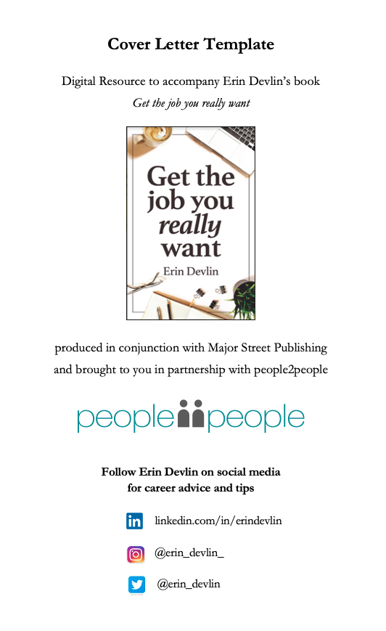

Your name
Your address or suburb
Your phone number
Your email

Date

Recipient’s name
Title
Company
Address
Email address

Dear (person’s name),

Re: Title of the position you are applying for

Body of letter.

Over four to six paragraphs, address key selection criteria with examples from your work experience. Include key skills, education, experience, and values. Clarify parts of your CV where needed, demonstrate research, express enthusiasm, show why you’re the right candidate for the job and finish with a call to action.

Refer to Chapter 8 of the book Get the job you really want by Erin Devlin for detailed cover letter content.

Sincerely,

Your signature

Your name
Mobile number
Email address

