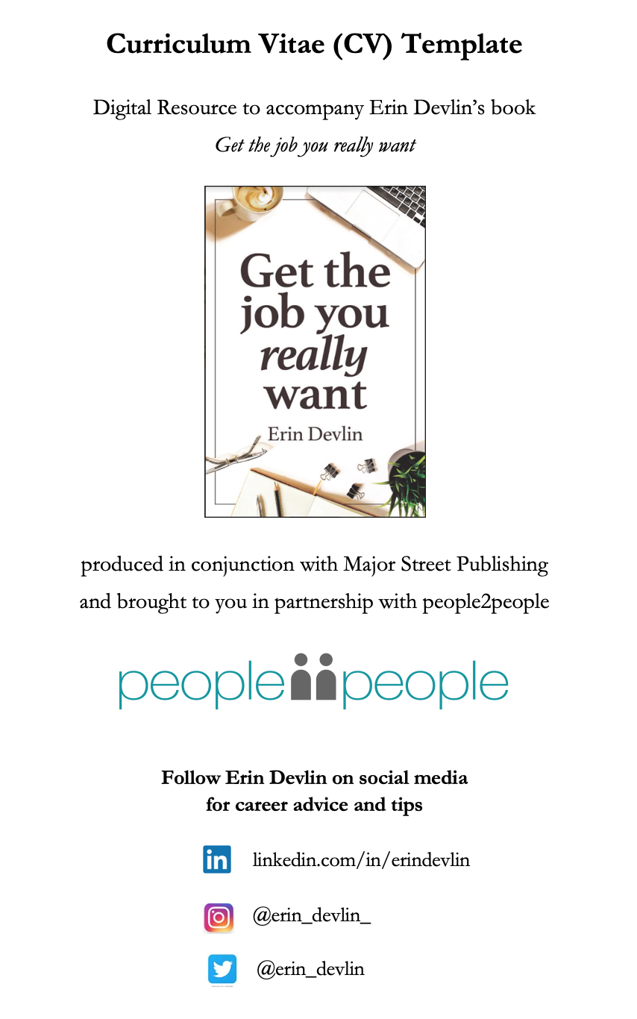
YOUR NAME CURRICULUM VITAE 2021
POSITION TITLE or TAGLINE

Your mobile I youremail@youremail.com.au | Suburb, state I LinkedIn/in/yourname

Career Summary: e.g. I am an experienced Sales Engineer with qualifications in mechanical engineering and over five years’ sales experience. I have worked with hydraulics and pneumatics solutions for three years and have been formally recognised as the top sales performer in Australian and New Zealand over the past three years. I am looking to join a diverse and forward-thinking organisation where I can add value and contribute my skills and experience.

QUALIFICATIONS

Qualification 1
Institution, Year

Qualification 2
Institution, Year

Qualification 3
Institution, Year

AWARDS or Achievements (Optional)

Award name 1 (related to position or industry)
Company/Organisation/Institution, Year

Award name 2
Company/Organisation/institution, Year

CAREER SUMMARY

Year Start – Year End Position Company

E.g., 2015 – Current Position ABC Company

2012 – 2015 Position DEF Company

2005 – 2011 Position GHI Company

(For detailed information about how to put together your CV, refer to Chapters 6 – 7 in the book Get the job you really want by Erin Devlin)

KEY SKILLS

Skills related to career and professional experience in list format

Skill 1
Skill 2
Skill 3

MEMBERSHIPS (Optional)

List professional memberships

VOLUNTEERING (Optional)

- E.g., Guide Dogs Australia
- Example 2
- Example 3

SYSTEMS (Optional)

- E.g., Xero
- Example 2
- Example 3

PROFESSIONAL EXPERIENCE

Position | Organisation | Dates of Employment including months

Brief company description. E.g., people2people is a multi-award-winning recruitment company with seven offices across Australia and New Zealand. Key specialisations include accounting, legal, human resources, administration, customer service, sales, marketing, logistics and property.

Key Responsibilities:

- Key responsibility 1
- Key responsibility 2
- List 3 – 8 more key responsibilities below

Key Achievements: (use data and timeframes)

- Key achievement 1
- List 2 – 4 more key achievements below

Position | Organisation | Dates of Employment

Brief company description

Key Responsibilities:

- Key responsibility 1
- List 2 – 8 more key responsibilities below

Key Achievements:

- Key achievement 1
- List 2 – 4 more key achievements below

Position | Organisation | Dates of Employment

Brief company description

Key Responsibilities:

- Key responsibility 1
- List 2 – 8 more key responsibilities below

Key Achievements:

- Key achievement 1
- List 2 – 4 more key achievements below

REFEREES
Available on request.

