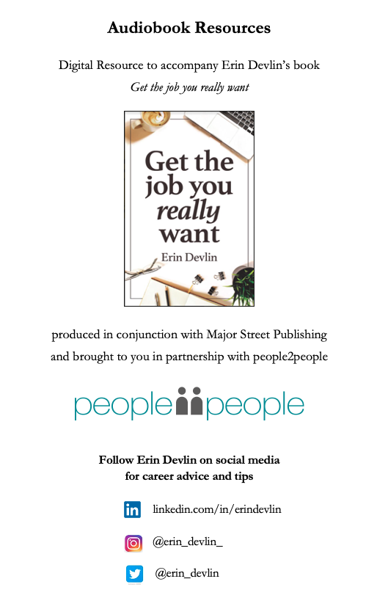
You can get your copy of Get the job you really want by Erin Devlin HERE

Chapter 1 Resources

Career Plan Template
Use this digital Career Plan Template in conjunction with instructions in Erin Devlin’s book Get the job you really want.

Life and career vision board

Using an art board, the space here, or a platform like Pinterest, you can pull together images that resonate with you relating to your life and career, or write some descriptive text. Examples might include a businessperson winning an award, a mother holding a baby, a traveller on top of a mountain or a social worker reaching out to someone in need. Choose images and words that resonate with you and include them here.

Career Vision

Create a vision statement for yourself which reflects you and what you want your career to look like in five or ten years’ time; e.g. ‘To be a world-class solar panels expert, furthering the use of renewable energy’. Include your vision statement here.

Motivating factors

From the list of motivating factors below, circle those which are important to you in a job, or list additional options. Choose your top ten and rank them in order of importance.
Keep them handy when assessing job opportunities to help you choose a job that you’ll enjoy.

- Caring for the environment
- Social good
- Giving back
- Community engagement
- Making money
- Status
- Business ownership
- Entrepreneurship
- Leadership opportunities
- Making people happy
- Having order and structure
- Being creative
- Lots of social interaction
- Meaningful work
- Being rewarded or recognised
- Standard hours
- Flexibility
- Work-life balance
- Being seen as an expert
- Close to home
- International travel
- Autonomy
- Work friendships
- Growth and development
- Being innovative
- Career progression
- Working with technology
- Ability to challenge
- Problem solving
- Realising potential
- Great work environment
- Stimulating work
- Being physically active
- Other?

- ______________________________________________________________________________
- ______________________________________________________________________________
- ______________________________________________________________________________
- ______________________________________________________________________________
- ______________________________________________________________________________
- ______________________________________________________________________________
- ______________________________________________________________________________
- ______________________________________________________________________________
- ______________________________________________________________________________
- ______________________________________________________________________________
Interests

What do you love doing? How do you spend your spare time? List your interests here.

__________________________________________________________________________________
__________________________________________________________________________________
__________________________________________________________________________________
__________________________________________________________________________________
__________________________________________________________________________________

Strengths

What are you good at? What are your natural abilities? List your strengths here.

__________________________________________________________________________________
__________________________________________________________________________________
__________________________________________________________________________________
__________________________________________________________________________________
__________________________________________________________________________________

Values exercise

Using the list below, choose 20 values that really resonate with you. Then group them together under five or six related headings with an accompanying phrase. For example, you might choose values like adventure, fun, joy, playfulness and happiness, and therefore your key heading and phrase might be ‘Happiness: having fun and seeing the positive side of situations’.

Accountability
Achievement
Adventure
Advocacy
Ambition
Autonomy
Balance
Brilliance
Calmness
Career focus
Caring
Challenge
Charity
Cheerfulness
Cleverness
Collaboration
Commitment
Community
Compassion
Consistency
Contribution
Creativity
Credibility
Curiosity
Decisiveness
Dependability
Development
Diversity
Empathy
Encouragement
Enthusiasm
Ethics
Excellence
Fairness
Family
Flexibility
Freedom
Friendships
Fun
Generosity
Growth
Happiness
Health
Honesty
Hope
Humility
Humour
Inclusiveness
Independence
Individuality
Innovation
Inspiration
Intelligence
Joy
Kindness
Knowledge
Leadership
Learning
Love
Loyalty
Making a difference
Mindfulness
Motivation
Open-mindedness
Optimism
Originality
Passion
Peace
Perfection
Performance
Playfulness
Popularity
Power
Proactivity
Professionalism
Quality
Recognition
Relationships
Reliability
Resilience
Resourcefulness
Responsibility
Responsiveness
Risk-taking
Safety
Security
Self-control
Selflessness
Service
Simplicity
Spirituality
Stability
Success
Teamwork
Thoughtfulness
Trustworthiness
Understanding
Usefulness
Versatility
Vision
Wealth
Wisdom

Once you’ve completed this exercise you will hopefully have a list of five or six core values. Here is an example of what this might look like:
- Giving: giving back and contributing for good
- Happiness: enjoying life and work, and always seeing the positive
- Achievement: learning, developing, seizing opportunities and continuously improving
- Integrity: staying true to what I believe in, and having the courage to advocate
- Teamwork: helping and supporting others

Your values
List your values here.

__________________________________________________________________________________
__________________________________________________________________________________
__________________________________________________________________________________
__________________________________________________________________________________
__________________________________________________________________________________
__________________________________________________________________________________

Profession

List your chosen profession, or jobs and professions to explore further.

__________________________________________________________________________________
__________________________________________________________________________________
__________________________________________________________________________________

Goals

What are your short- and long-term S.M.A.R.T career goals? List them here.
S.M.A.R.T. stands for Specific, Measurable, Assignable, Realistic and Time-based.

__________________________________________________________________________________
__________________________________________________________________________________
__________________________________________________________________________________
__________________________________________________________________________________
__________________________________________________________________________________
__________________________________________________________________________________

Action Steps

What are the action steps you need to take to achieve your career goals? List them here.
- Include education, training, work experience and exploration steps
- Include skills, knowledge and certifications you need

__________________________________________________________________________________
__________________________________________________________________________________
__________________________________________________________________________________
__________________________________________________________________________________
__________________________________________________________________________________
__________________________________________________________________________________

Status

Include status updates as you take steps towards your career goals

__________________________________________________________________________________
__________________________________________________________________________________
__________________________________________________________________________________
__________________________________________________________________________________
__________________________________________________________________________________
__________________________________________________________________________________

Chapter 2 Resources
p.50 Example of a LinkedIn or CV tagline
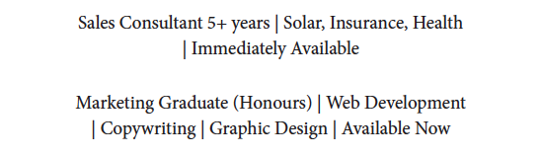

p.51 Example of an EVP summary on your LinkedIn profile
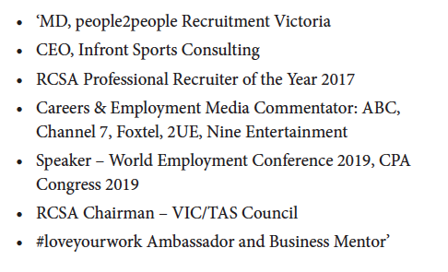

p.52 Examples of technology that you can list on your LinkedIn profile or CV

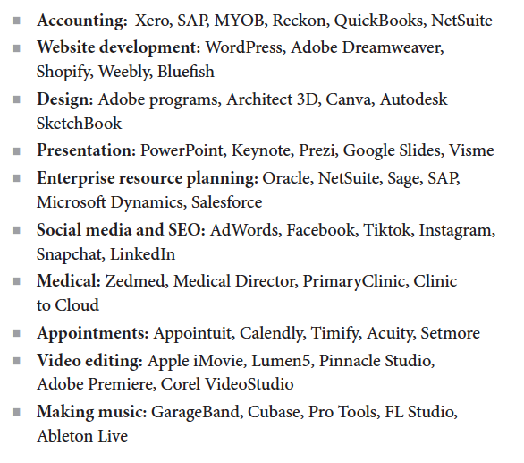

p.55 Example of proactive language

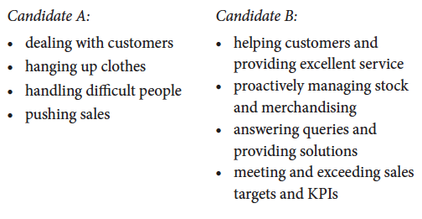

p.59 Space to list your personal branding goals and target audience:

Personal Branding Goals

List what you would like to achieve in relation to your employment through personal branding goals

__________________________________________________________________________________
__________________________________________________________________________________
__________________________________________________________________________________
__________________________________________________________________________________
__________________________________________________________________________________
__________________________________________________________________________________

Target Audience

Define your social media audience in relation to your personal branding goals

__________________________________________________________________________________
__________________________________________________________________________________
__________________________________________________________________________________

Chapter 6 Resources
p.73 Title examples
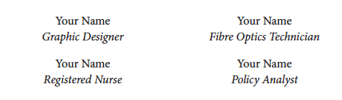

p.73 – 74 Tagline examples

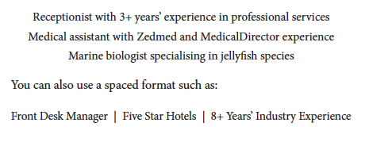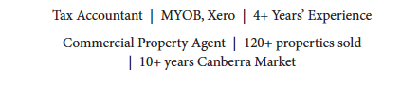

p.74 Contact details example
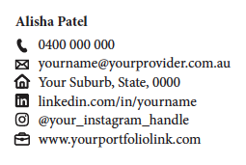

p.76 Career summary example

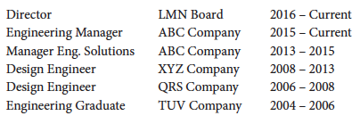

p.80 Company description example

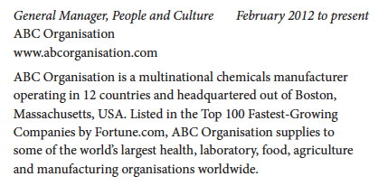

p.81 Example duties list for a Senior AFL Coach

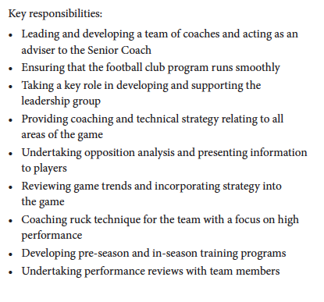

p.84 Referee format example

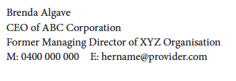

p.84 Example professional development list



Chapter 7 Resources
p.97 Example of how to show promotions within organisations

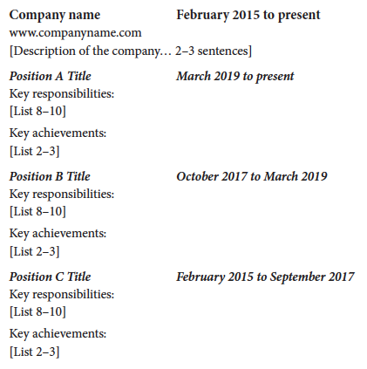

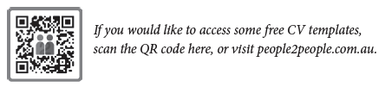
p.99 Example of transferable skills within different professions

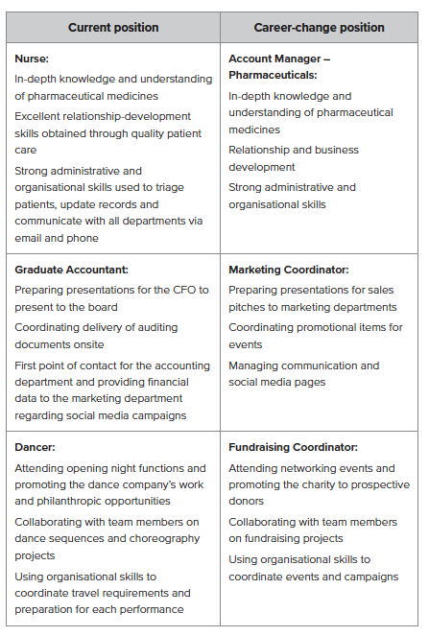

p.100 Key Highlights example

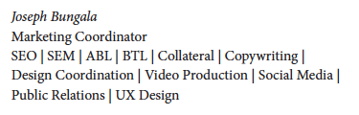

Chapter 8 Resources
p.105 Cover Letter Format example

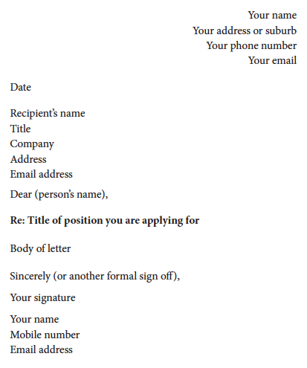



p.111 Cover Letter Video Format

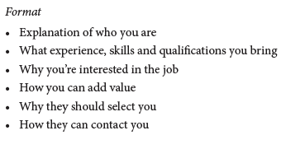
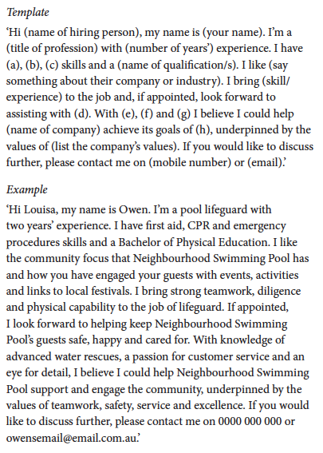

Chapter 9 Resources
p.120 Job applications tracker

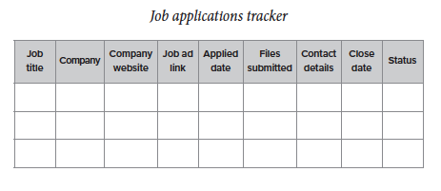

Chapter 12 Resources
p.173 Research questions to answer prior to interview

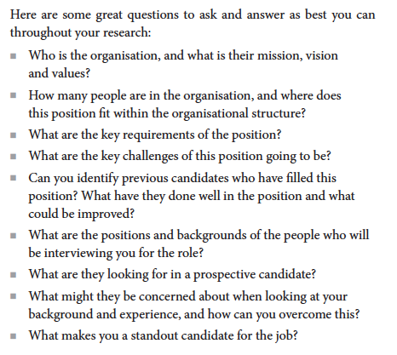

p.175 – 176 Commonly Asked Interview Questions

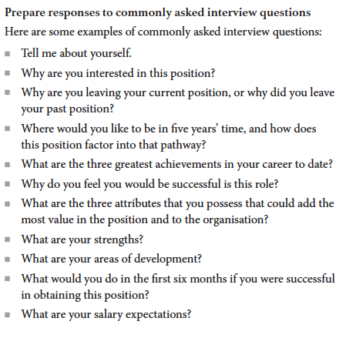
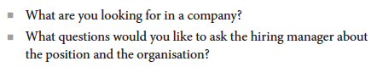

p.176 – 177 Examples of S.T.A.R. questions
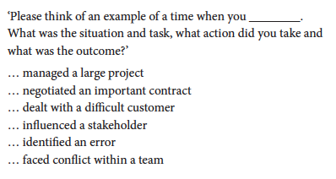
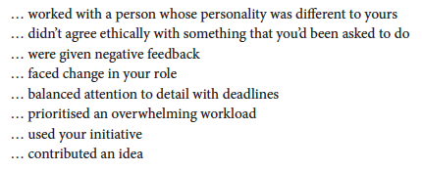

Chapter 13 Resources
p.189 Checklist for a great interview

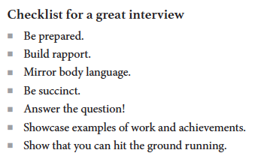
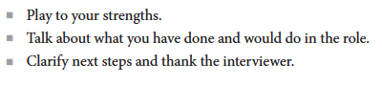

Chapter 14 Resources
p.194 Questions to consider ahead of a job offer

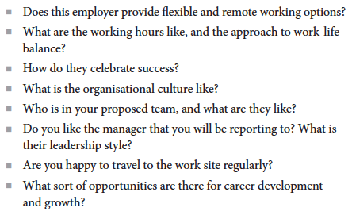

Chapter 15 Resources
p.208 Career plan roadmap

12-month plan:

What would I like to achieve in this position over the next 12 months?

__________________________________________________________________________________
__________________________________________________________________________________
__________________________________________________________________________________
What action do I need to take to make that happen?

__________________________________________________________________________________
__________________________________________________________________________________
__________________________________________________________________________________
What support, training or resources do I need from my manager or organisation to get there?

__________________________________________________________________________________
__________________________________________________________________________________
__________________________________________________________________________________
Five-year plan:

Where would I like to be in my career in five (or ten) years’ time?

__________________________________________________________________________________
__________________________________________________________________________________
__________________________________________________________________________________
What action do I need to take to make that happen?

__________________________________________________________________________________
__________________________________________________________________________________
__________________________________________________________________________________
What support, training or resources do I need from my manager or organisation to get there?

__________________________________________________________________________________
__________________________________________________________________________________
__________________________________________________________________________________

