 | 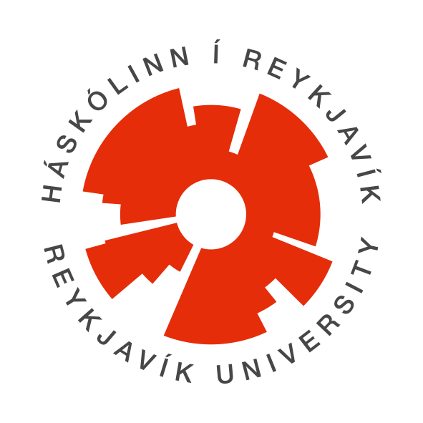

Rafíþróttir (Esports) – KR & Skema
Esports training for ages 8–16, grouped by age, at Reykjavík University.

About the course
The KR & Skema Esports Division offers a targeted, structured training program that supports both personal development and competitive progress. The program is split into age groups to ensure each participant gets appropriate challenges, guidance, and the chance to develop at their own pace.
Across all age groups, we emphasize that success in esports is connected to general health and wellbeing. Every session opens with guided physical activity — mobility work, stretching, coordination exercises, or light cardio. Participants also learn about body mechanics, focus, recovery, and healthy habits, including the importance of nutrition and balance in daily life.
We prioritize a positive, social training environment where participants come together around shared goals, build strong relationships, and grow as teammates. Esports training with us is about more than the games themselves — it's about communication, discipline, cooperation, and healthy paths to success.
Students also have the opportunity to participate in competitions hosted by RÍSÍ, representing the KR/HR team. These competitions typically take place on weekends.

Topics covered
Ages 8–10 — A foundation built on fun and teamwork
For younger participants, the focus is on age-appropriate competitive games that encourage cooperation, coordination, and creative thinking in a supportive environment.
- Fundamental skills and technical elements
- Teamwork and clear communication
- Positive gaming culture and sportsmanship
- Building confidence within a structured group
- Healthy body mechanics and movement habits
The goal is to build a strong foundation — both physically and mentally — while keeping learning fun and motivating.
Ages 11–14 — Strategy, competition, and performance development
Older participants train in more demanding competitive games that call for tactical thinking, clearly defined roles within a team, and focused communication.
- In-depth strategy and game understanding
- Role division and leadership skills
- Performance under pressure
- Structured teamwork and accountability
- Understanding how movement, rest, and nutrition support performance
Participants learn that competitive success is built on preparation, balance, and healthy habits — both during training and outside of it.

Who the course is for
Prerequisite: None. No prior experience required.

Group | Ages | Days | Time
Group 1 | 8–10 | Monday & Wednesday | 15:30–17:00
Group 2 | 11–14 | Monday & Wednesday | 17:15–18:45

Meet your coach
Aron brings a lifelong background in competitive gaming and hands-on esports experience — including work in live broadcasting and helping launch RÍSÍ's Fortnite esports division. He also has solid coaching experience from football, having coached at Leiknir Reykjavík, and holds a KSÍ C-license coaching certification.

Format
- 15-week course, 2 days a week, 90 minutes per lesson
- Running August 31 – December 16, 2026
- Location: Reykjavík University — room M107, Menntavegur 1, 102 Reykjavík

Course schedule
Group 1 (Ages 8–10): Mondays & Wednesdays, 15:30–17:00
Group 2 (Ages 11–14): Mondays & Wednesdays, 17:15–18:45
Full session dates (both groups):
Session #17 (Oct 26) highlighted below.
# | Date | Day
1 | Aug 31, 2026 | Monday
2 | Sept 2, 2026 | Wednesday
3 | Sept 7, 2026 | Monday
4 | Sept 9, 2026 | Wednesday
5 | Sept 14, 2026 | Monday
6 | Sept 16, 2026 | Wednesday
7 | Sept 21, 2026 | Monday
8 | Sept 23, 2026 | Wednesday
9 | Sept 28, 2026 | Monday
10 | Sept 30, 2026 | Wednesday
11 | Oct 5, 2026 | Monday
12 | Oct 7, 2026 | Wednesday
13 | Oct 12, 2026 | Monday
14 | Oct 14, 2026 | Wednesday
15 | Oct 19, 2026 | Monday
16 | Oct 21, 2026 | Wednesday
17 | Oct 26, 2026 | Monday
18 | Oct 28, 2026 | Wednesday
19 | Nov 2, 2026 | Monday
20 | Nov 4, 2026 | Wednesday
21 | Nov 9, 2026 | Monday
22 | Nov 11, 2026 | Wednesday
23 | Nov 16, 2026 | Monday
24 | Nov 18, 2026 | Wednesday
25 | Nov 23, 2026 | Monday
26 | Nov 25, 2026 | Wednesday
27 | Nov 30, 2026 | Monday
28 | Dec 2, 2026 | Wednesday
29 | Dec 7, 2026 | Monday
30 | Dec 9, 2026 | Wednesday
31 | Dec 14, 2026 | Monday
32 | Dec 16, 2026 | Wednesday

Practical information
- Price: 58,000 kr.
- Registration and use of leisure/recreation subsidies via Sportabler: sportabler.com/shop/rafithrottir
- Contact: Skema staff — skema@ru.is, 599 6300
- Reykjavík University — Menntavegur 1, 102 Reykjavík — 599 6200

