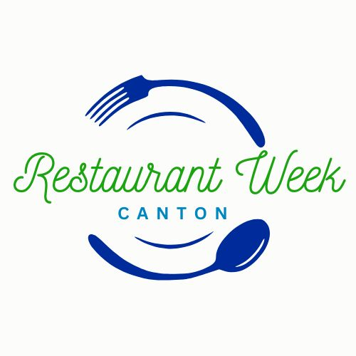
CANTON Restaurant Week
March 1-7, 2026

Across Michigan, many communities have benefited from hosting a Restaurant Week. For restaurants, the benefit is an increase in traffic and new patronage.

We invite you to take part in this celebration of local cuisine.

To participate in Canton Restaurant Week, you should be a Canton Chamber member. However, if you are not a member yet, we are offering a one-time bonus to become a member. If you join the Chamber and register for Restaurant Week 2026, the $30 initial application fee will be waived. Choose the new membership option on the registration form or in the link below. If you do not wish to join the Chamber at this time, you are still welcome to participate. See the registration form at: Https://cantonchamber.com/restaurantweek for more information.

Participating restaurants will be promoted on social media, sponsored eblasts, on our website: Https://cantonchamber.com/restaurantweek, in-restaurant promotions (flyers and table tents), and local news outlets. The target audience for this event will be Canton Township and surrounding communities.

What we ask from participating restaurants is simple:
- Offer a menu chosen by you for breakfast, lunch or dinner (pick 1-3) at price points of $15, $25, $40. The $40 option can be for 1 or 2 people.
- Price points are non-negotiable as we want to offer fixed price points from all participating restaurants for a uniform and easy to understand offer to patrons.
- You do not need to offer all-day meals.
- You do not have to offer the same menu options as other participants, just the same price points.
- We encourage you to get creative. Offer new and interesting items, promote venue favorites, put your best plate/cup forward to draw new patrons and bring regulars back more often.

Canton Restaurant Week is brought to you by the Canton Chamber of Commerce, as well as our supporting sponsors. It is our goal that your decision regarding menu offerings and the set price points will increase your revenue and draw new and frequently returning customers to your establishments, making it a win for all involved!

Please complete the attached form to be included in the event this year. We will need your menu details and payment no later than January 23rd. Please complete and email the attached form or access the fillable registration form Https://cantonchamber.com/restaurantweek by the January 23rd deadline.

Please contact us with any questions via the phone number or email address below.

We look forward to promoting your establishment during the inaugural Canton Restaurant Week March 1-7, 2026!

Faisal Kamran (Kam) Restaurant Week Chair  Ambassador Contact Information:
Pamela Batcho __________________________________
Canton Chamber of Commerce
Membership & Community Engagement Director __________________________________
pbatcho@cantonchamber.com
734.453.4040 Office __________________________________

