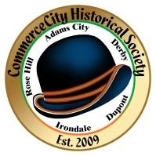

COMMERCE CITY HISTORICAL SOCIETY

20
2
6

CALENDAR

ANNUAL
MEMBERSHIP
MEETING

Meeti
(
ng
s held at Commerce City Heritage and Cultural Center)

6505
East
60
^{th}

Avenue

June
6
, 202
6

(
Saturday at noon
)

BOARD MEETINGS

2
^{nd}

Tuesday

of every month at 6
:
3
0

pm

ANNUAL EVENTS:

City Council Reception
-
Saturday January 31, 2026

Legendary Locals
Reception
-
Saturday
February 7
, 202
6

Rummage Sale
-
May 2
, 202
6

Heritage Family Celebration
-
Saturday
September
19
, 202
6

Christmas Part
y
-
Saturday December
5
, 202
6

PROGRAM
S:

History Lectures as scheduled

Museum group tours as requested

History Coloring Book distribution at museum

Children (3rd grade)

Reading Books distribution at museum

Legendary Locals program

Quarterly Newsletter

COMMERCE CITY HERITAGE AND CULTURAL CENTER:

Hours
Mon
:
, Wed, Fri

& Sat

am to 2 p
10
m

Tuesday & Thursday by Appointment

6505
East
60
^{th}

Avenue

Commerce City, CO 80022

303
-
288
-
2590

