COVID-19 Resources: Addressing Anti-Asian Racism

  Rapid Response: Racism is a Virus Too
  The Nellie Mae Education Foundation created this rapid response fund to respond to the hate crimes and bias against Asian American communities resulting from COVID-19. The Foundation has allocated resources for the Racism is a Virus Too rapid response grant fund to support Community-Based Organizations (CBOs) that provide services for AAPI communities.
  

  
  Addressing Racial Bias
  Through the COVID-19 Emergency Response Fund, the San Francisco Foundation will make capacity building grants ($3,000 – $25,000) to nonprofit organizations in San Francisco, Alameda, San Mateo, Contra Costa, and Marin Counties addressing the following four issue areas, described in greater detail below: worker support, preventing homelessness and providing renter protection/housing security, ensuring food security, and addressing racial bias.

  Grants to Organizations Providing Essential Services and Advocacy
  The California Wellness Foundation on March 25, 2020 announced nearly $3 million in grants to combat the effects of the novel coronavirus pandemic. Grants support the most vulnerable communities and people in our state: frontline health workers, economically disadvantaged people, immigrants, seniors, and Asian Americans experiencing race-based harassment and assaults, among others.
  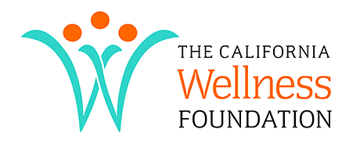

  
  2020 Resilience-NYC: COVID-19 Response and Recovery Fund
  Through the COVID-19 Response and Recovery Fund, The New York Women's Foundation is supporting organizations that prioritize the following communities: low-income immigrants, survivors of gender-based violence, Chinese and other East Asian communities, Muslims/Arab/South Asian communities, individuals with disabilities, LGBTQ, TGNCNB individuals, older adult women, women small-business owners and worker-owned cooperatives.

COVID-19 Resources from Asian American Organizations

  Asian Americans Advancing Justice (AAJC) offers the following resource in response to the growing number of Asian Americans being targeted by racism and xenophobia related to COVID-19.
  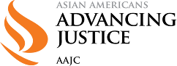

  
  Asian Americans for Civil Rights and Equality (AACRE) has compiled a comprehensive resource including information regarding symptoms of COVID-19 to testing, building resilience, addressing racism and stigma, creating work adjustments, how to advocate, and much more.

  Asian Pacific Community Fund (APCF) has created this online resource directory listing timely sources of funding, relief, and information for individuals, families, nonprofits, and small businesses.
  